**Lecture: Introduction To Amazon Simple Queue Service (SQS)**

In this lesson we are going to take a look at Amazon Simple Queue service. More specifically, we are going to look at the core concepts and design architecture surrounding SQS usage.

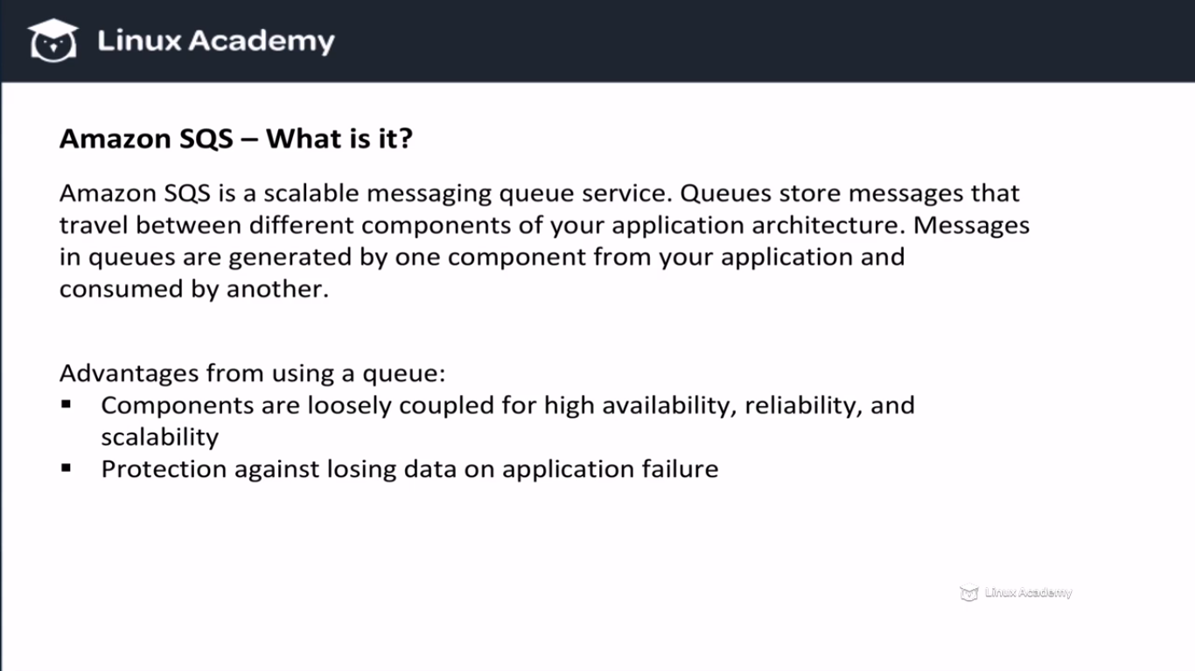

Difference between and SNS and SQS is that SQS has polling mechanism while SNS has a push mechanism. Using the polling mechanism we can de-couple our different components. All the components of our architecture need not to be available at the same time.If there is one failure or a delay of some kind the message will still eventually get consumed, we don’t have any bottlenecks.

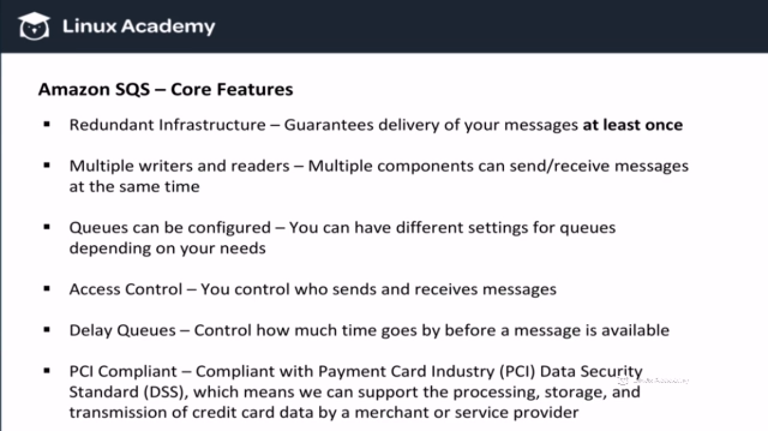

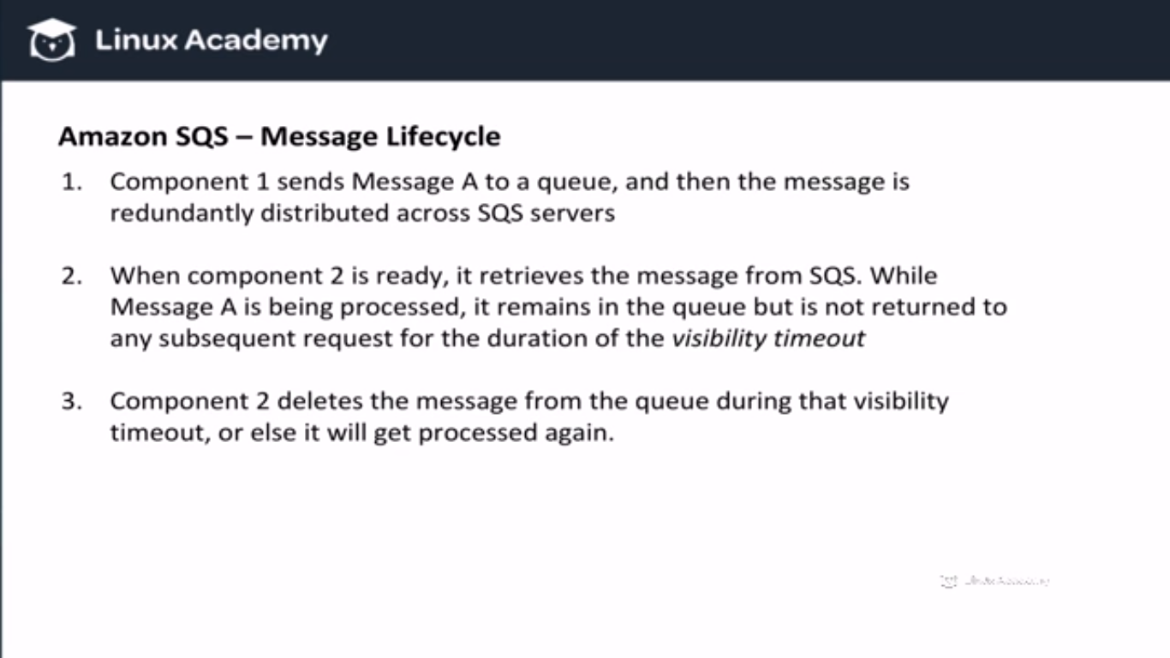

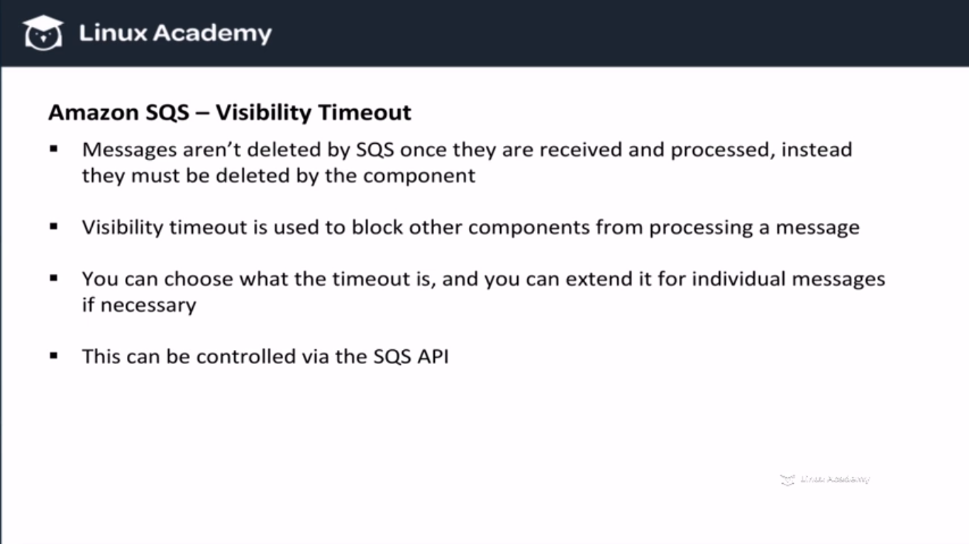

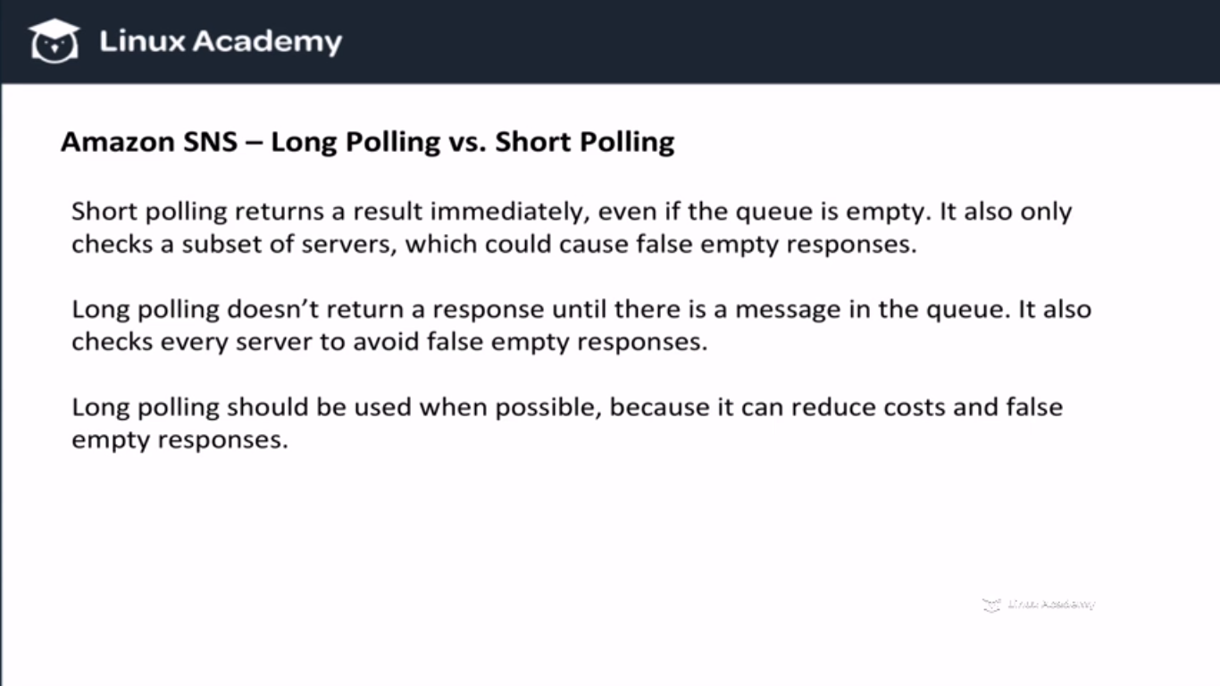

By default SQS uses short polling.

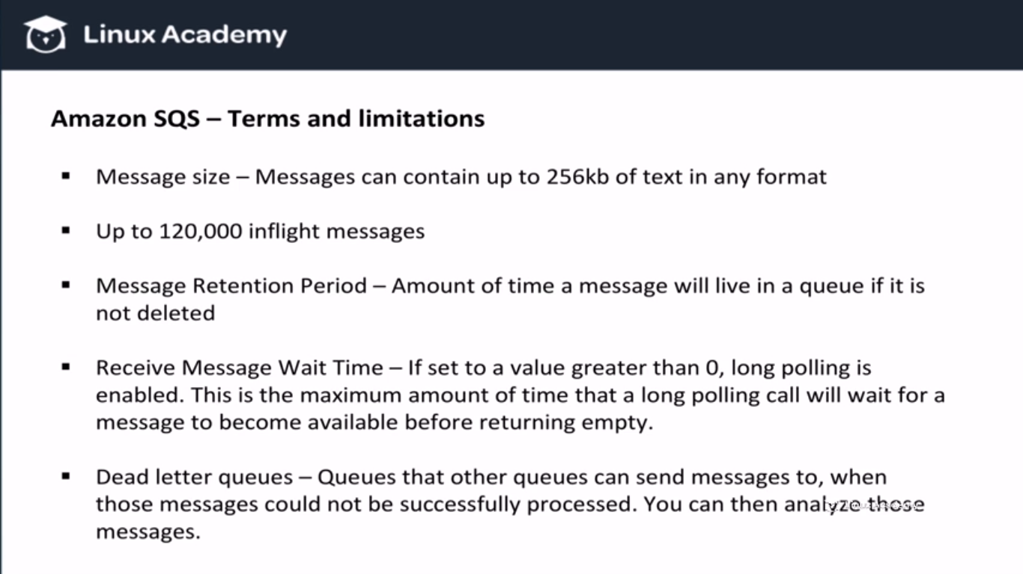

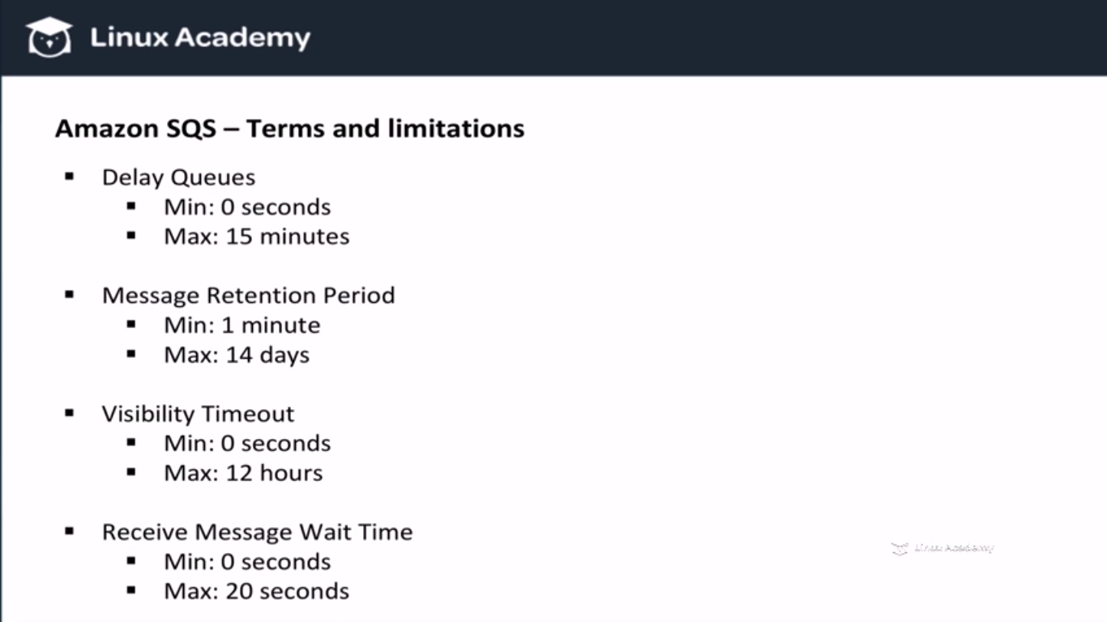

**Lecture: SQS API Developer Requirements**

In this lesson we are going to look at SQS API requirements for the developer certification. We will learn the required concepts and knowledge in order to pass the developer section of the exam.

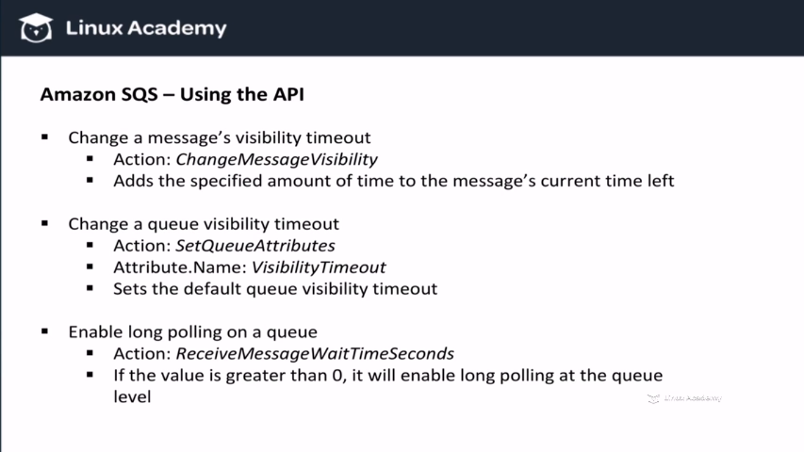

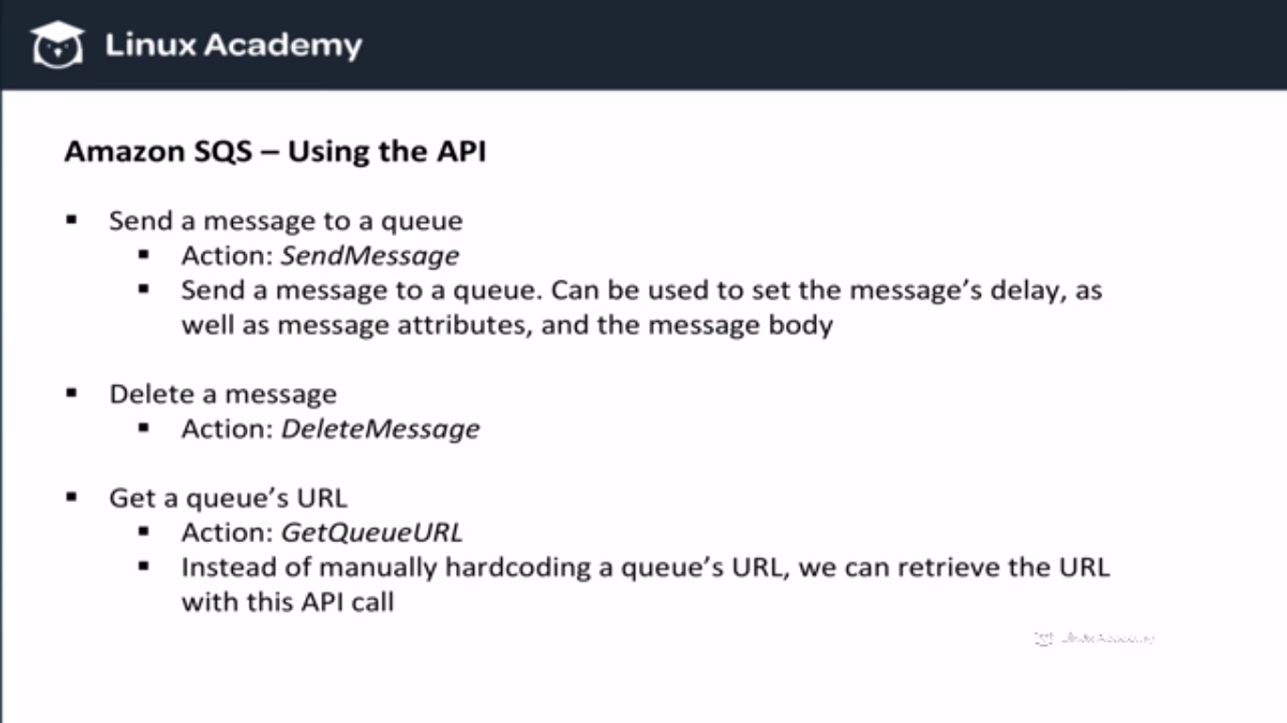

**AWS Elastic Beanstalk**

In this lesson, we take a look at what Elastic Beanstalk is and what we can do with it. We also discuss what platforms are supported and the core components that make up this service.

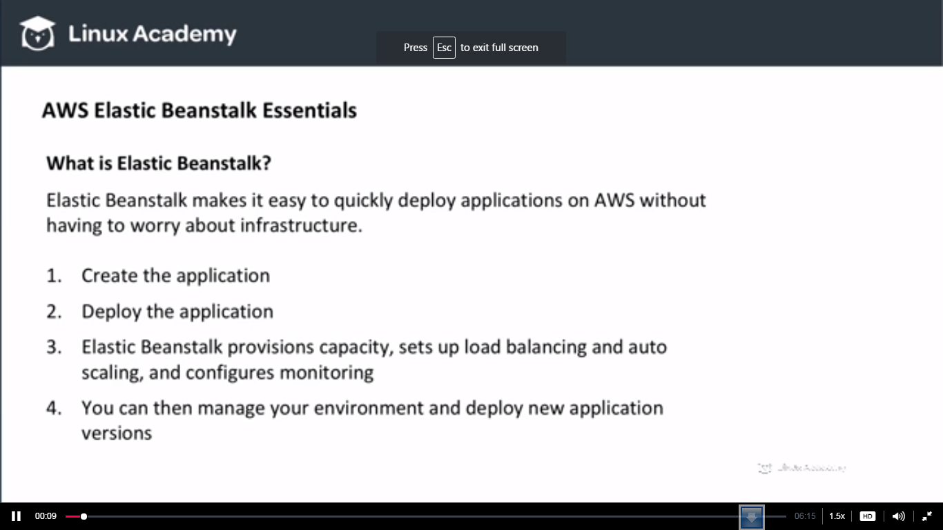

**Once our environment is up we can even access all the resources as of we created them ourselves. This is major difference between AWS Elastic beanstalk and other similar tools.**

**So what kind of platforms are supported**

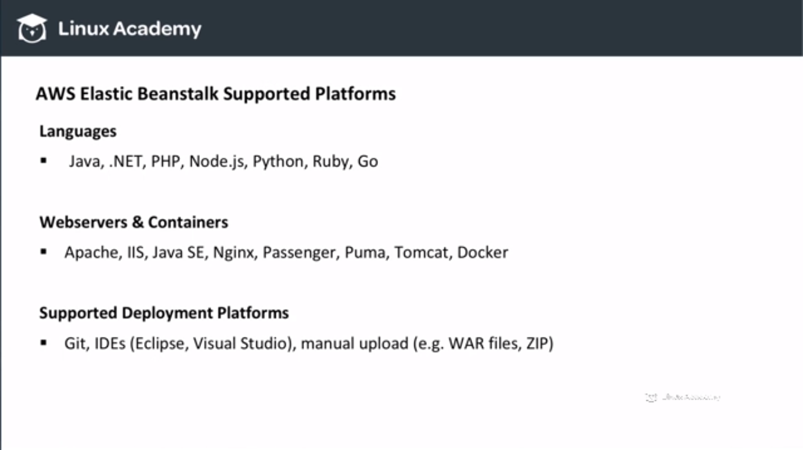

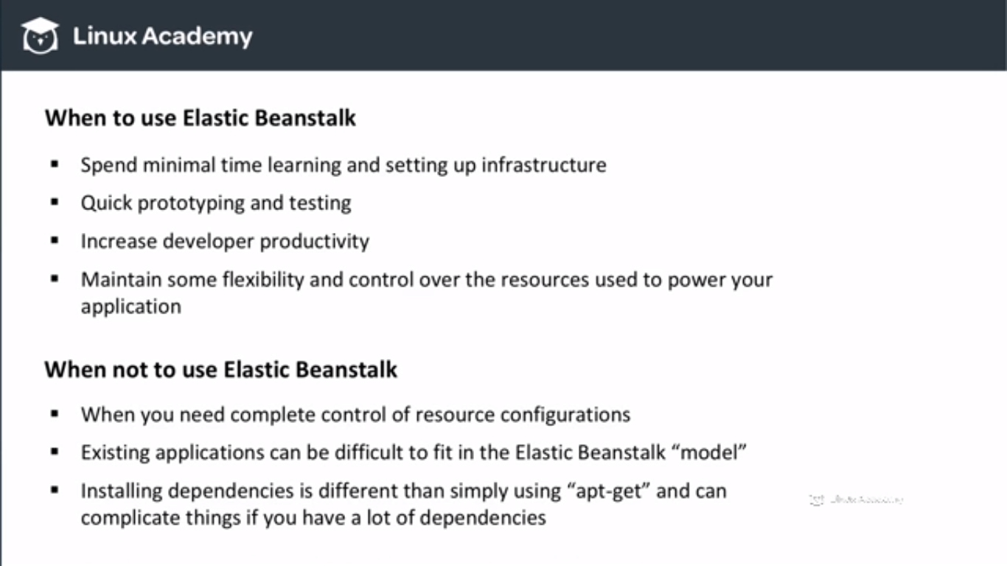

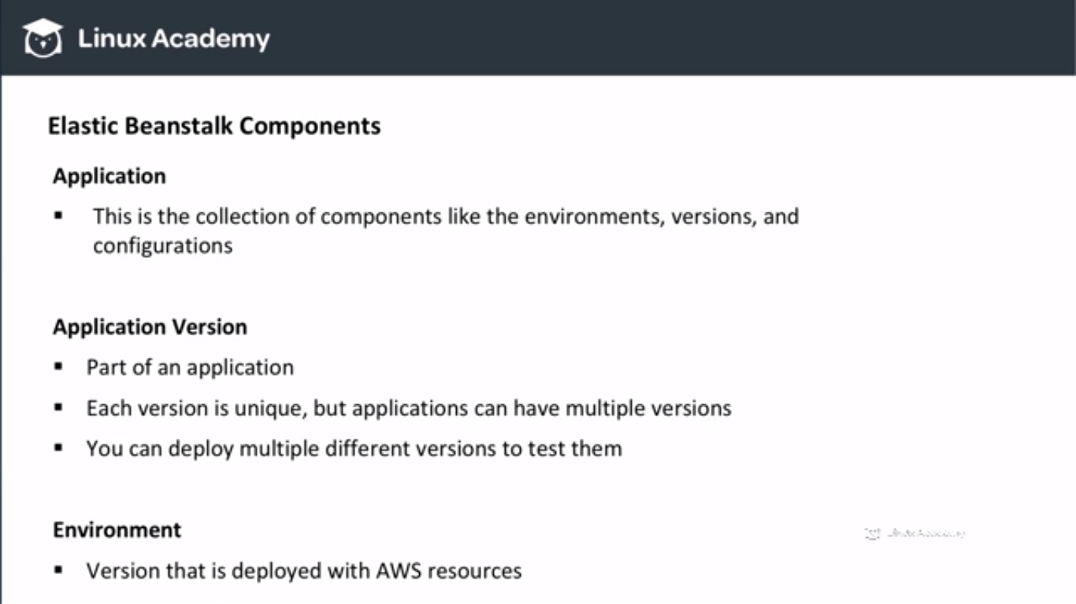

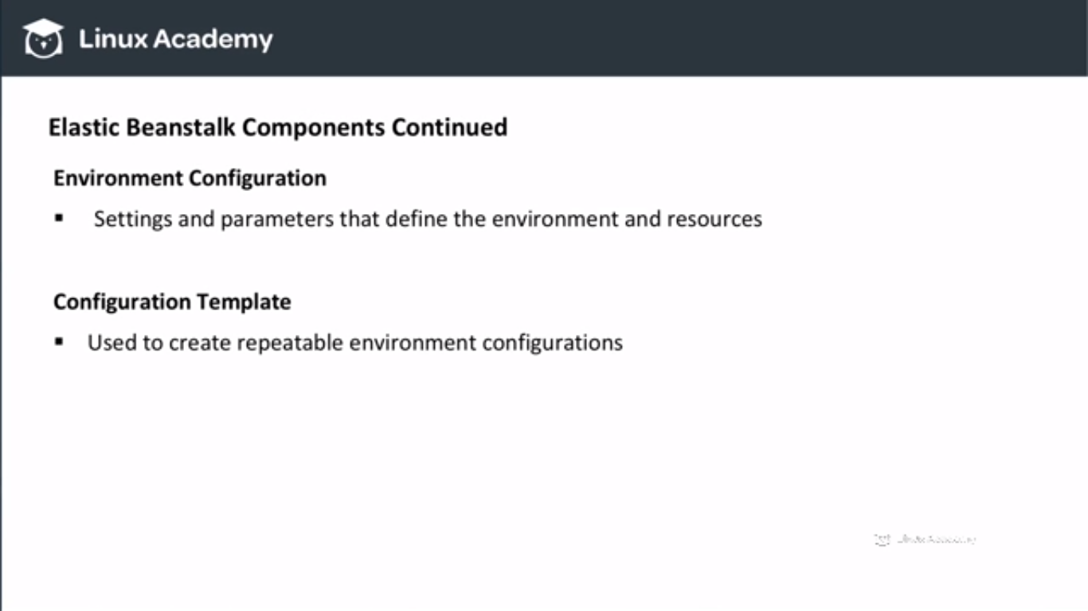

**Amazon SWF (Simple Workflow Service)**

**Lecture: Simple Workflow Service Concepts And Overview**

In this lesson we are going to learn about the Simple Workflow service. This lesson discusses the concepts required to understand the distributed nature and benefits of the AWS Simple Workflow Service.

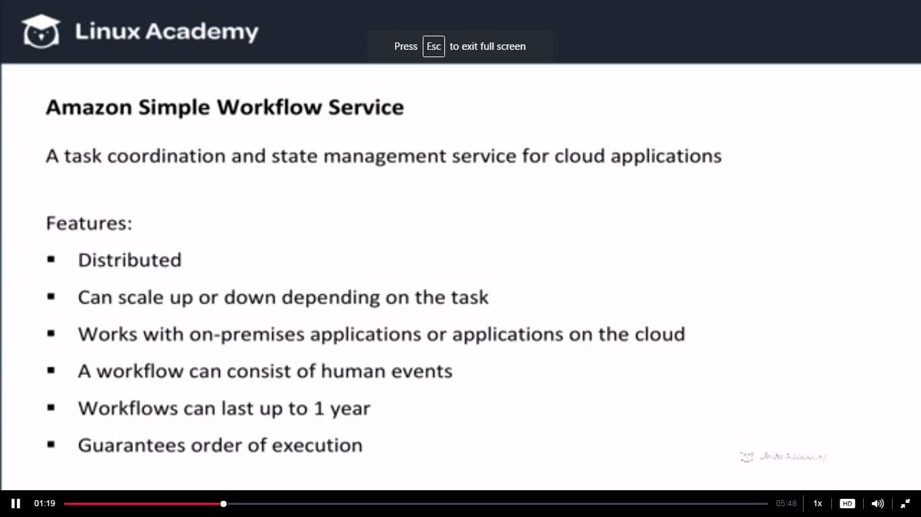

**Key difference between SWF and SQS is that workflows can actually consist of human events and human tasks. Since a workflow is made up of a lot of tasks each task performs and receives a set of instruction frm something called a decider. It receives a set of instruction and it executes its tasks based of that set of instructions. When a worker is done with executing a job it will return that result to the decider . the decider then determines that what task needs to be run as part of this workflow. Human interaction can actually take place.**

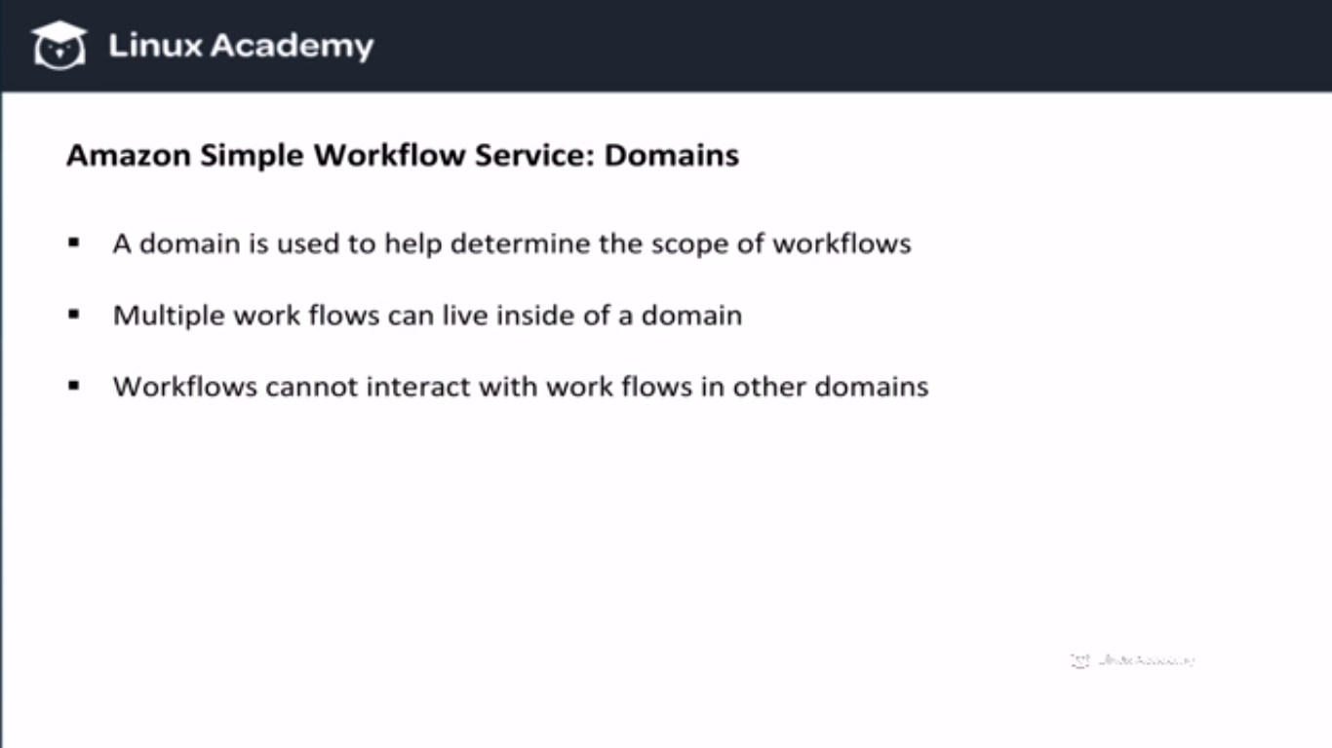

**So a domain is the scope. For eg I can have a workflow from ecommerce application and all the workflows from this ecommerce application will live in the same domain**

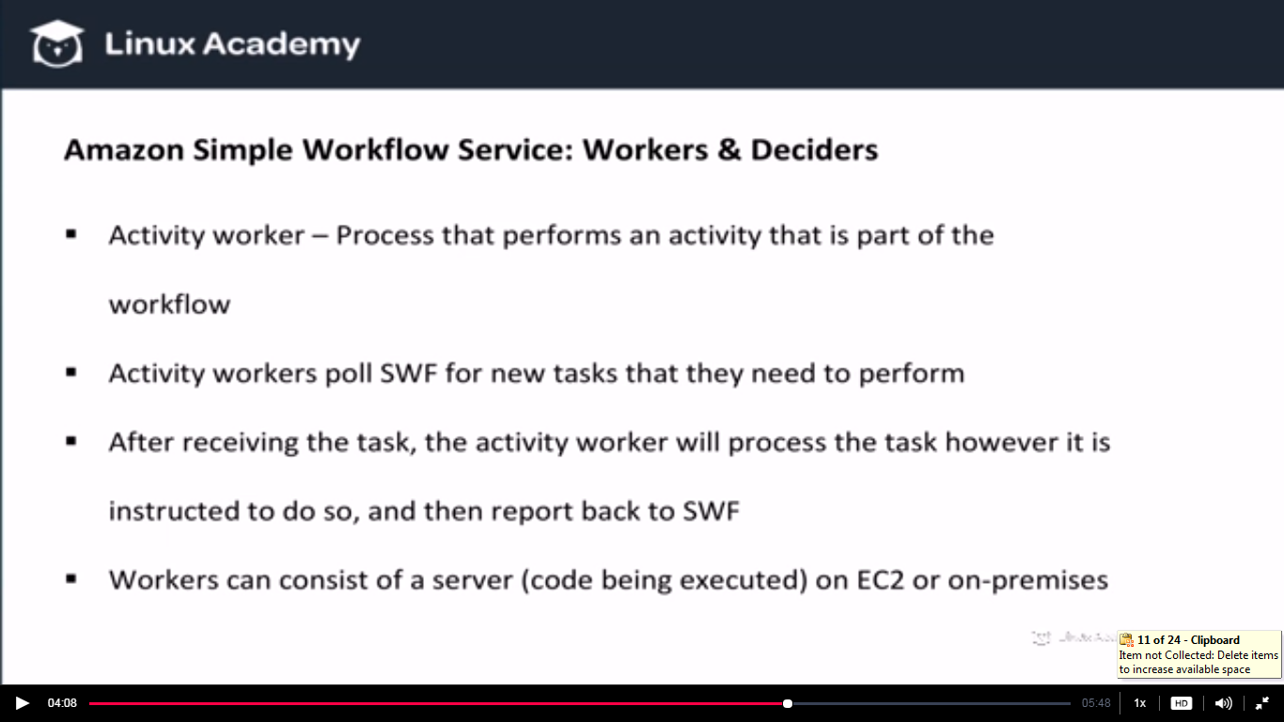

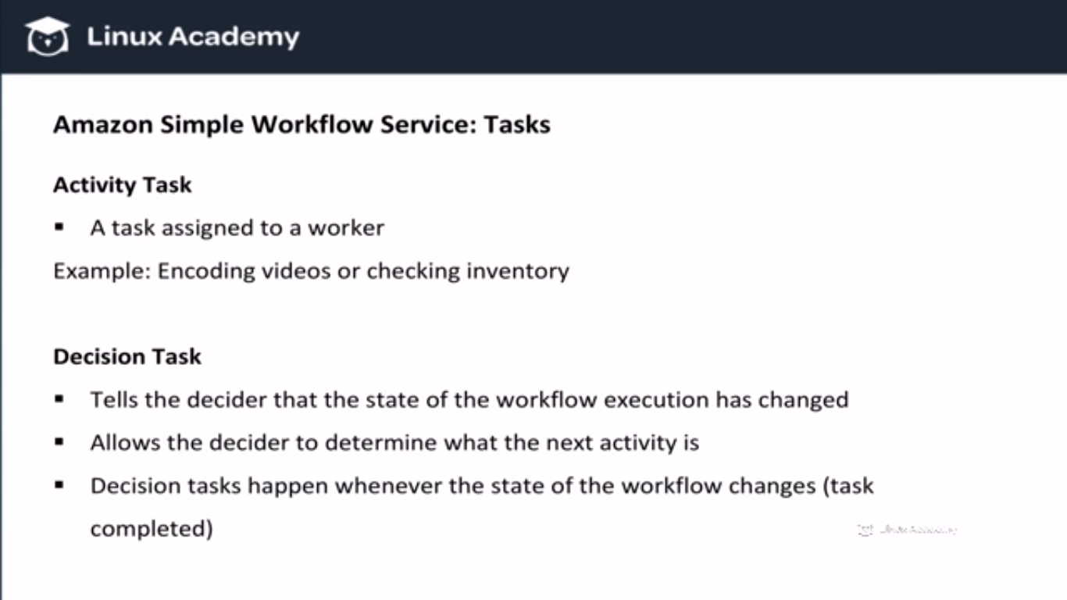

**Lecture: Simple Workflow Service Examples**

Now that we understand the concepts behind Amazon's Simple Workflow Service (SWF), let's take a look at examples of how this service can be used. This includes a use-case example of how NASA used SWF.

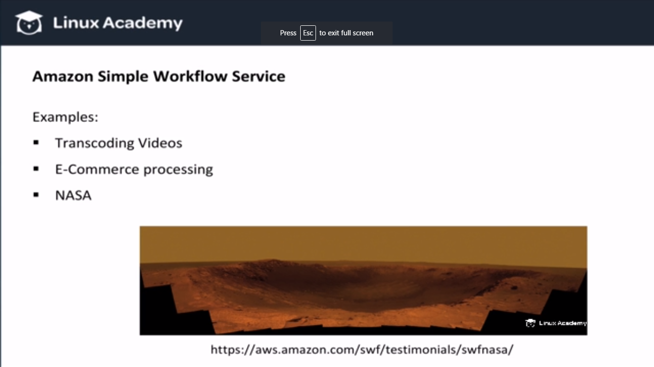

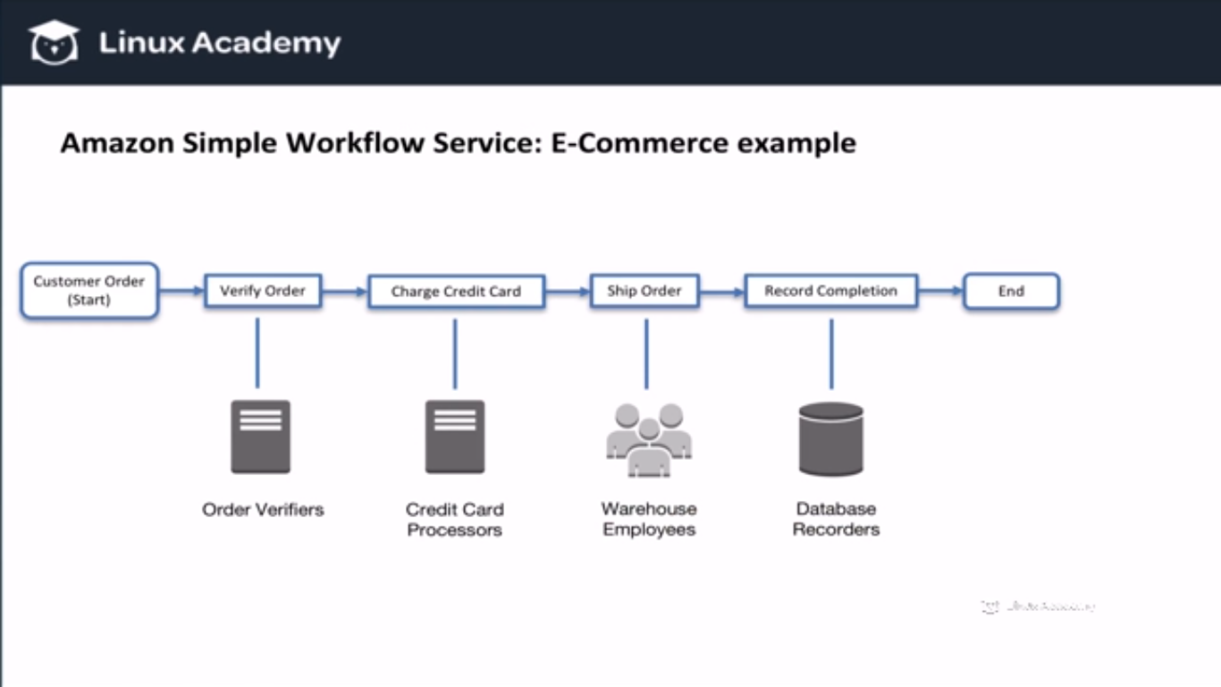

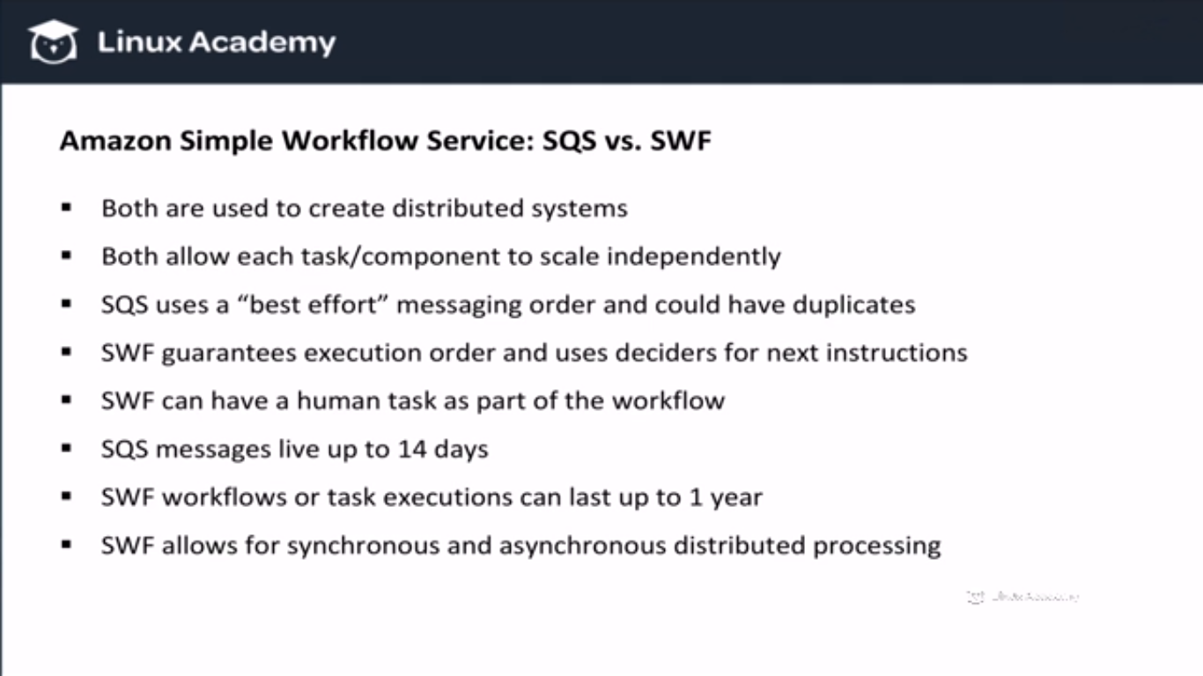

**Amazon EC2**

**Lecture: EC2 Fundamentals**

In this lesson we are going to look at a basic overview of Amazon EC2. Even if you are familiar with launching EC2 instances this lesson is still valuable.

**Lecture: EC2 Essentials**

In this lesson we are going to cover core concepts around Amazon EC2. These items will be found in all the associate level AWS certifications

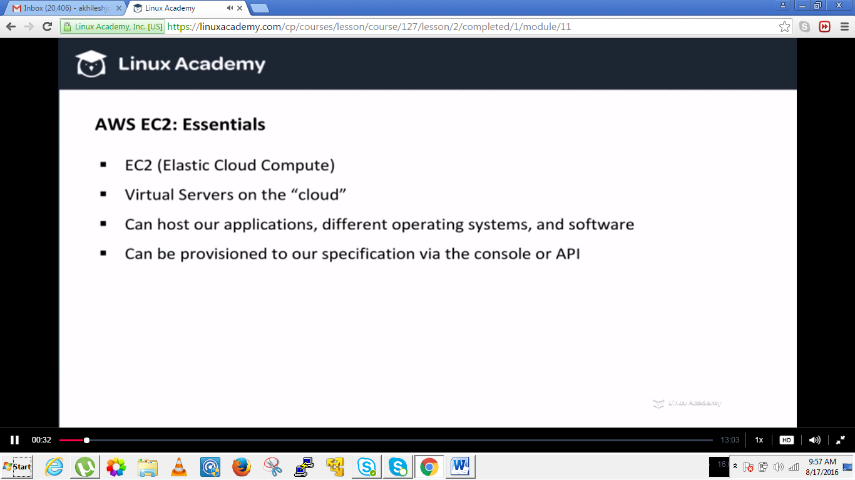

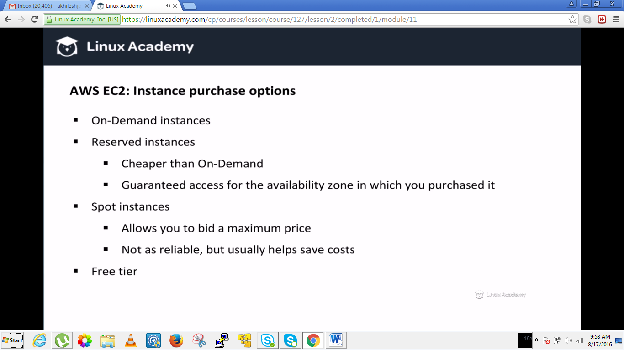

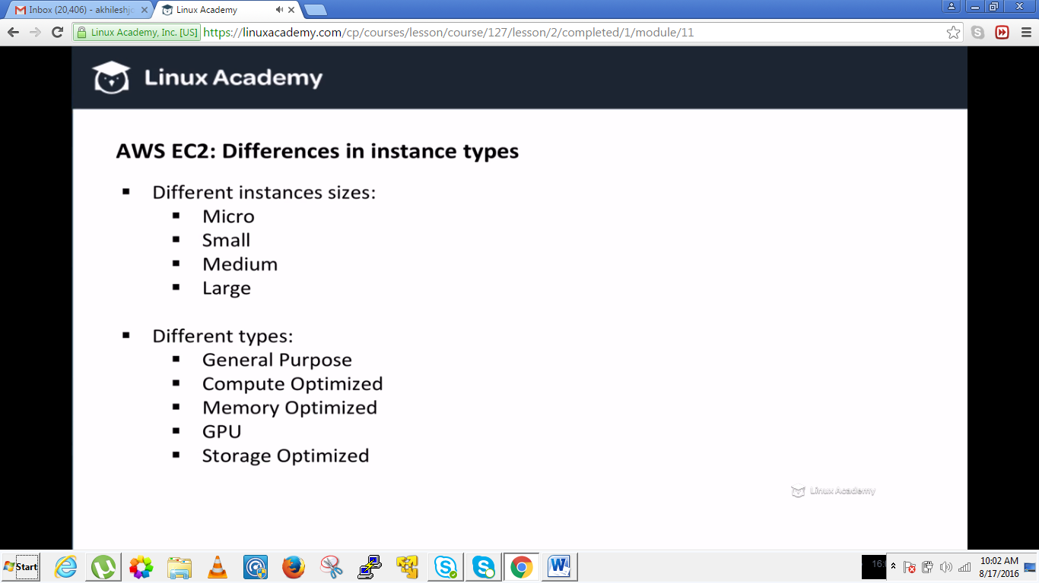

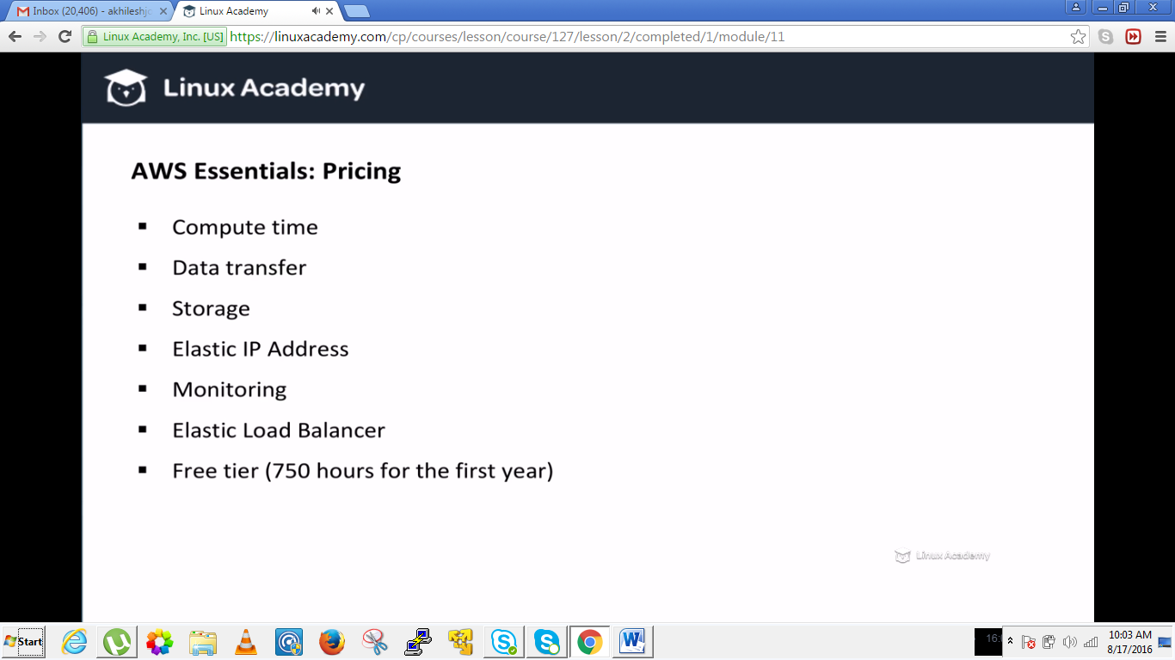

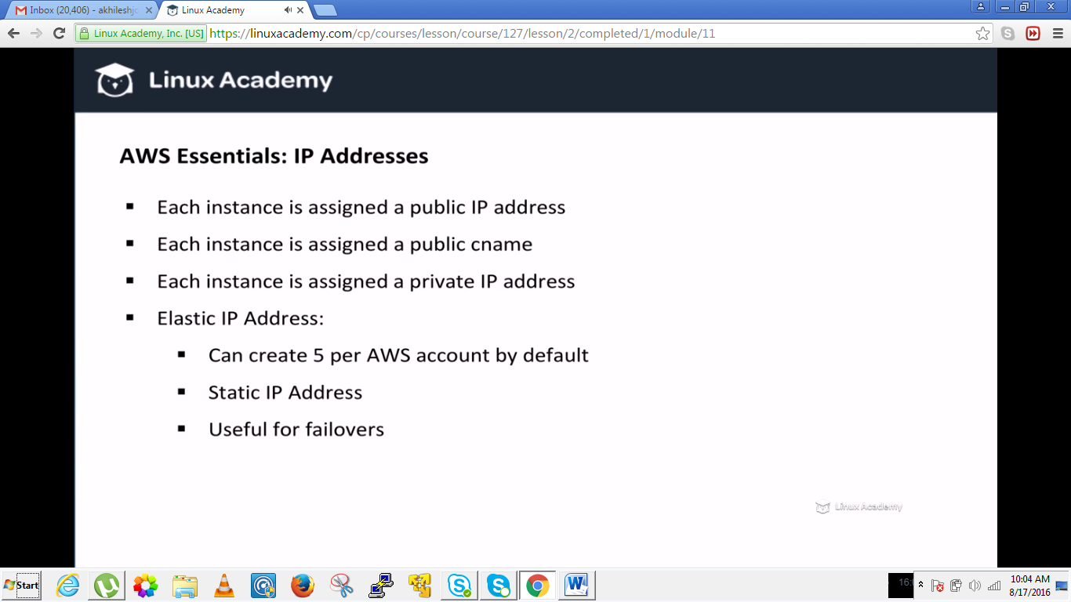

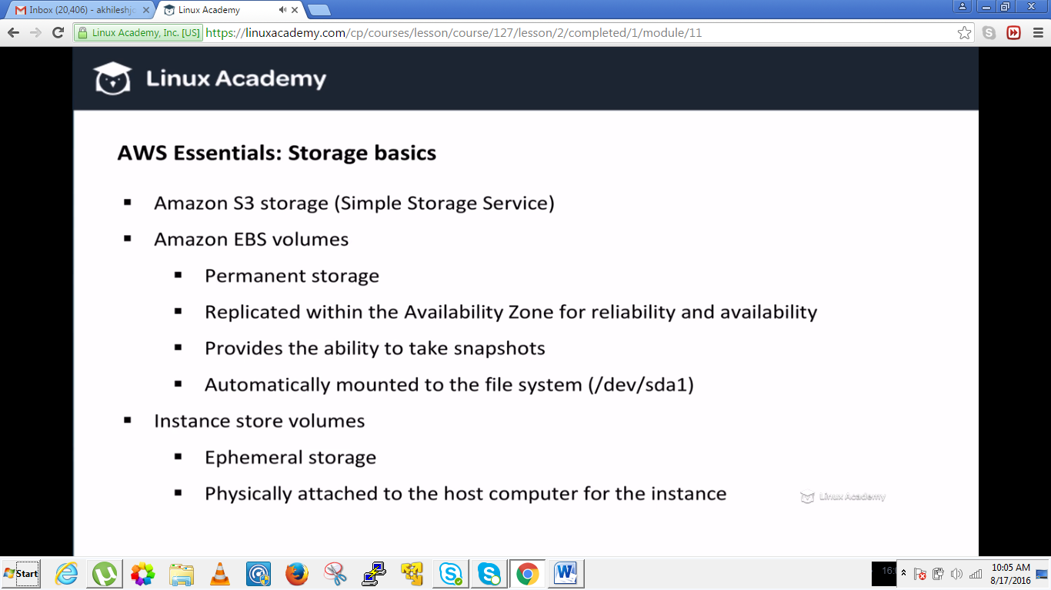

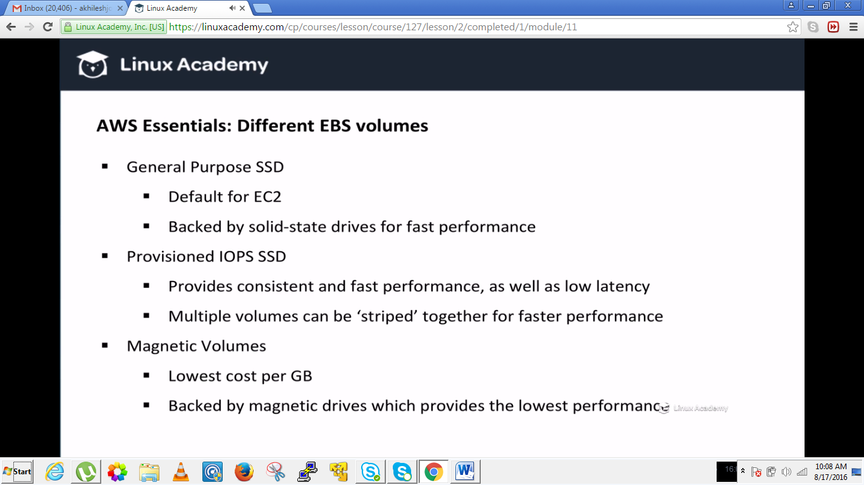

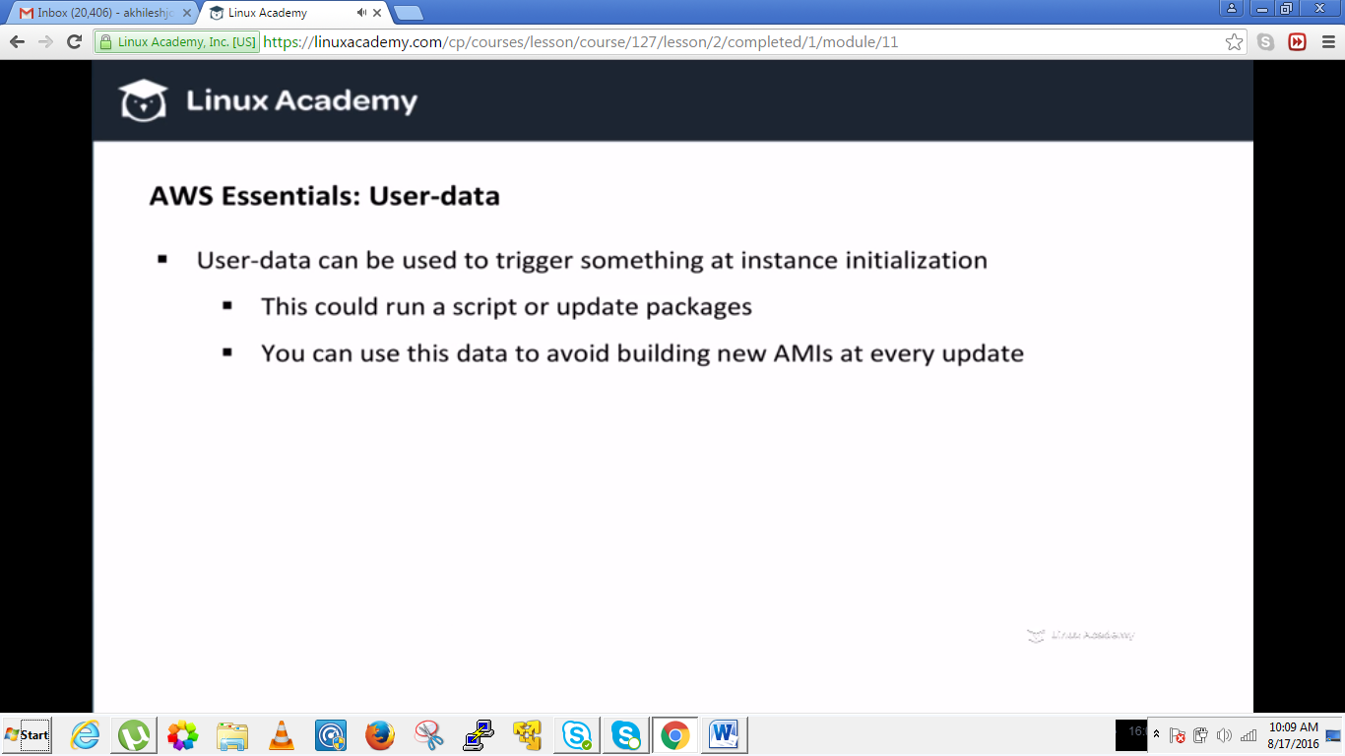

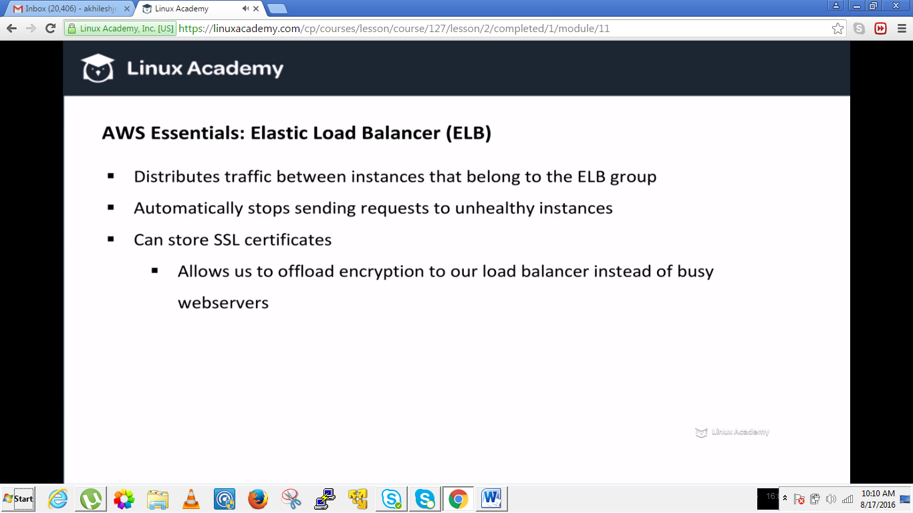

**Lecture: Maintaining Session State On ELB Applications**

In this lesson we are going to talk about maintaining application session state when using the Elastic Load Balancer and EC2 instances to serve an application.

How to maintain sessions.

For this go to loadbalancers from the AWS console and then after creating a load balancer click the stickness disabled to edit it as

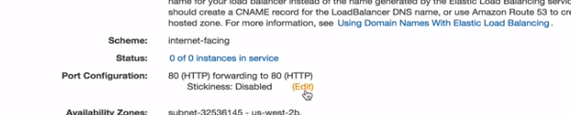

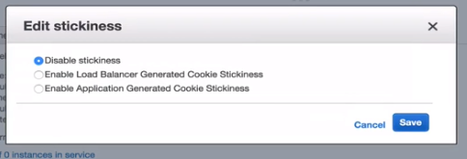

We have two options now to enable cookie stickiness. So what to use when. Lets see the difference via the below diagram. Lets have a look first from the load balancer gererated cookie stickiness also called duration based stickiness.

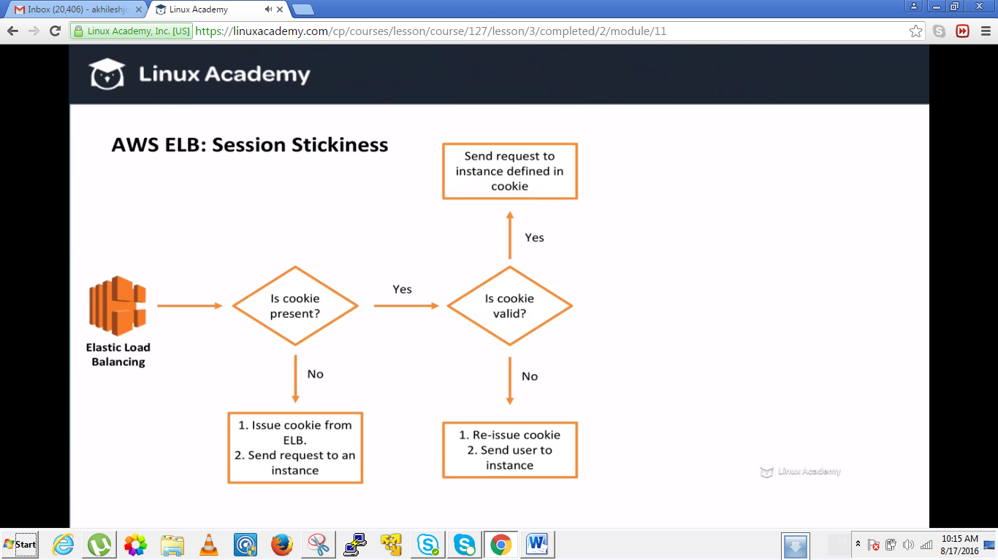

Here the life time of the cookie is decided by the load balancer. Here actually we are removing the load balancer functionality because we are sending a user to a specific instance instead of spreading the load to different instances. So this results in uneven load balancing which we should avoid if possible. We don’t want one instance with 70% of the requests. We want to spread load equally as possible between all of our individual instances.

Here the cookie duration is generated and determined by the load balancer. The other available method that we saw from the amazon console is the ability to enable application generated cookie stickiness. This is different because this time the lifetime of the cookie is determined by the application itself, so the load balancer itself still uses a cookie to figure our what instance the user should be sent to but this time the load balancer only changes the stickiness cookie if the application cookie changes. In other words the application issues a session and the elastic load balancer then issues a special cookie to associate that session with the original instance. So elastic load balancer generated cookiness issues a cookie that sends the user to the proper instance but with the application generated cookie stickiness the elastic loadbalancer issues a special cookie to associate the session with the original server. If the instance that issues the session disappears then the elastic load balancer will find the another instance to send the request to. But still we have the same problem this is not the load balancing evenly. We need something that can distribute request evenly across all of our instances. So how we can do that?/

So we have another option and this is the preferred option.

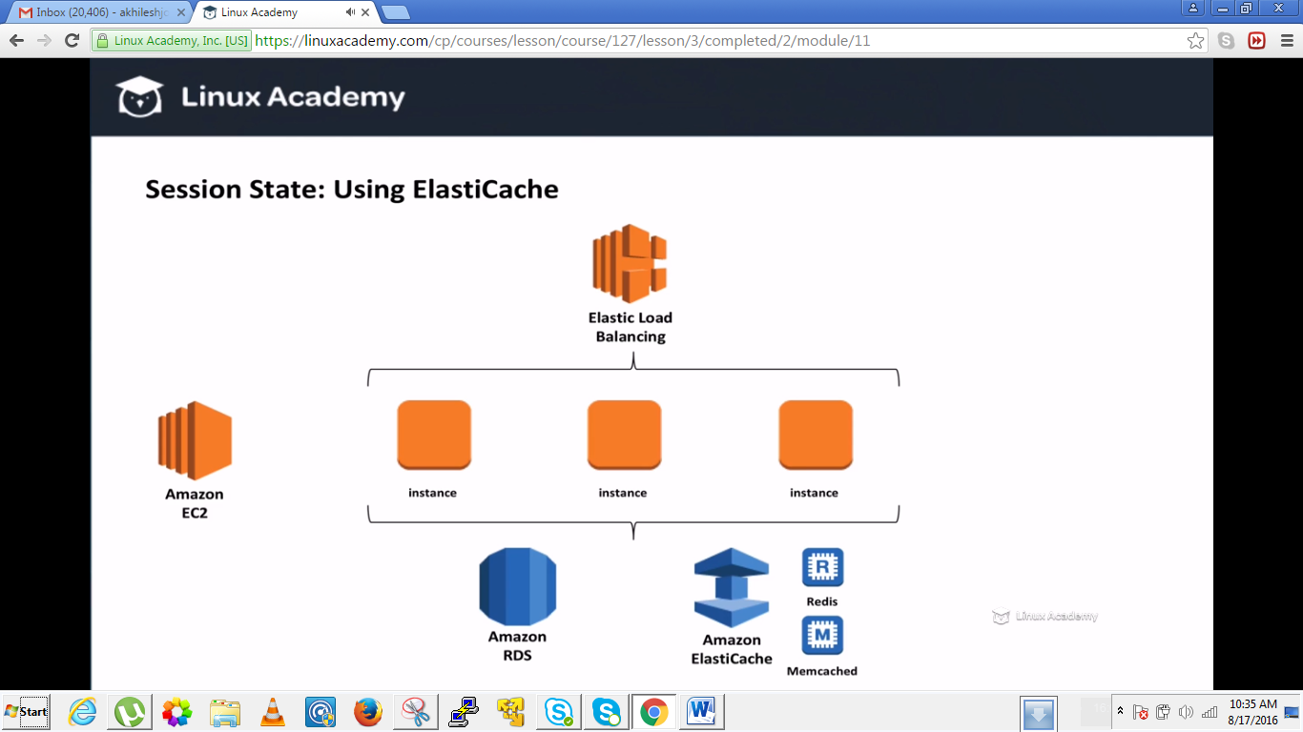

We can use the service called elastic cache. However we can use a specific instance that has the special job of handling sessions but elastic cache is the managed in memory cache service by amazon so it makes easy to start.

We have the elastic load balancer which will distribute the traffic evenly amongst the instances. We remove the cookie stickiness scenario from the load balancer. So instead how should we store our session state.

We can either store the session state in our database like mysql or we can store that in elastic cache using either redis or memcache. These are the two options when using elastic cache and they are two powerful and fast engines. With these engines we can store our session objects in memory and this gives us the central location for all of our session data. So not this solve the problem of stickiness to stick to one instance, since we can instead grab the information from redis or memcache in one central location but its also very fast since it all stored in memory and both of these engines are extremely very fast. So here is the workflow.

We get the request from the load balancer. The load balancer request to the application instance to get response back. This time the request are evenly distributed using a special algorithm. For eg our roundrobin algorithm. From there each instance will look to see if the session exists in elastic cache. If it doesn’t exist though it can still look into the database which will then update the redis or elastic memcache.

So actually why don’t we stick to our database for storing sessions then because it doesn’t make sense to increase the load on our database when we can use something which is both faster and completely separate. So this is the recommended method because it sends request evenly and we don’t hve to depend on cookie stickiness.

**Amazon Web Services Fundamentals**

**Lecture: Storage Basics On AWS**

This lesson will discuss common storage options available on AWS. We'll look at Elastic Block Stores, ephemeral storage, database storage, S3 storage, NoSQL options, and more. This will introduce you to the basic storage methods available for the AWS cloud.

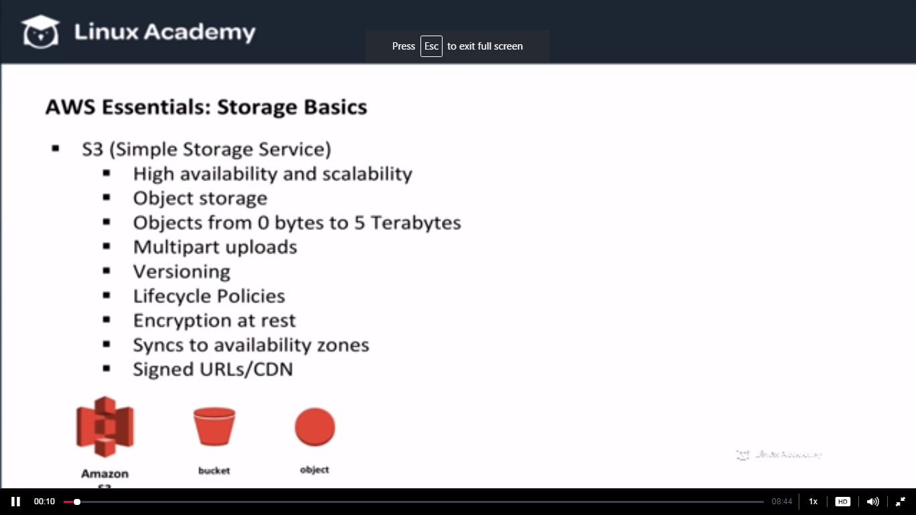

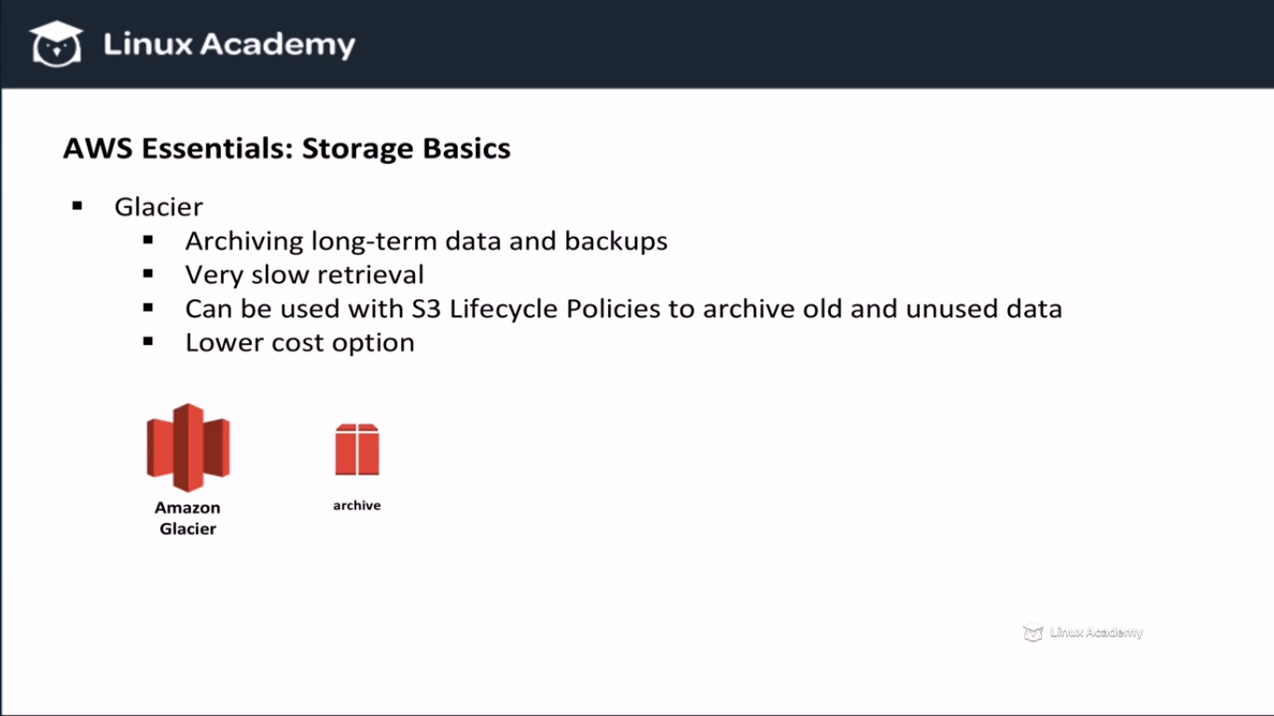

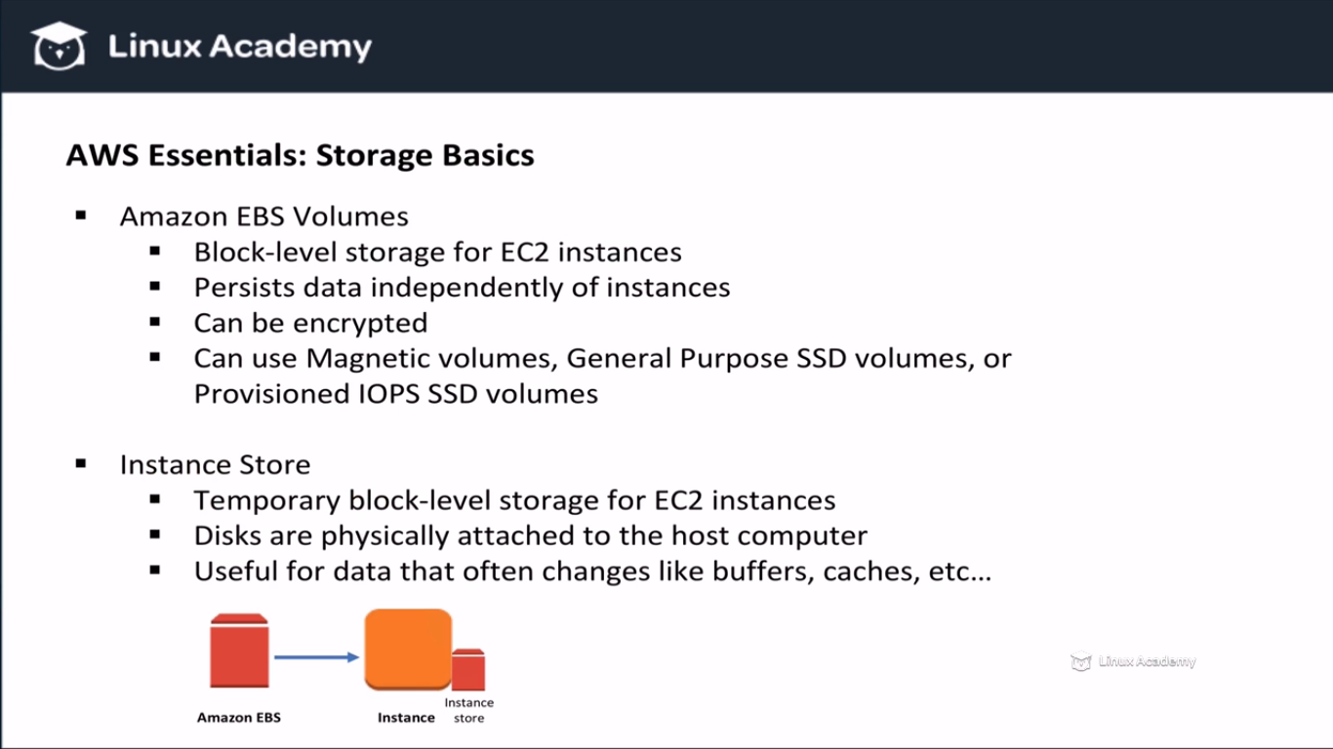

**WE can attach EBS volumes to running EC2 instances as long as they are in the same availability zone. EBS volumes are replicated so you don’t loose data.**

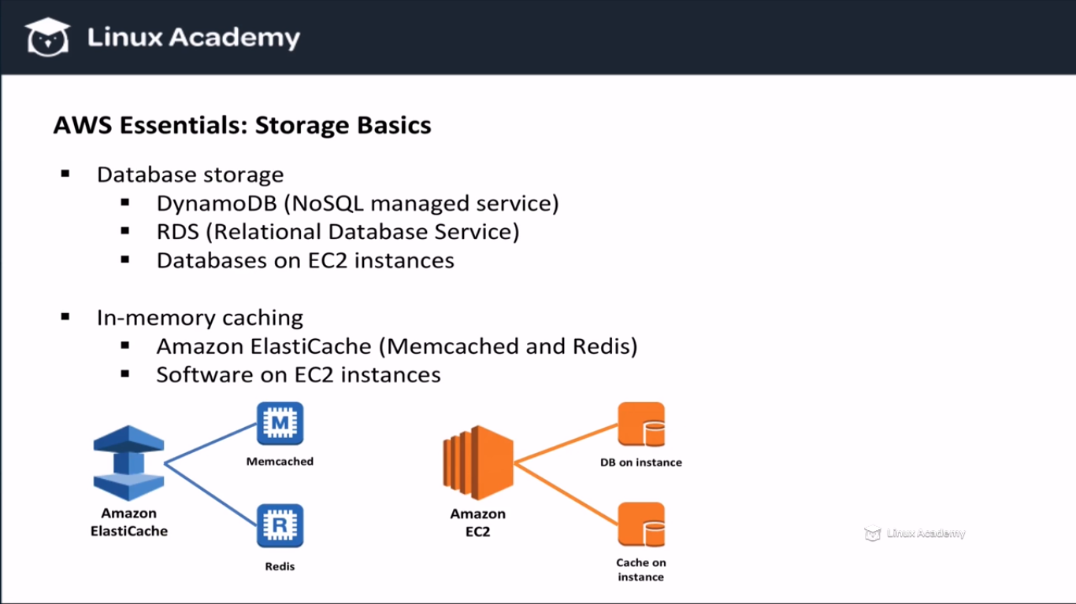

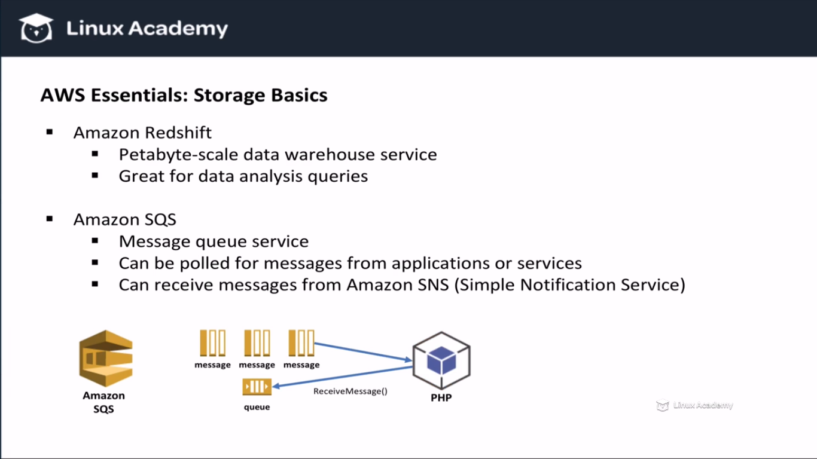

**If you large amount of data and you want to perform data analysis on that data, you need a storage engine that can keep up with demand. Amazon solve this problem with redshift which was designed to store large amount of data and to make quaries be fast enough for data analytics.**

**Lecture: Security On AWS**

In this lesson we will learn about AWS security and the shared security model. We'll discuss which security measures AWS is responsible for, and which measures users are responsible for.

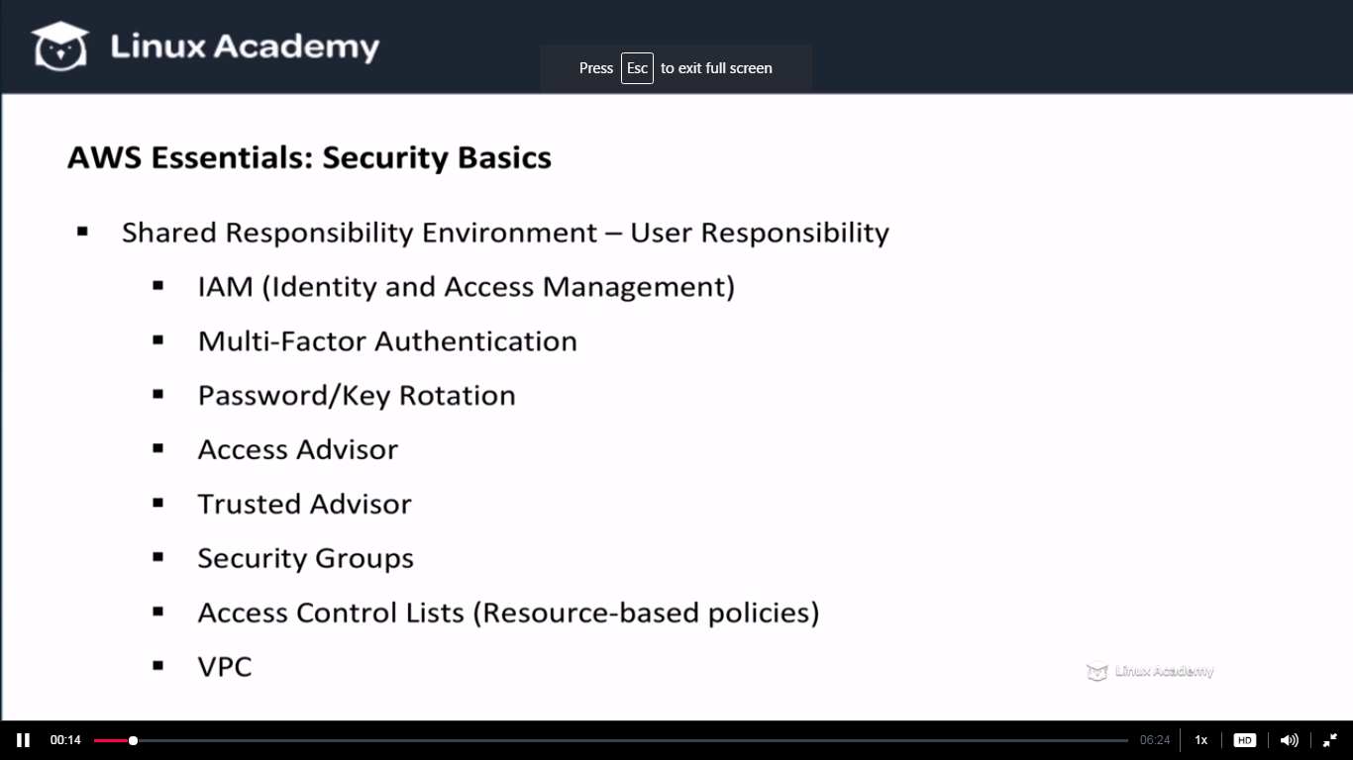

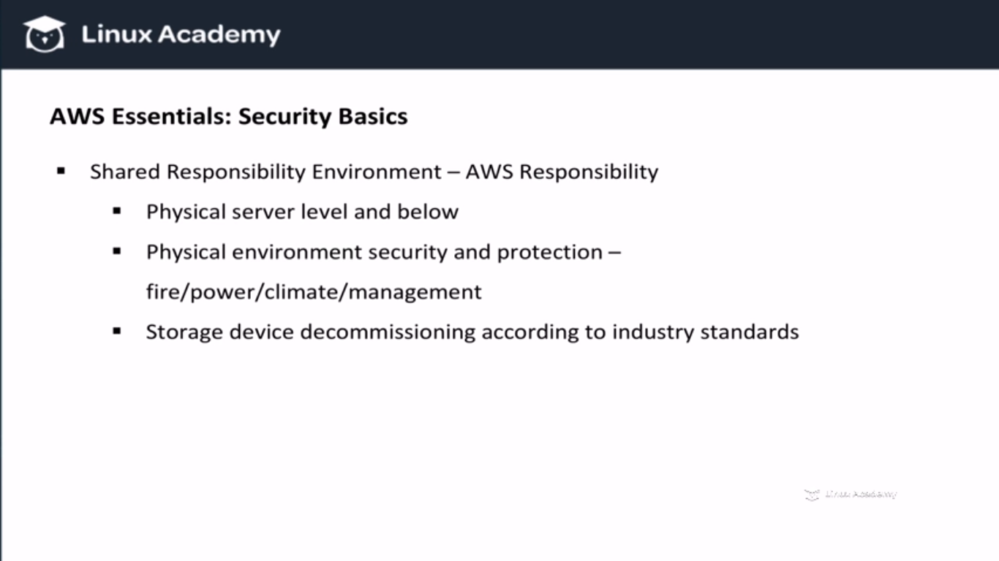

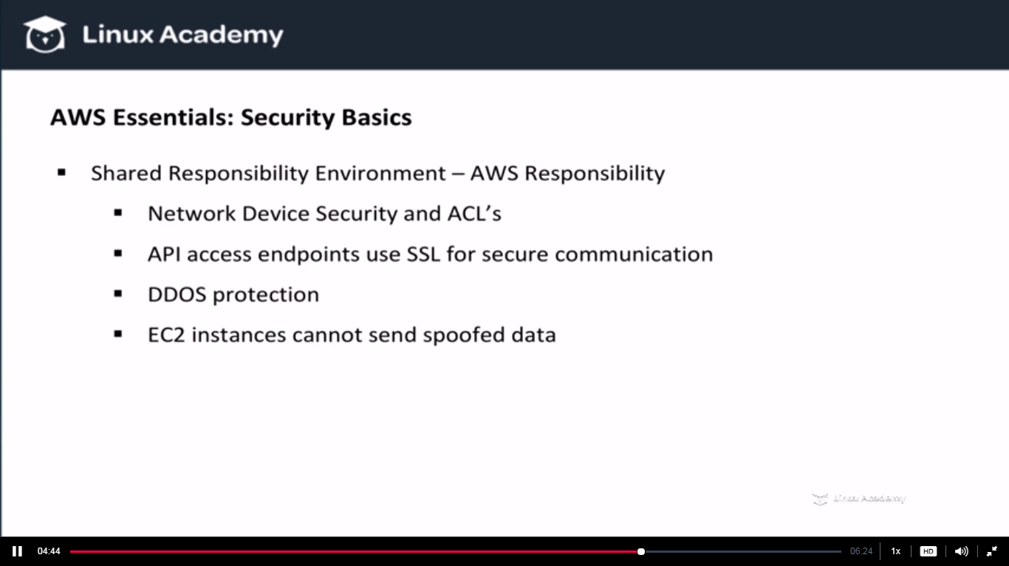

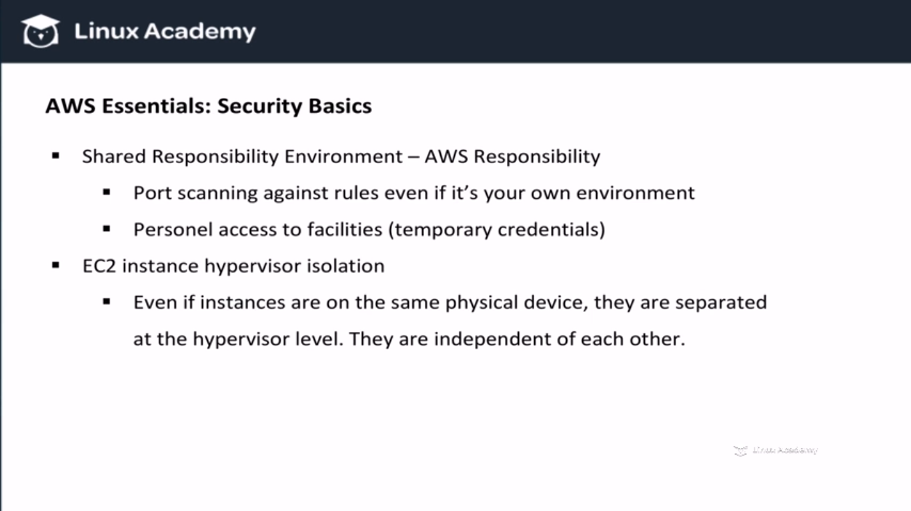

**Lecture: Understanding AWS Global Infrastructure**

This lesson will look at how AWS has built the cloud. We'll learn how Availability Zones, Regions, edge locations and other infrastructure facilities apply to using the AWS cloud.

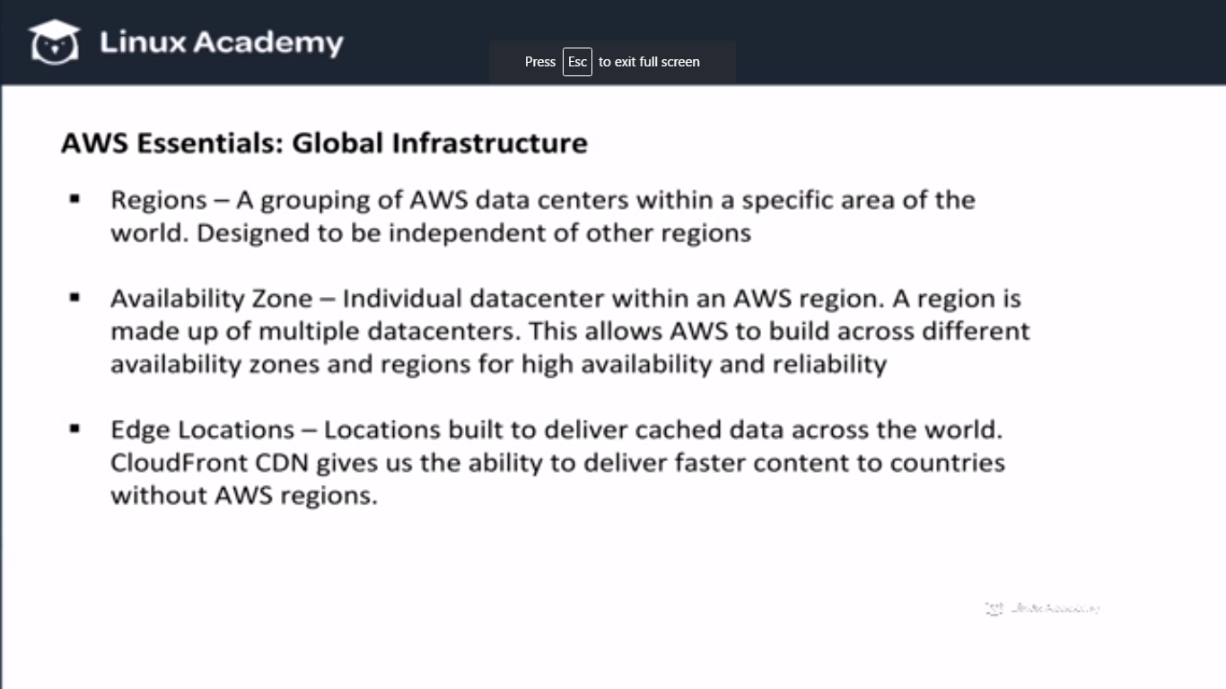

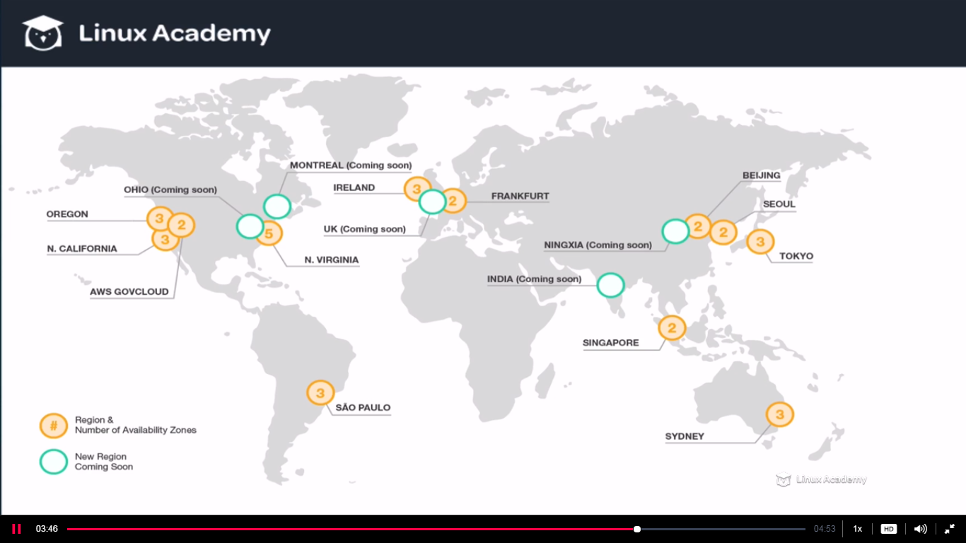

**Amazon VPC (Virtual Private Cloud) Fundamentals**

**Lecture: VPC Essentials**

In this lesson we are going to learn the essential concepts of an Amazon VPC. We are going to learn when to use it and why to use it. We are also going to discuss the Amazon Default VPC, versus a non-default VPC

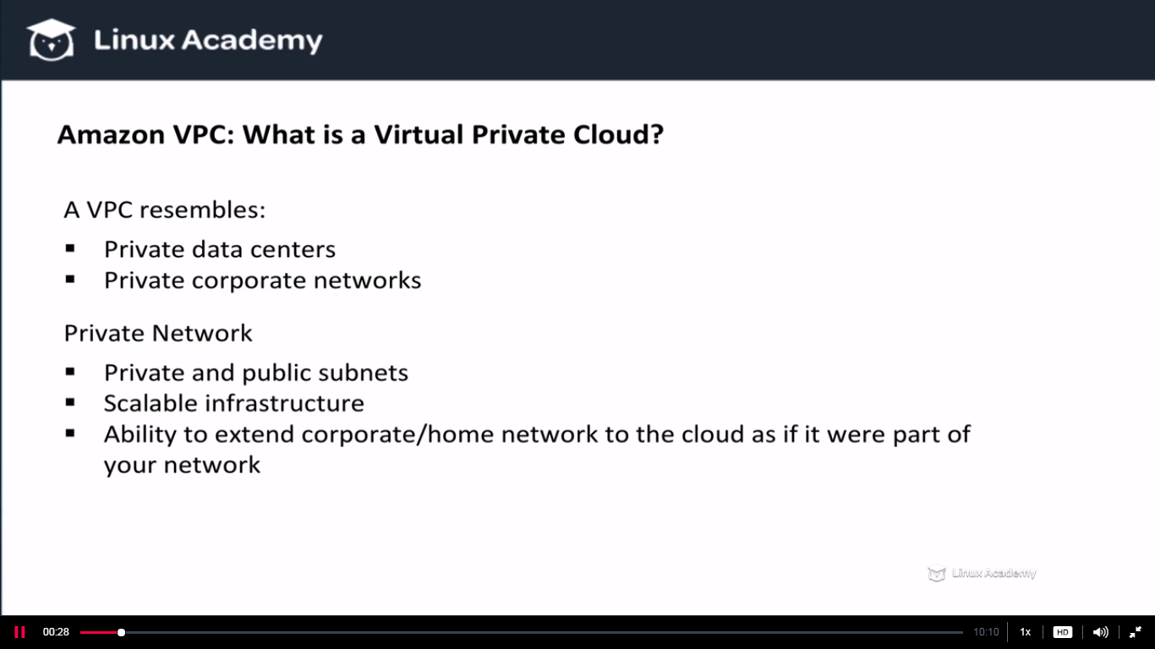

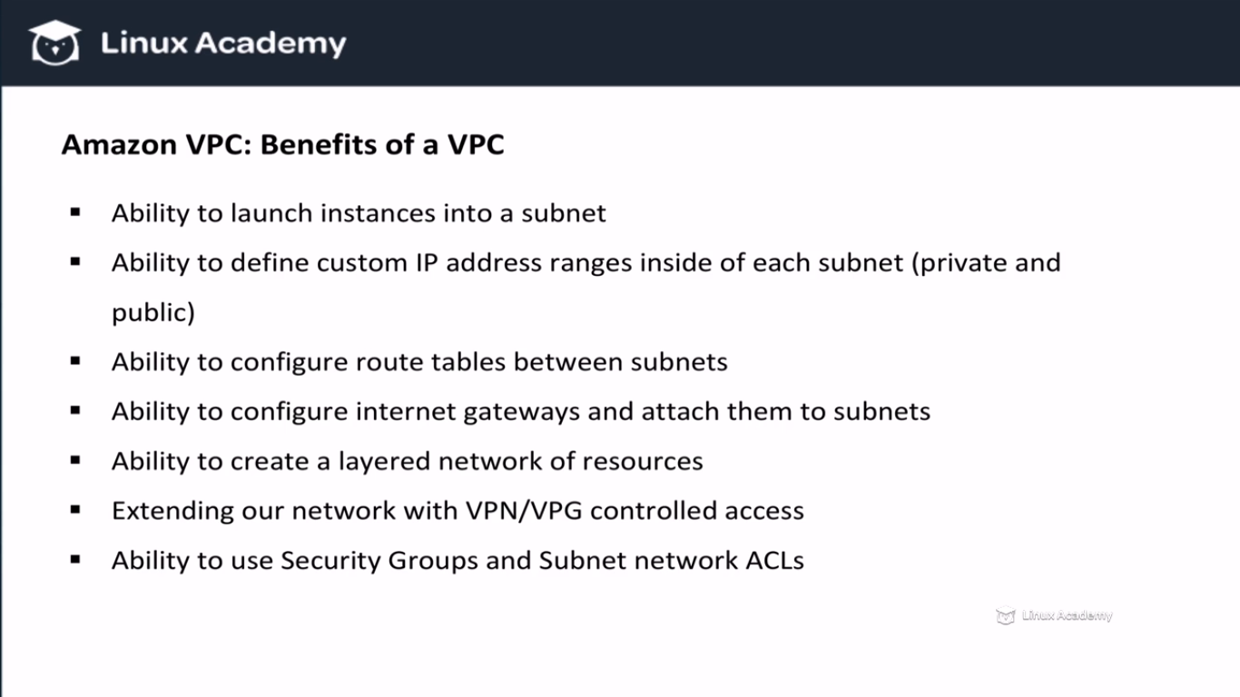

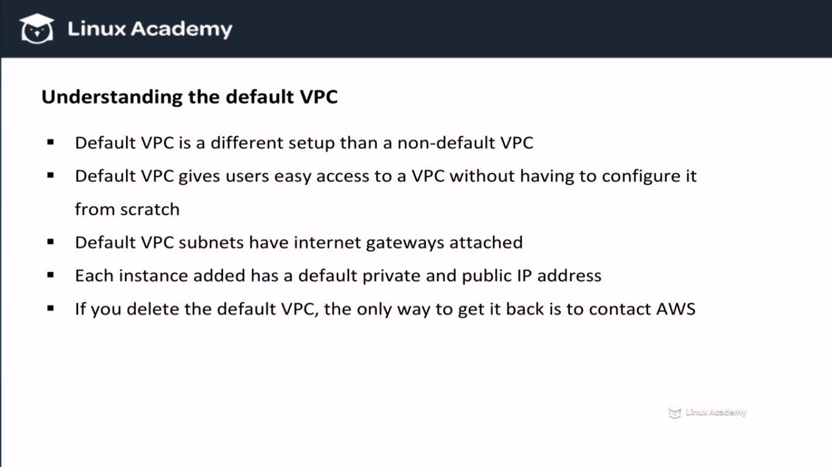

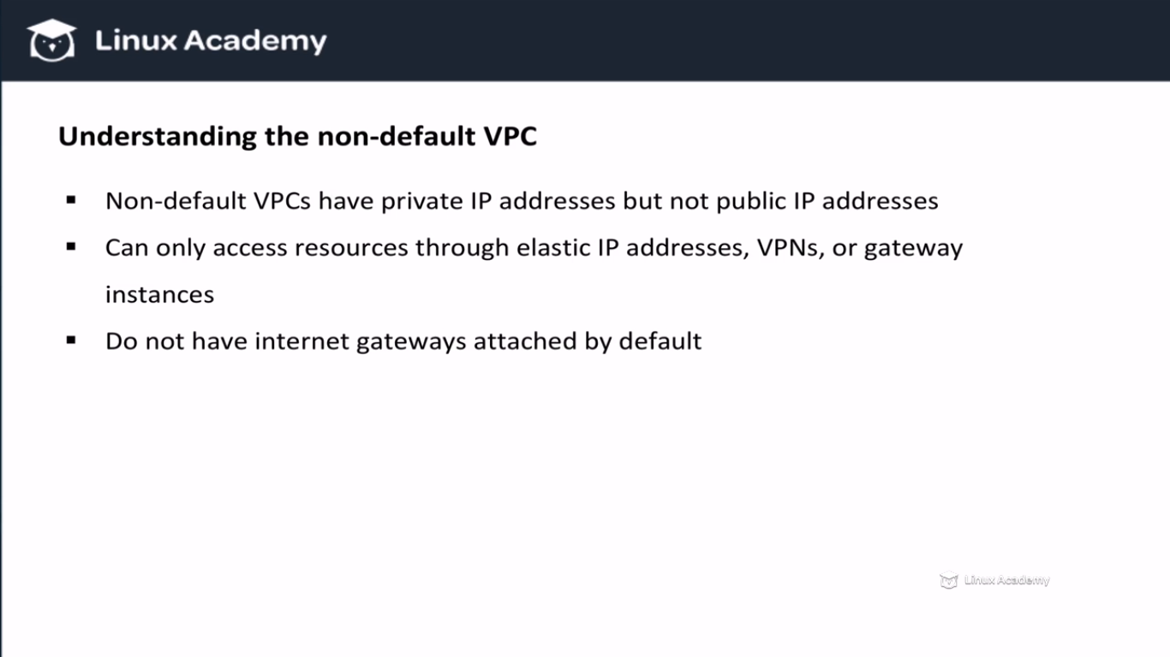

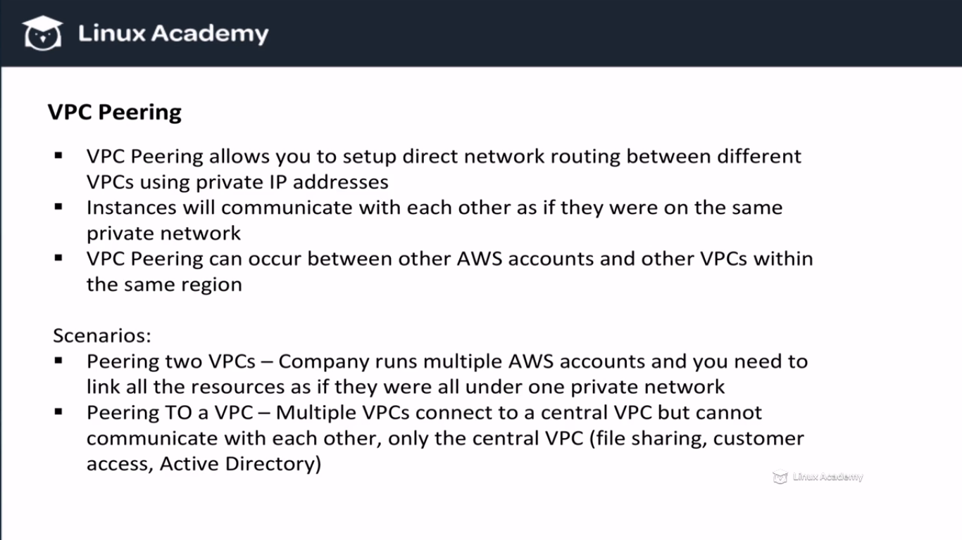

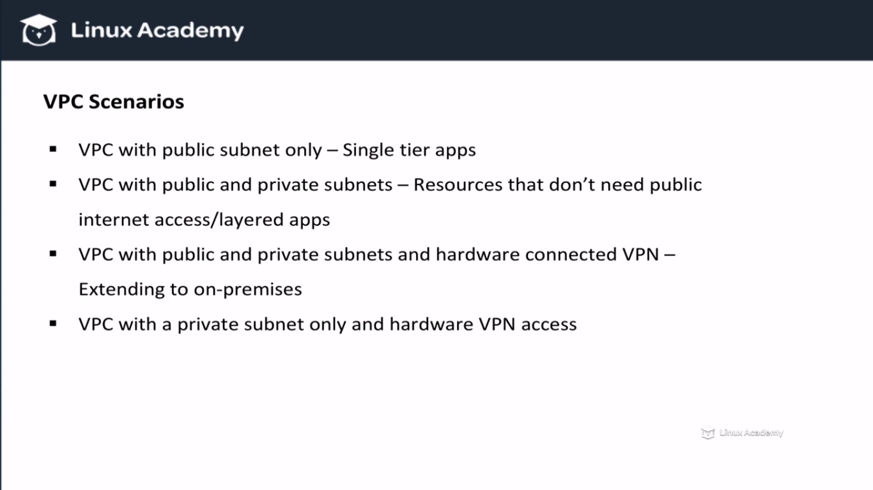

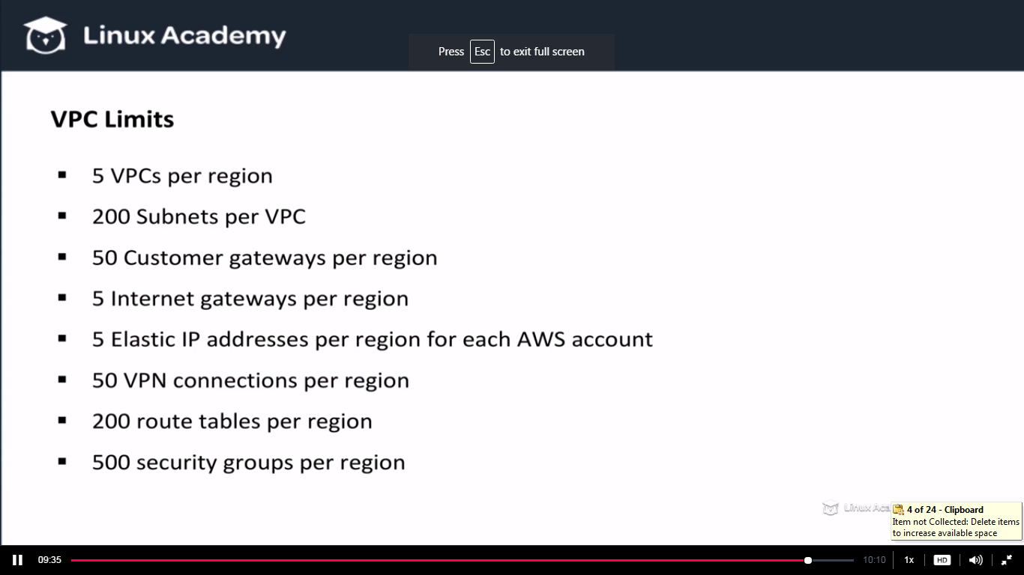

**Lecture: Building A Non-Default VPC**

In this lesson we are going to build our first non-default VPC from scratch. We are going to learn the core concepts of public vs private instances, route tables, and an internet gateway. We will go over several troubleshooting items as it relates to instances working inside of a VPC. This lesson covers a lot of the core concepts about VPC.

**If we launch an instance in the default VPC we get a public ip and public dns attach to the instance.**

**We can one Internet gateway attached to one VPC.**

**WE are going to do something called ssh agent forwading inorder to ssh into the instance with using the .pem file.**

**First thing we need to make sure we have proper permission on our pem file using chmod 400 .pem(key file name).**

**Then do the below**

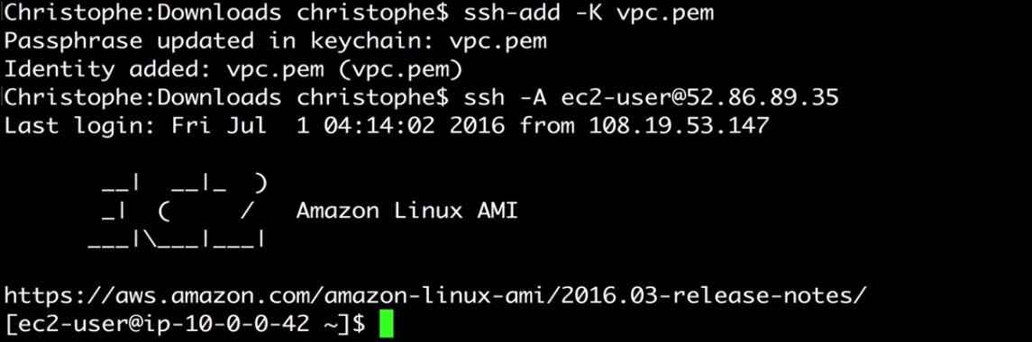

**We needn’t to use ssh –I .pem command to ssh. The key file is already added to the agent. So now I can do the same thing to ssh into other instances using the same pem keys.**

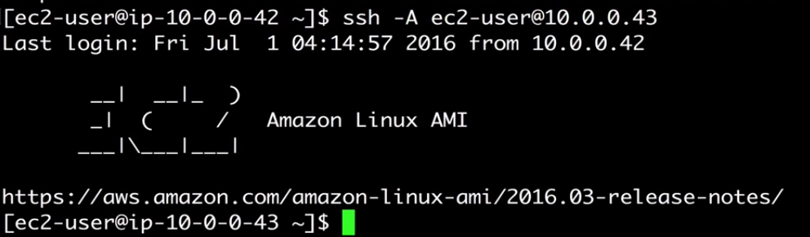

**Another recommended method is to use the proxy command. This method is also similar to what we did but the setup is different. So are not covering that here.**

**Lecture: VPC Networking**

In this lesson we are going to look at VPN, Virtual Customer Gateway, and Virtual Private Gateway. These concepts are important in order to understand how to extend networks to (or from) the Virtual Private Cloud.

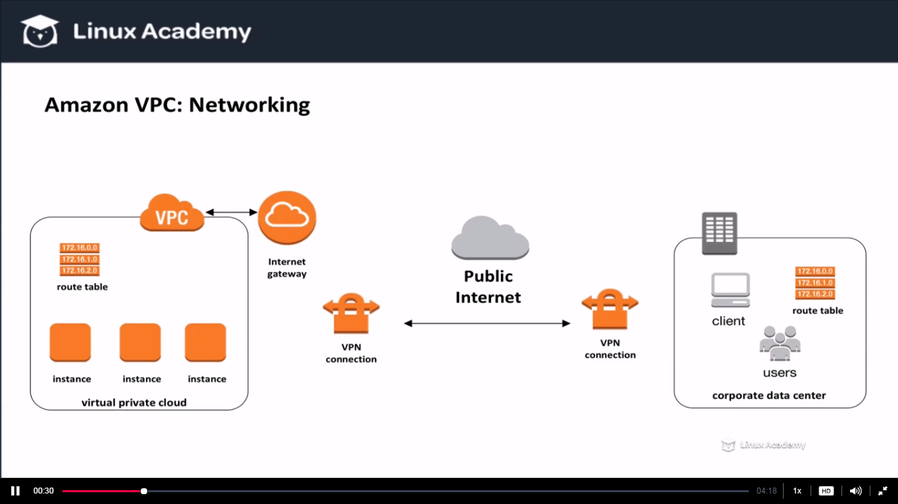

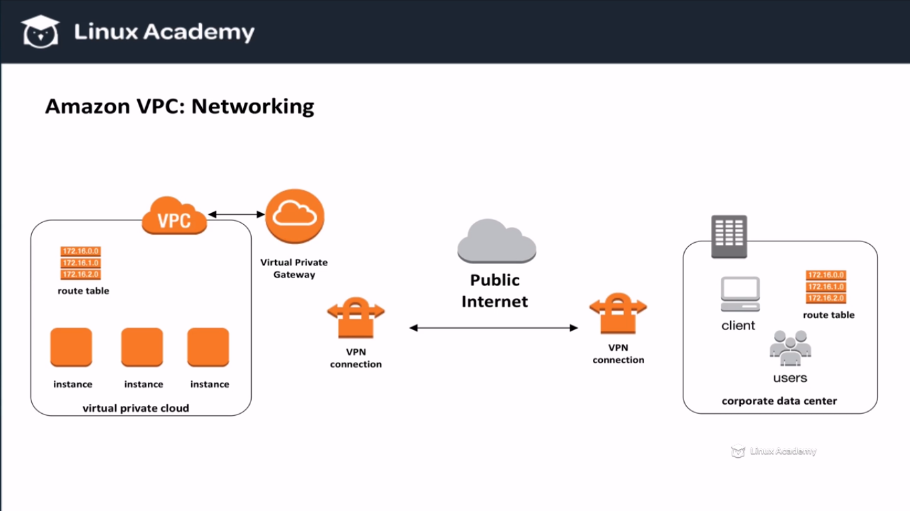

**Lecture: VPC Security**

In this lesson we are going to take a look at VPC Network ACLs and Security groups. We'll talk about a few situations for troubleshooting security and protecting your network traffic.

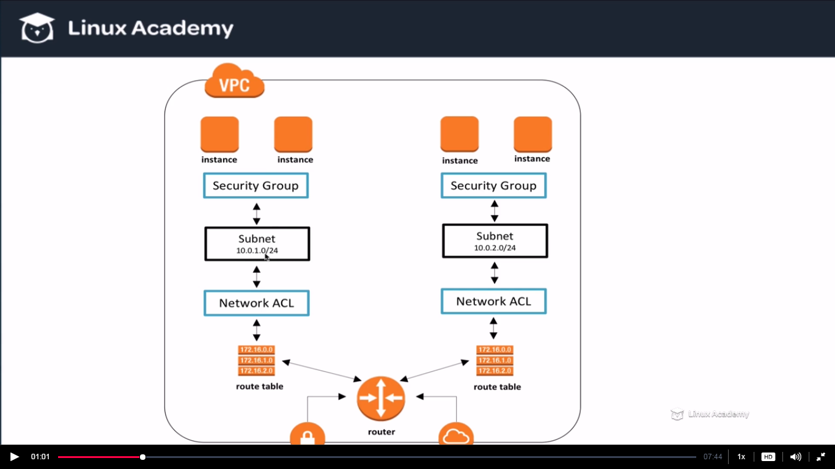

**The outbound traffic is allowed bydefault in the NACL rules.**

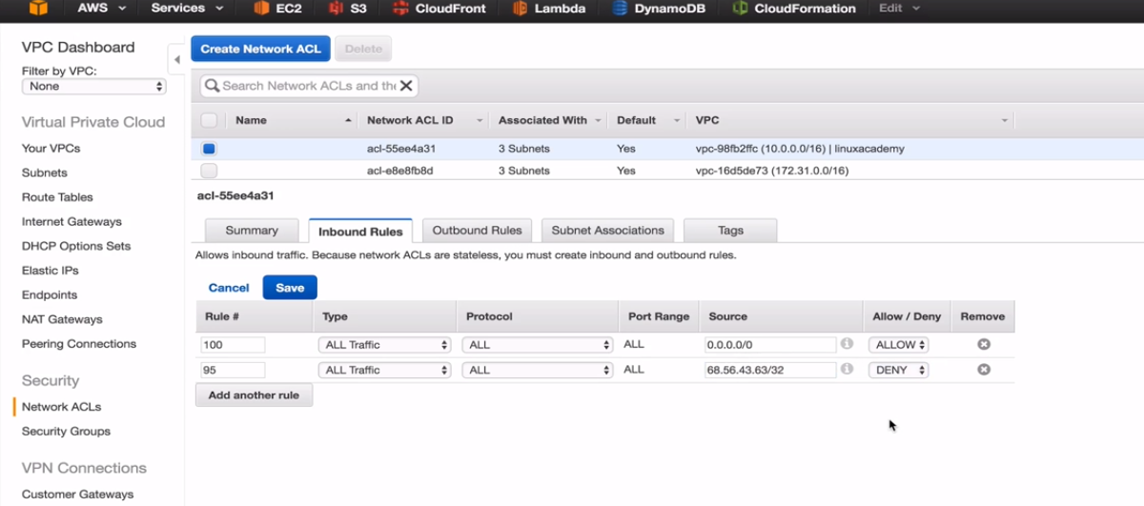

**Lecture: Configuring A NAT Instance**

In this lesson we are going to learn how to configure a NAT instance inside a VPC. This allows our instances on our private subnets to be able to communicate in specific ways to the internet.

**Lecture: DB Subnet Groups**

In this lesson we are going to learn how to setup RDS instances and configure DB subnet groups.

There is no reason for our database to be avaialable and open to the world, we just want certain instances to have access to our database inorder to return information to our users but no users should have direct access unless they are administrators. We can setup this control by launching our RDS instance inside our VPC using a private subnet . Another important concept to remember while launching our database instance inside of our VPC is high availability. By design Amazon RDS allows us to enable multi-availability zone which means my sql instance or whichever database instance we are using will replicate to another instance in a different availability zone and this creates inturn high availability. So how we keep this high availability when we have multiple subnets . Lets see

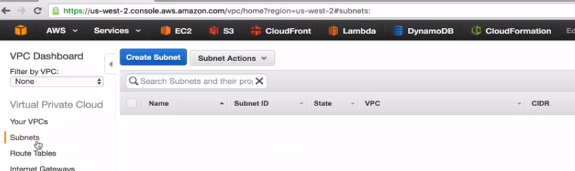

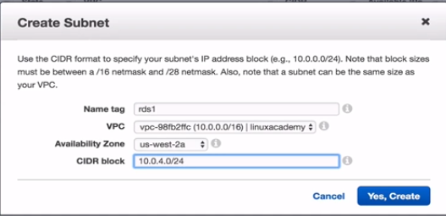

**We have already created 3 subnets earlier so this is the 4th subnet in the same VPC.**

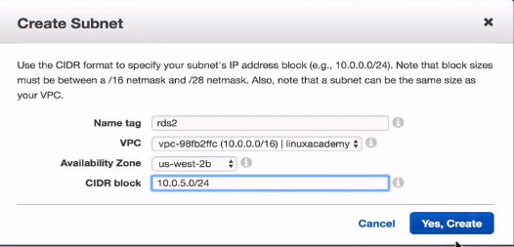

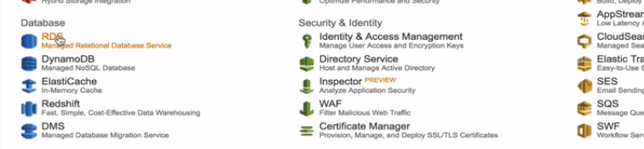

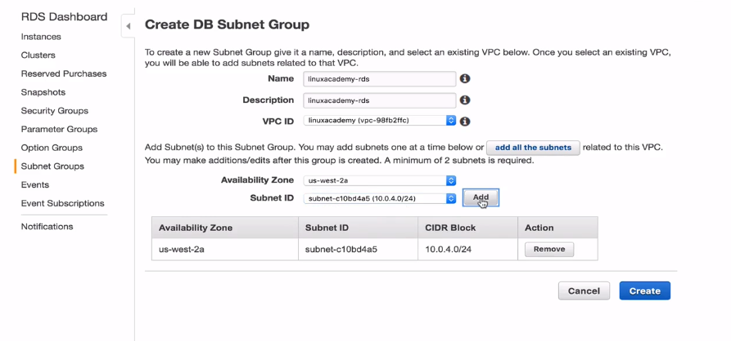

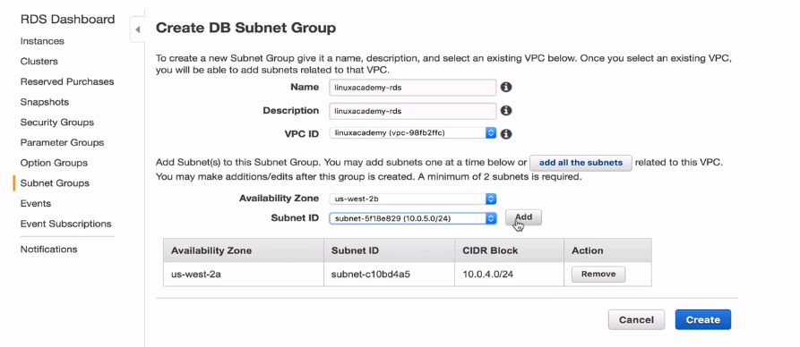

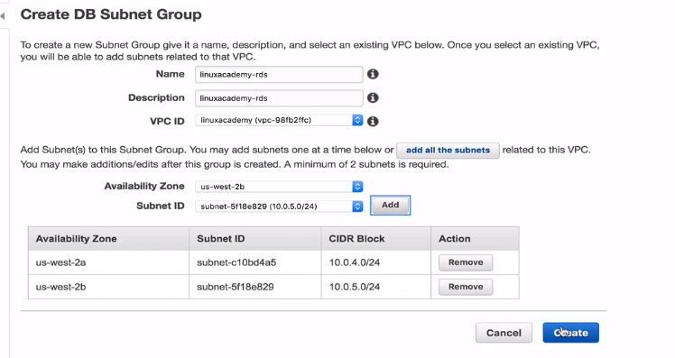

We have taken the first step of making this database highly available across multiple AZ’s.

Now its time to launch our RDS instance.

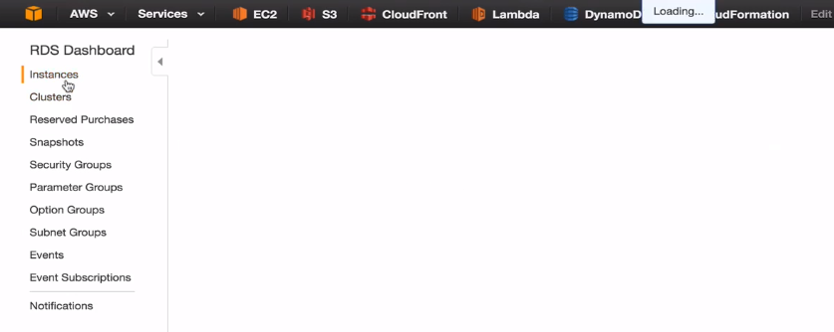

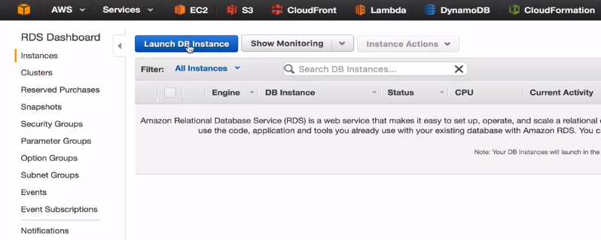

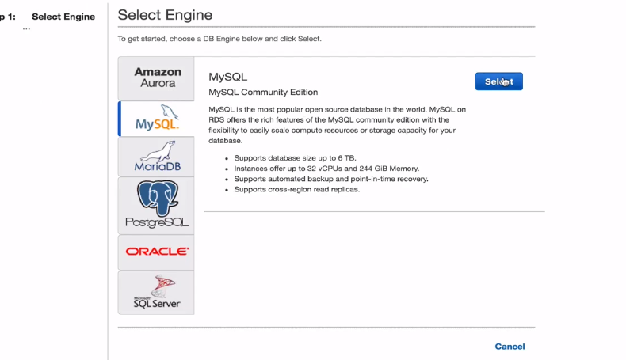

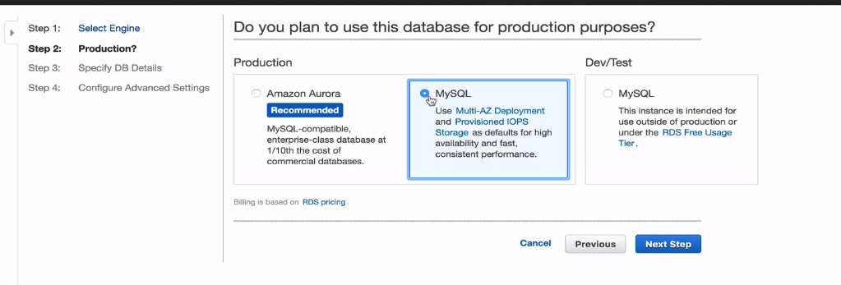

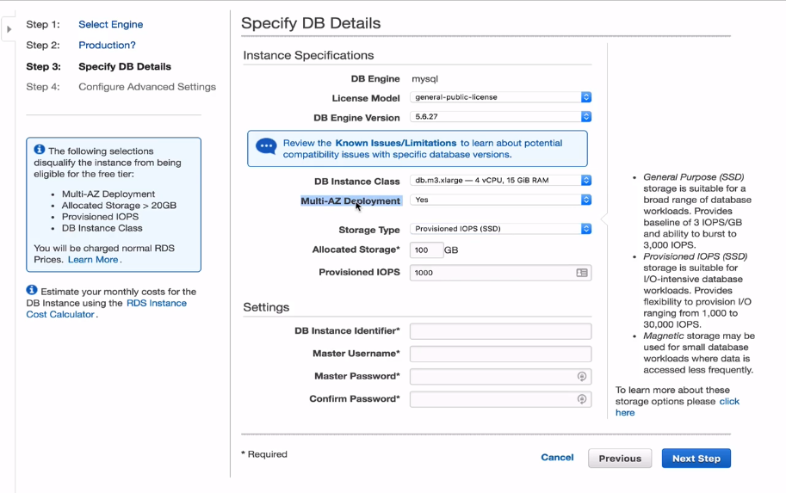

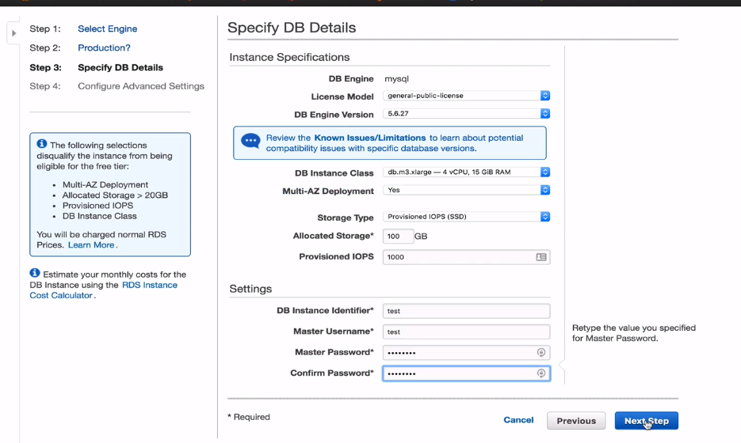

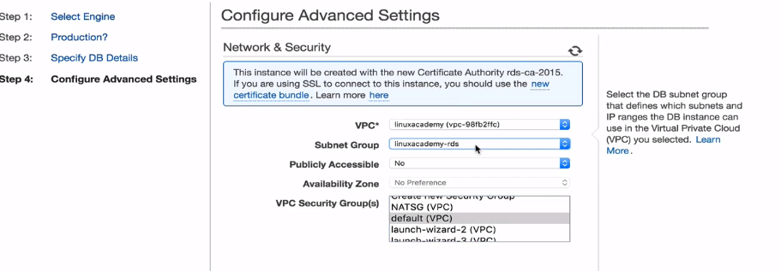

**Lecture: Elastic IP Addresses And Elastic Network Interfaces**

In this lesson we are going to look at how Elastic IP Addresses and Elastic Network Interfaces work with our EC2 instances.

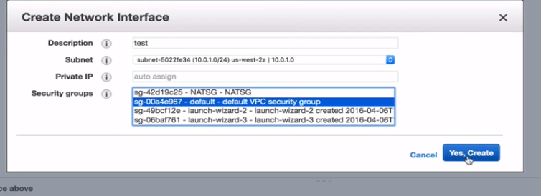

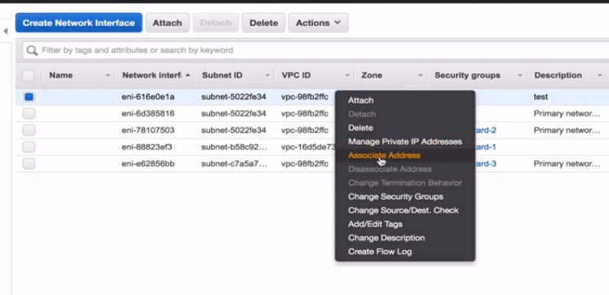

Before the above step create an EIP first and then associate it to the instance.

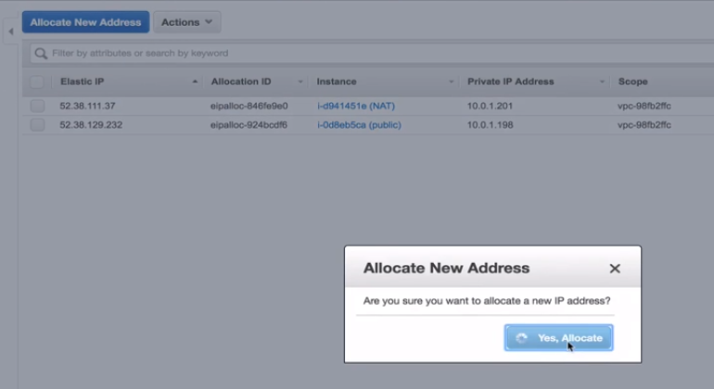

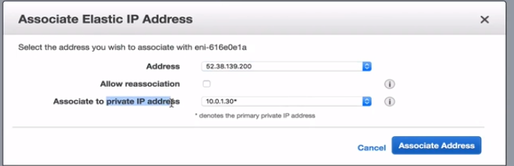

Lets attach this new interface to an instance as

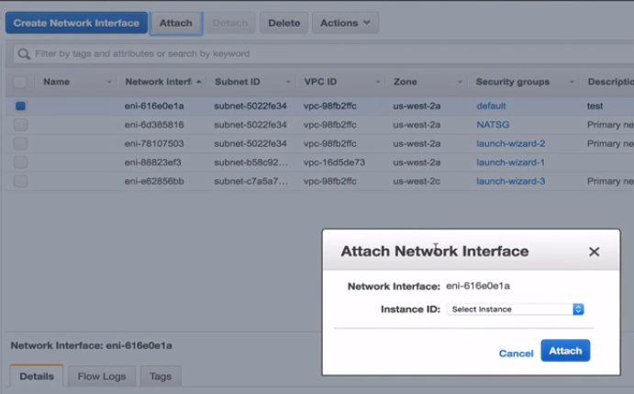

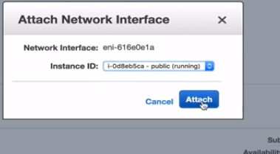

IF I want to switch it immediately to an another instance then I can detach it

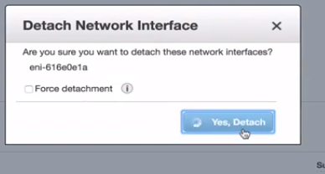

We can reattach it to some other instance as

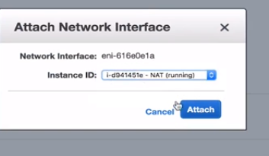

If we stop the instance which the elastic ip attached to it then also the elastic ip will be attached to that instance only because the elastic ip is attached to the network interface . That network interface is attached to our VPC.

**Lecture: Configuring A Web Application In VPC**

In this lesson, we build an application from the ground up in a Virtual Private Cloud on Amazon Web Services. To do this, we are going to use an Elastic Loab Balancer (ELB), EC2 instances, an Amazon RDS database, and a PHP Application (Laravel).

Commands to copy/paste (in order, but not including steps in between):

sudo apt-get install git php5 php5-fpm nginx php5-common php5-curl php5-cli php5-gd php5-intl php5-imagick php5-mcrypt php5-mysql mysql-client libexpat1 ssl-cert

git clone https://github.com/christophelimpalair/laravel5-example app

curl -sS https://getcomposer.org/installer | php

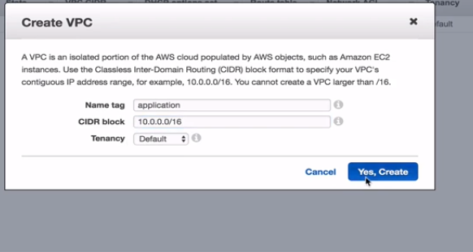

We will be having the webservers and the RDS in the private subnets and instances in the public subnets so we will create both private subnets and public subnets.

On top of it we want to enable multi-AZ deployment for the RDS for high availability.

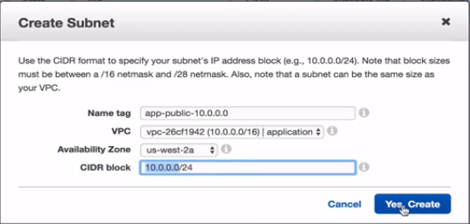

This would be the public subnet and lets make a private subnet.

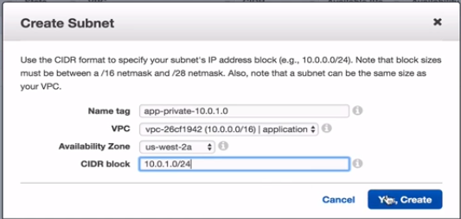

And finally the third subnet and this is going to be a private subnet as well and in a different AZ

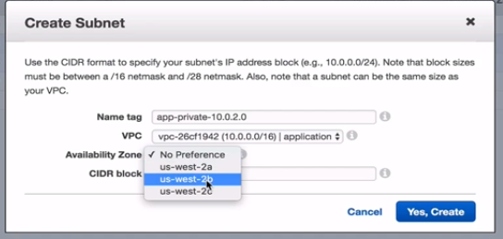

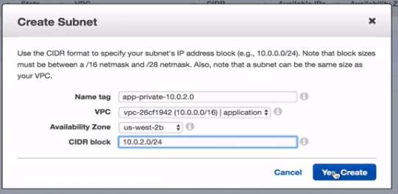

We need to attach internet gateway to the public subnet

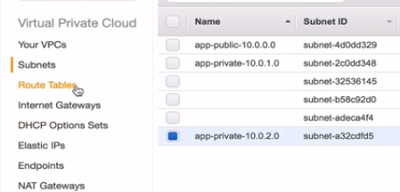

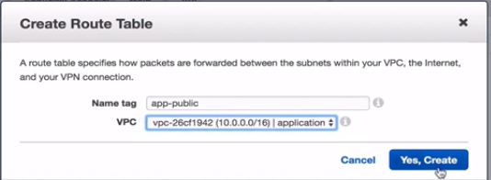

This is the route table that’s going to route from our internet gateway to our public subnet or the subnet we want to be public.

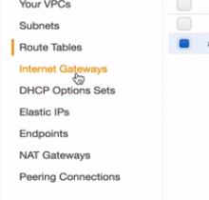

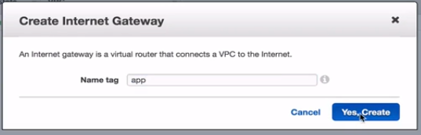

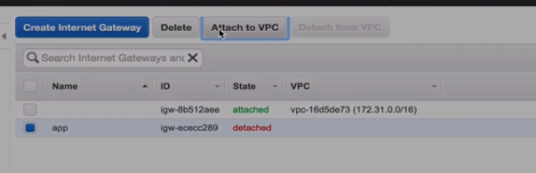

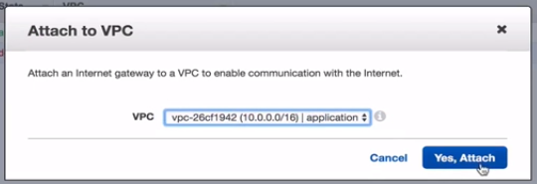

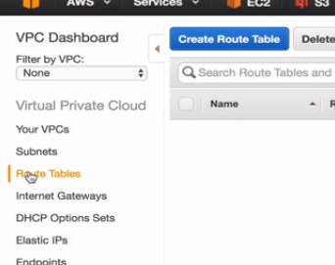

Select the route table we just created before and edit the rules as

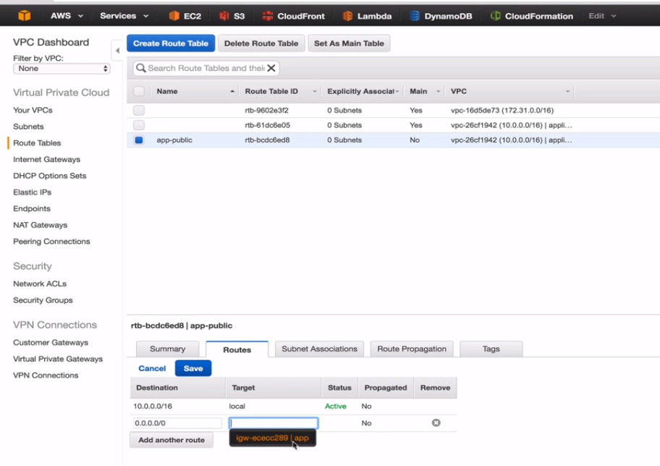

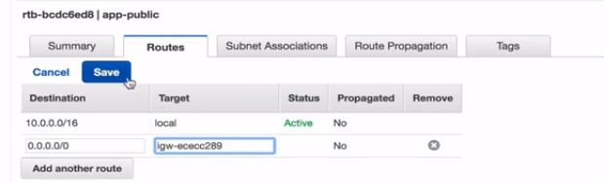

Then make sure this is associated to the right subnet as

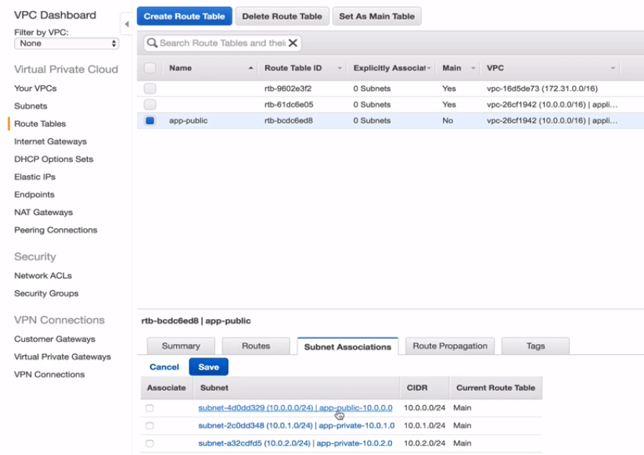

This is the same route table in which we modified the rules just above and then there is an option for the subnet association where we will associate the route to the public subnet as above

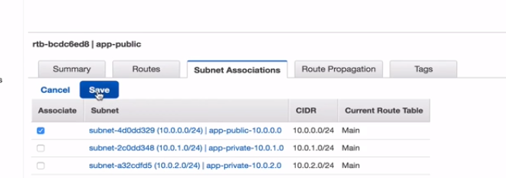

Now we have an internet gateway attached to our route and that route is attached to a subnet that we want to make public so we have a public subnet.

Lets now launch an instance and lets start with RDS.

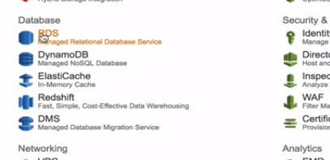

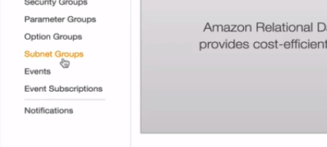

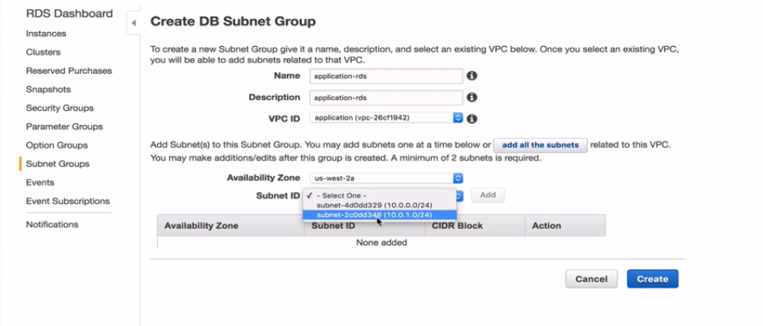

Launch it in the private subnet which is in 2a availability zone.

Add it as

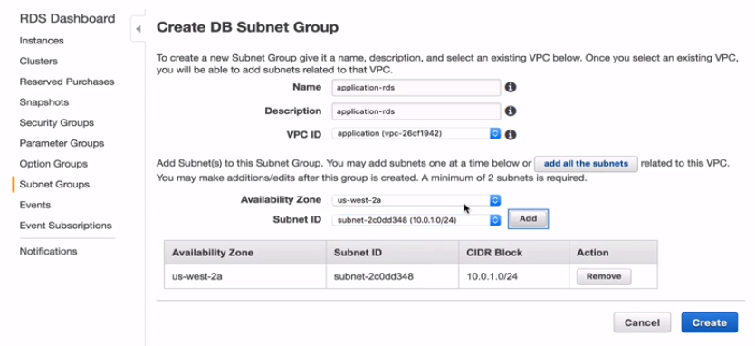

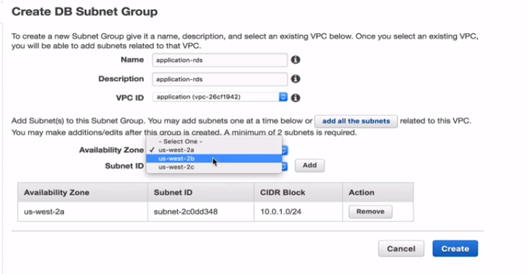

Change to 2b as we want our RDS to be highly available so we need to have to 2 az’s

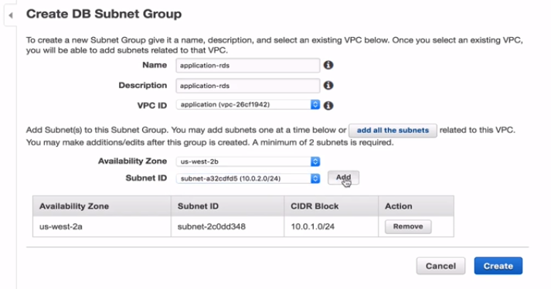

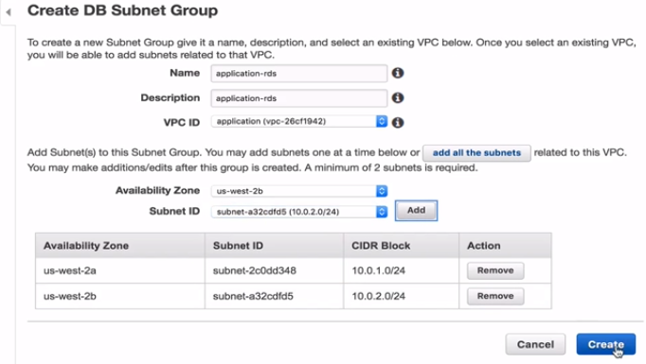

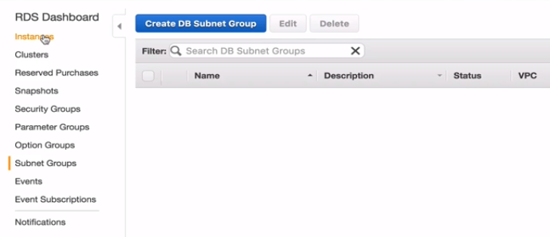

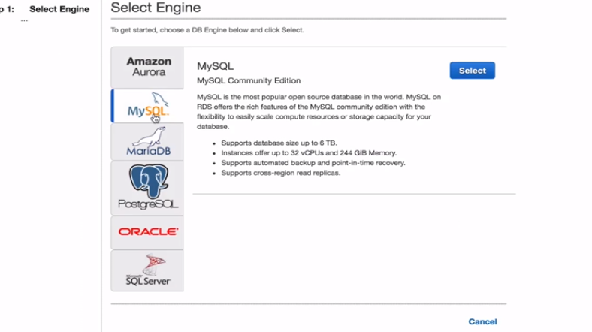

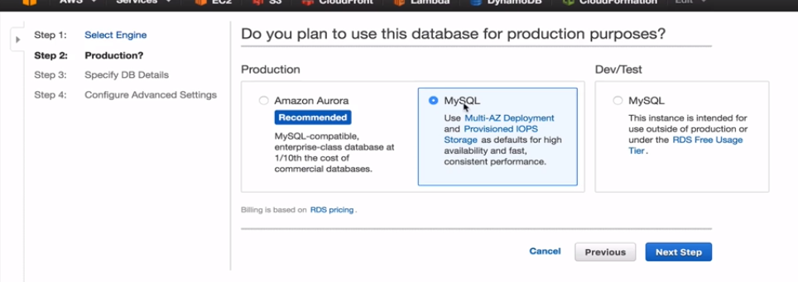

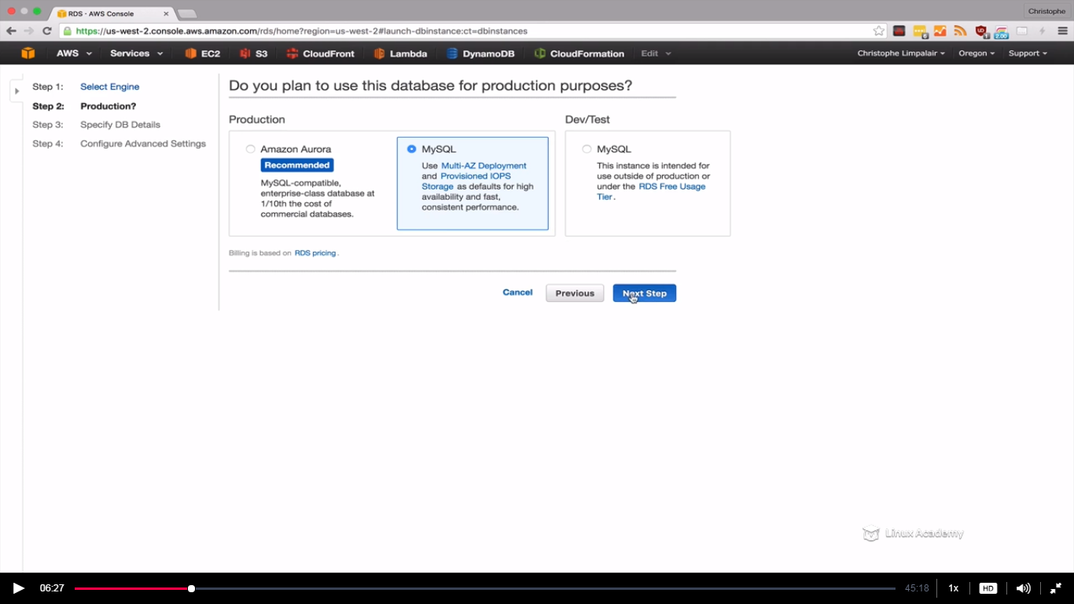

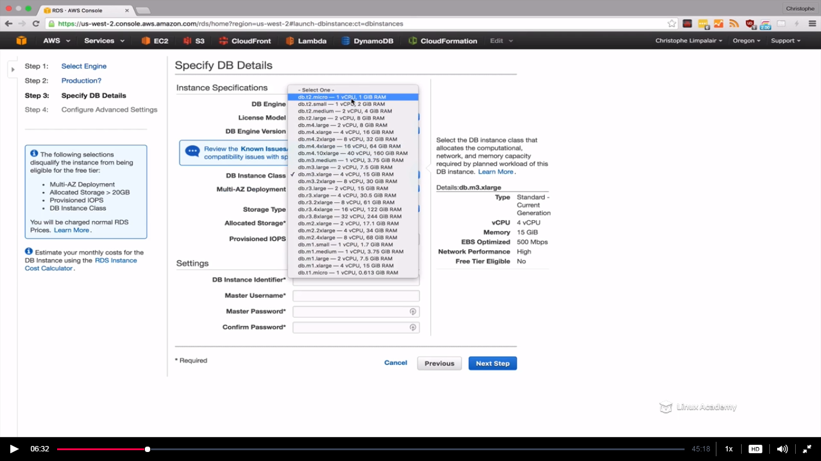

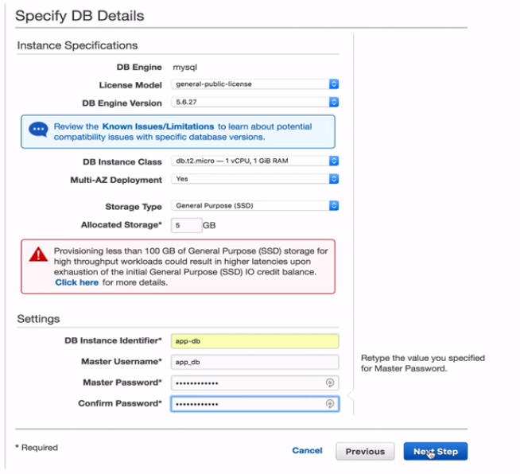

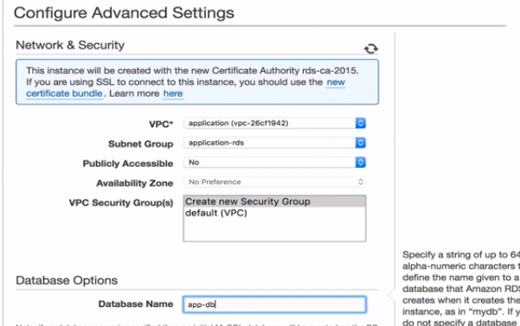

Rest things need to be default for now so

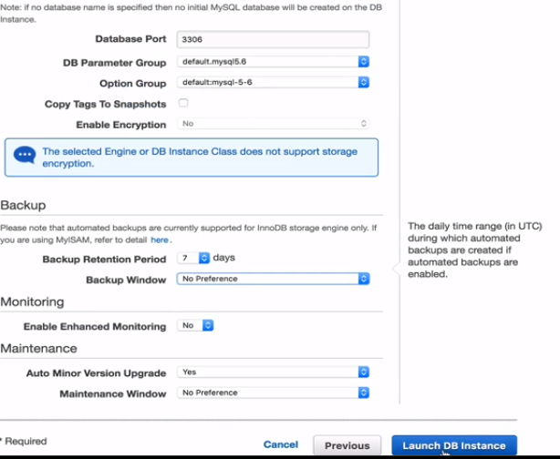

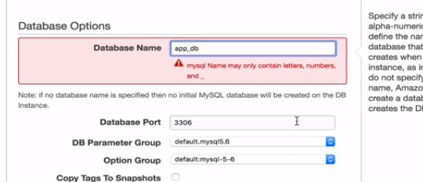

So underscore instead of hipen in the name.

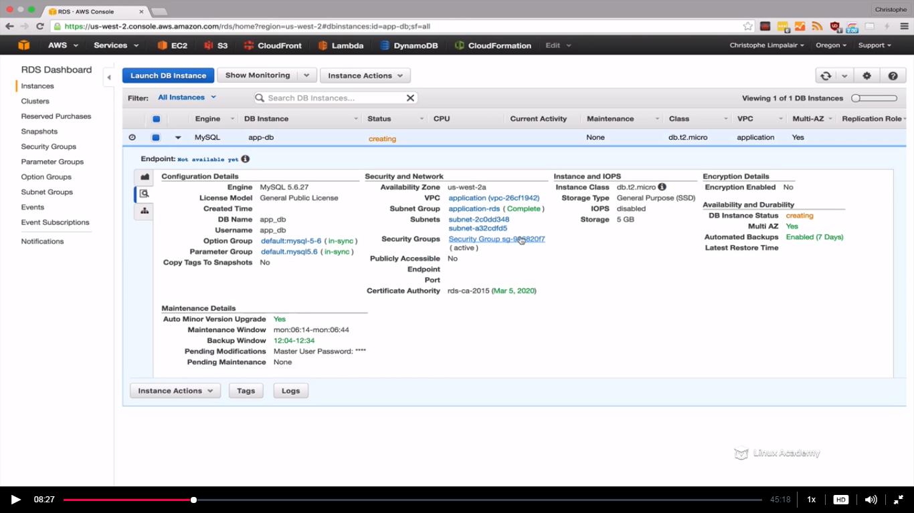

So instance is getting created. So once it get created we can see more details.

Lets go and launch a EC2 instance.

We are going to create this instance to create a web server with a PHP level application, we are going to configure everything to work with the database. Then we are going to bake an image. We are going to create an image out of our instance so that we can launch it a private subnets using auto-scaling.

Since we can’t access any instance in a private subnet as for that we need to have VPN or something like that we are going to create a public instance instead and connect to that, configure that and make an image and deploy that to private subnet to private instances.

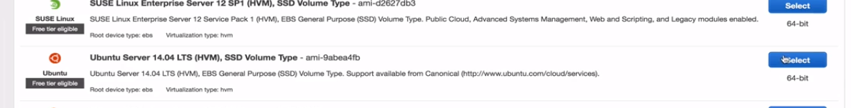

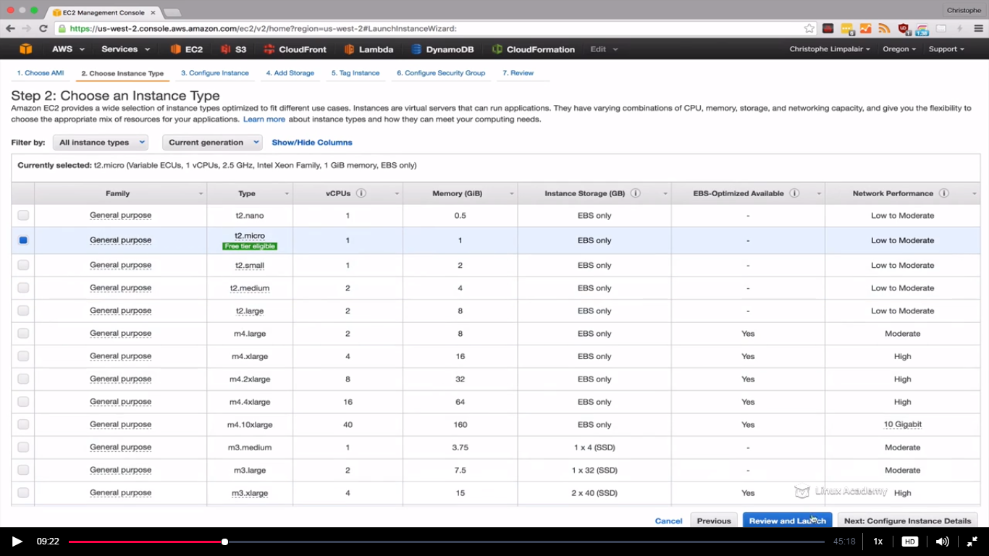

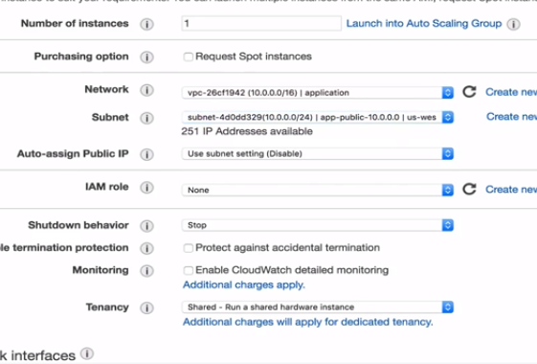

Public subnet choose

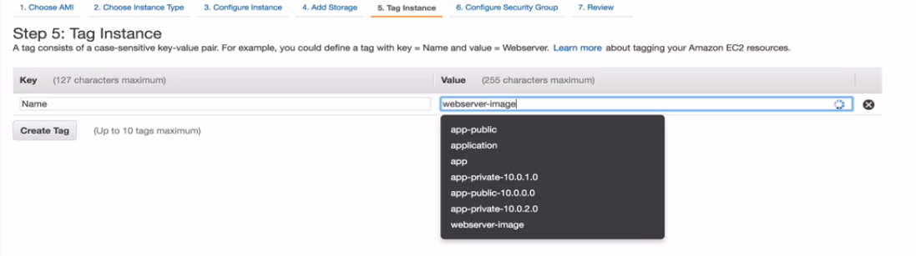

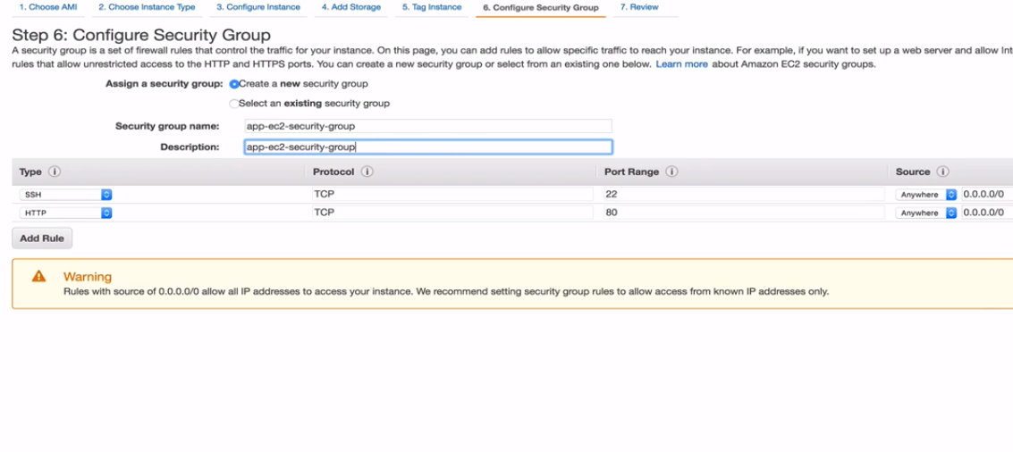

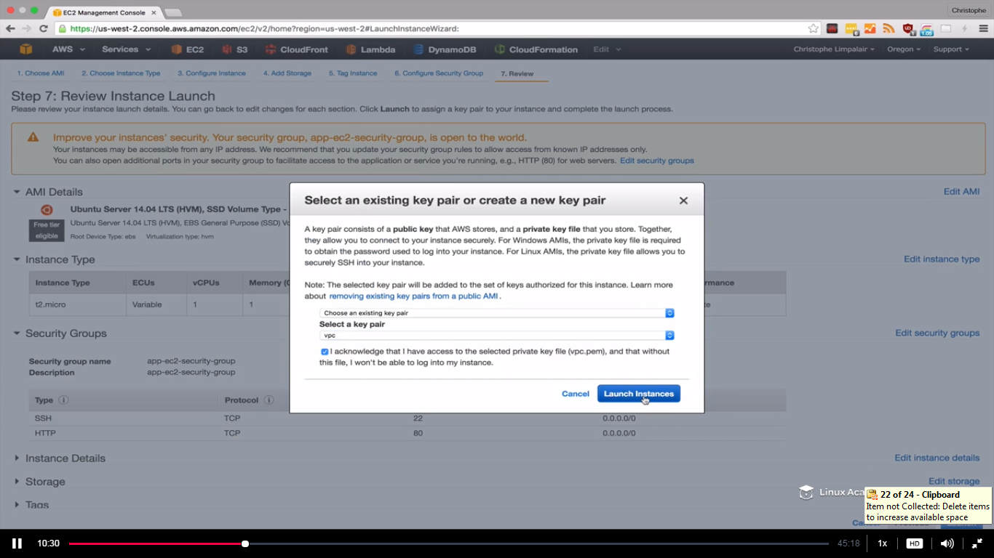

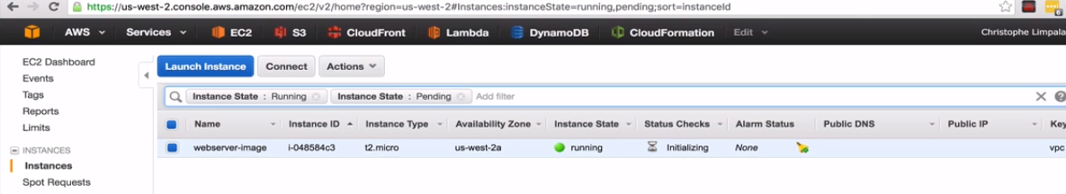

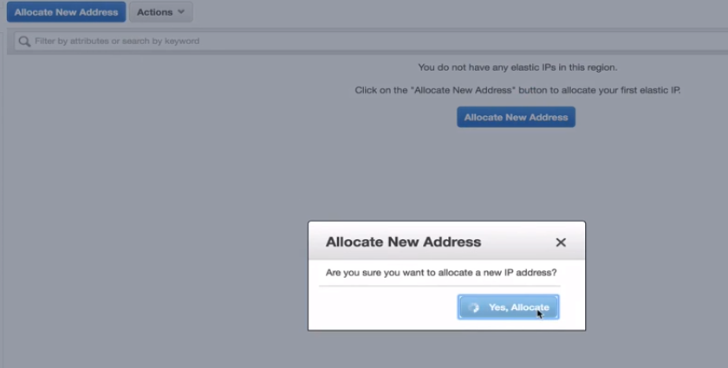

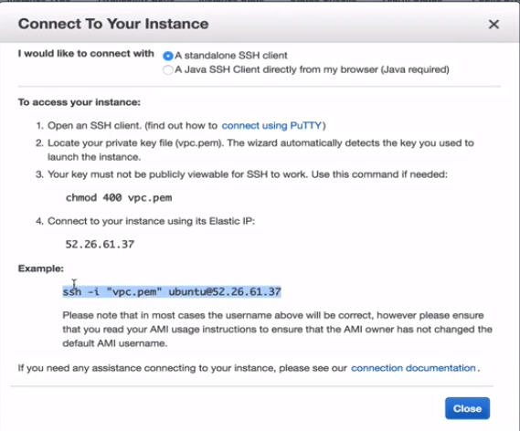



Do a change mode on the pem file else you will get an error.

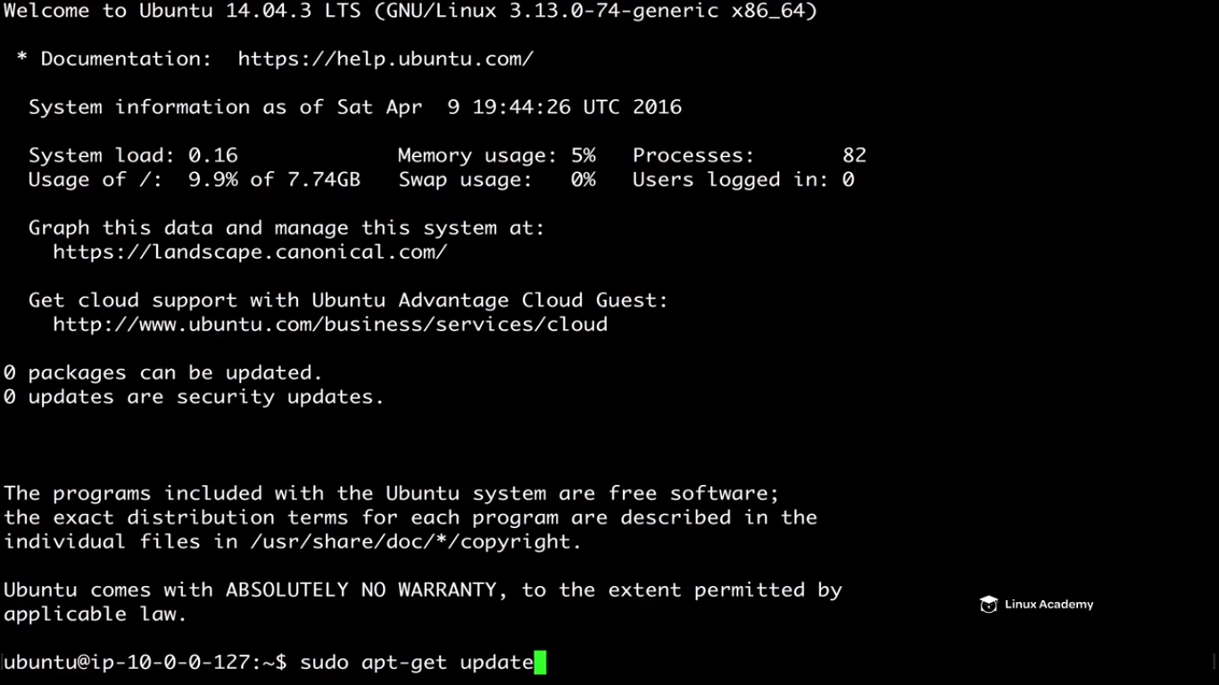

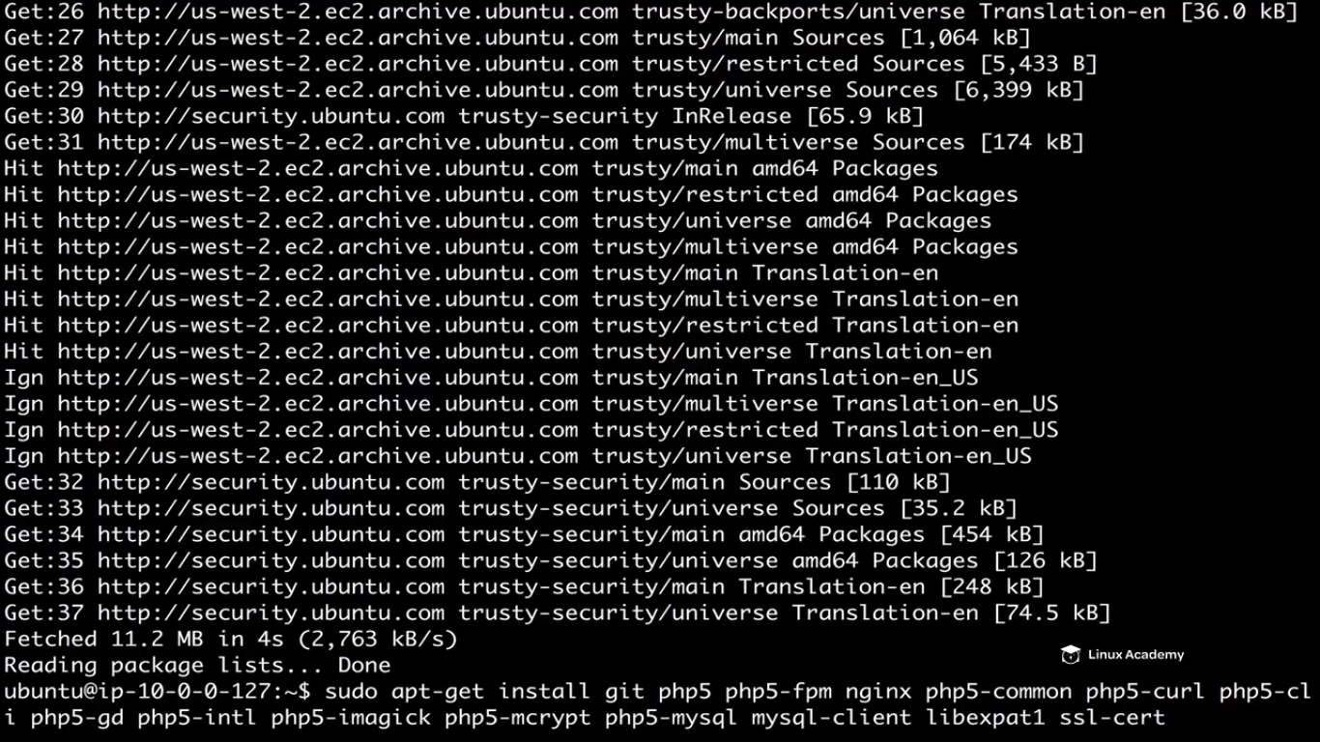

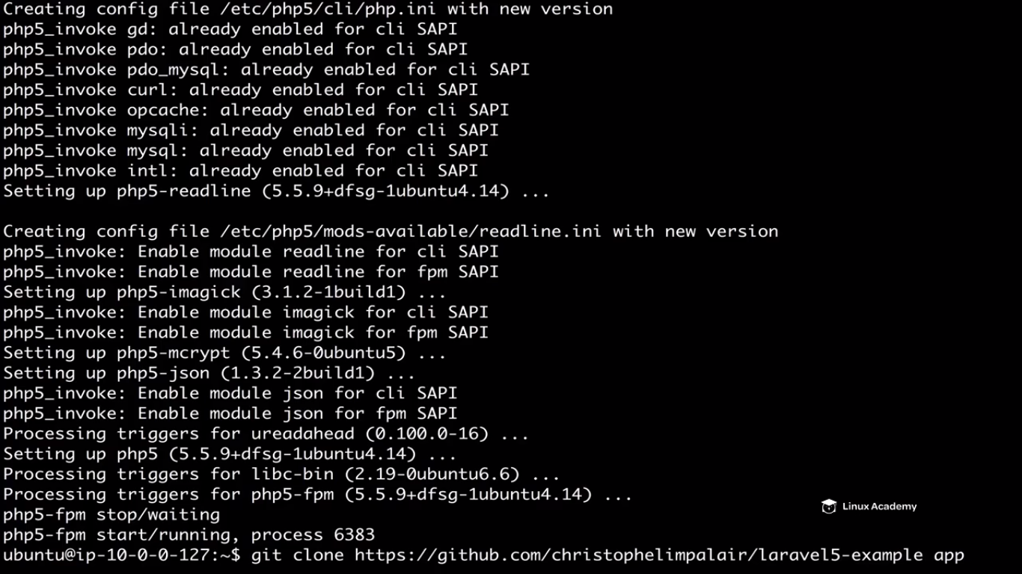

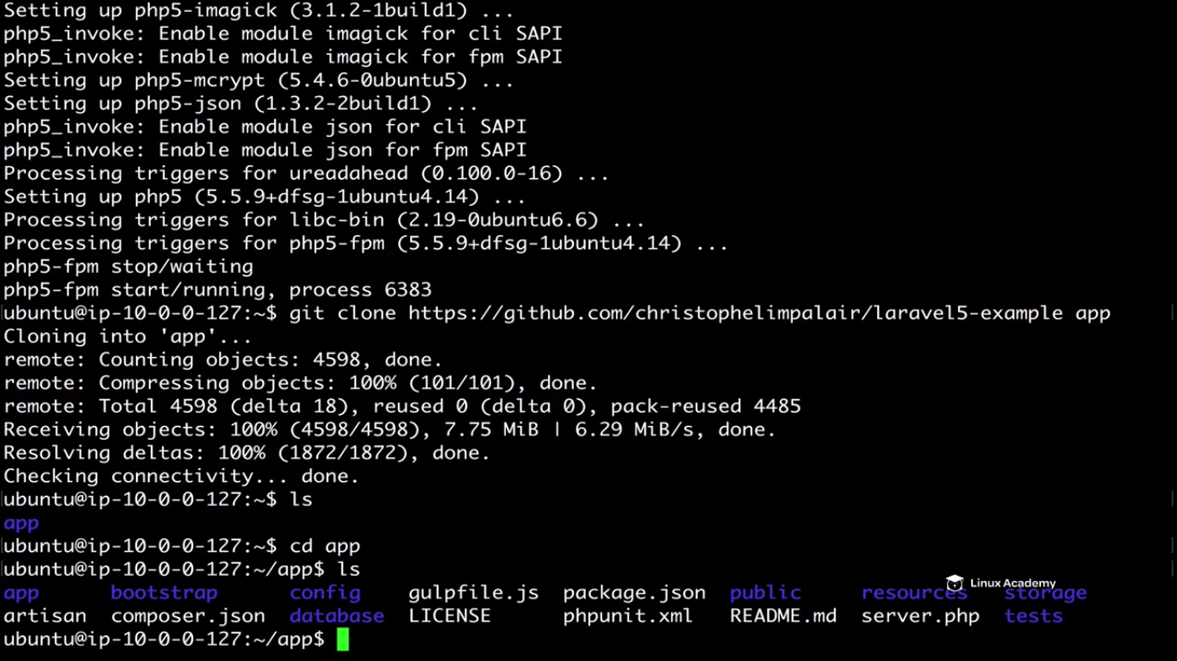

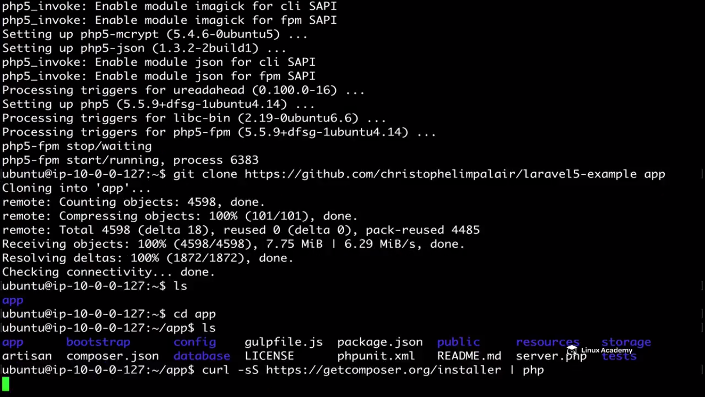

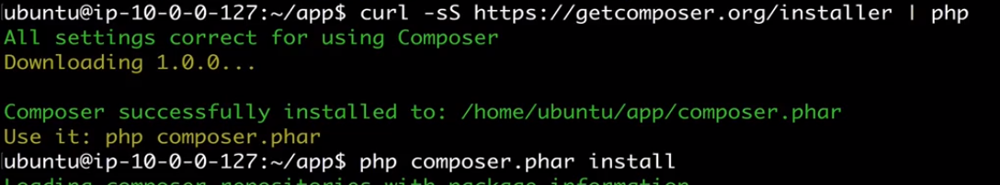

We can php composer.phar install and this will install our leveral dependencies from what we have in our composer.json file. So we aren’t discussing here what a composer is and how its installed.

Once that’s done composer will generate a class loader for us

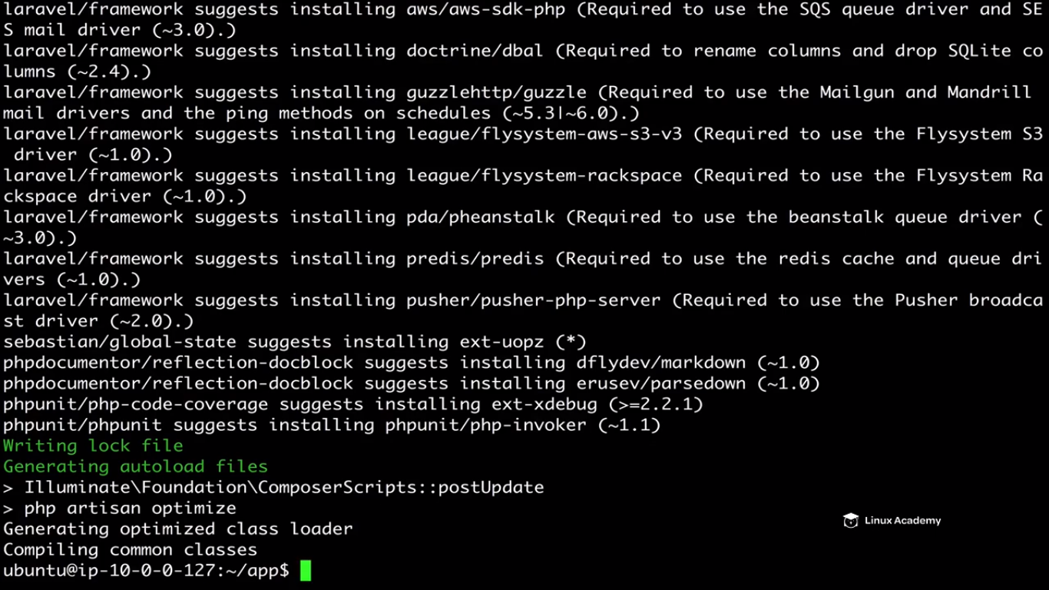

Now what we need to do is to configure our application to connect to our RDS instance. How can we do that. We can use a .env file



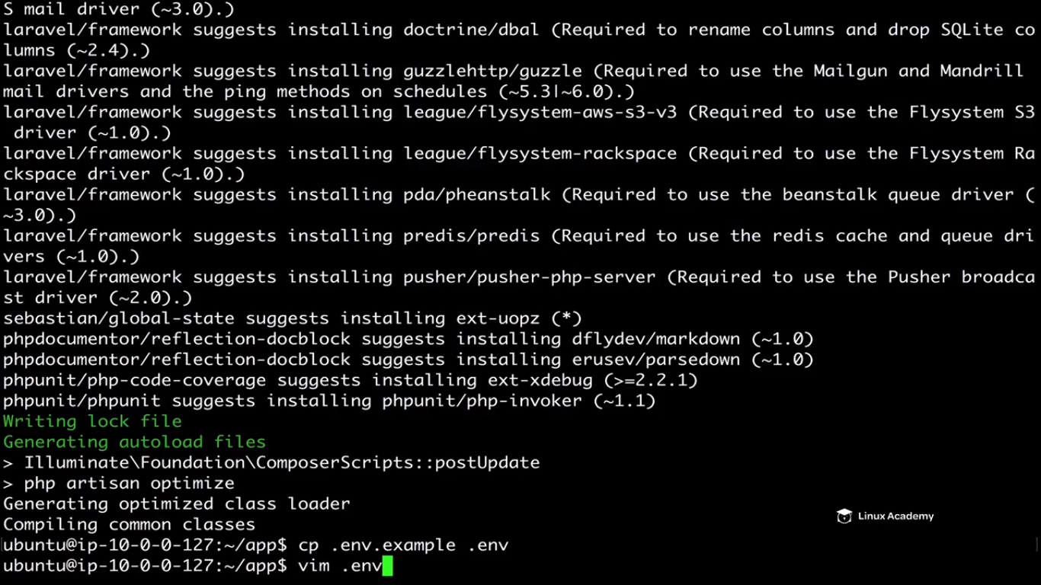

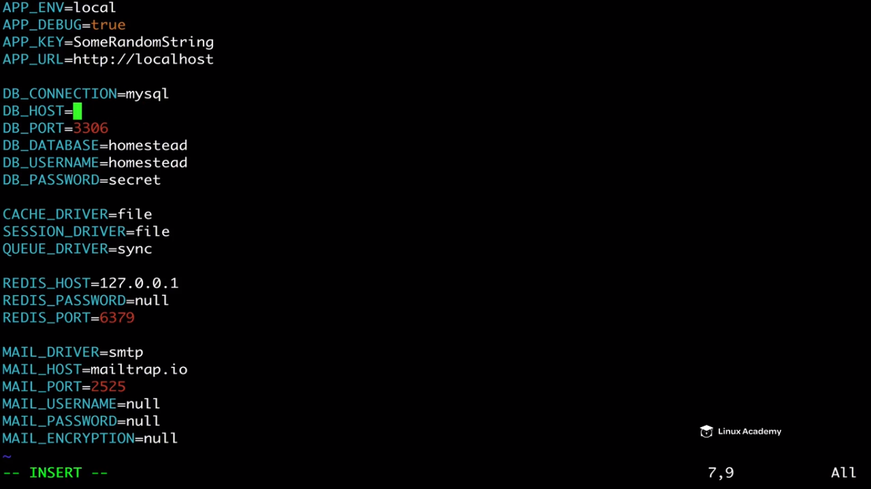

We are not hosting this on the host but on Amazon so lets delete this value and go to AWS console

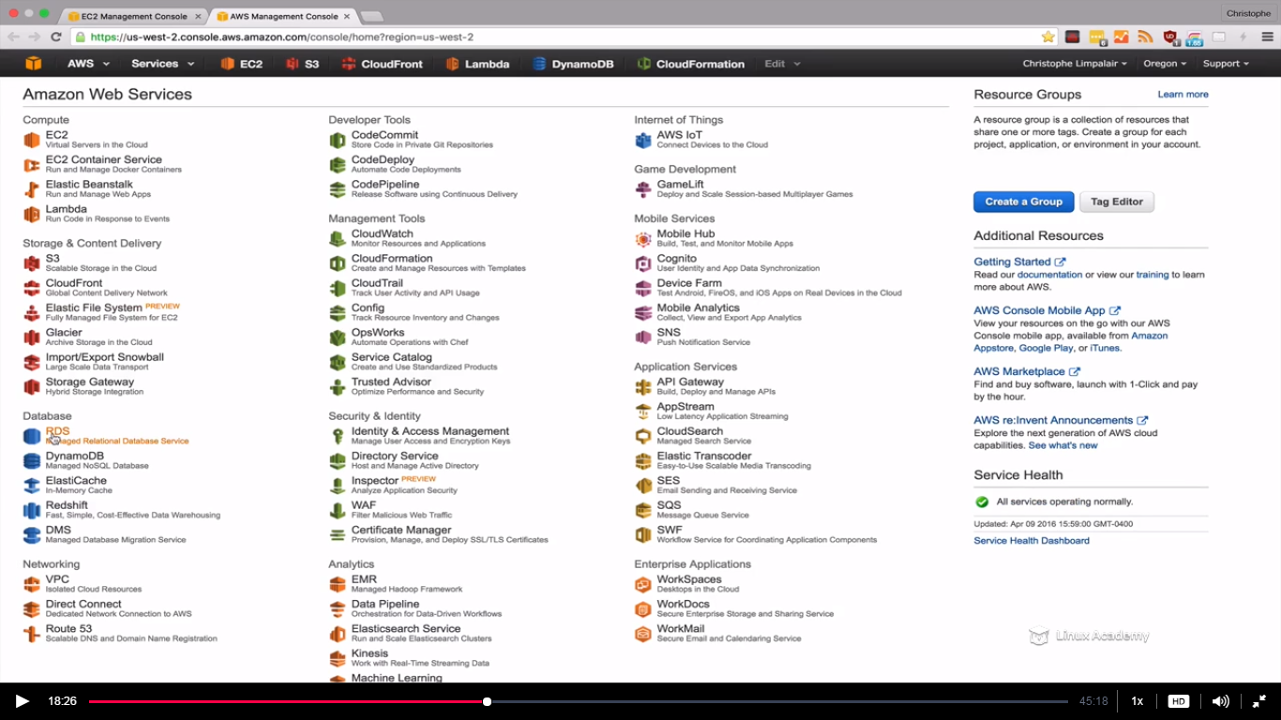

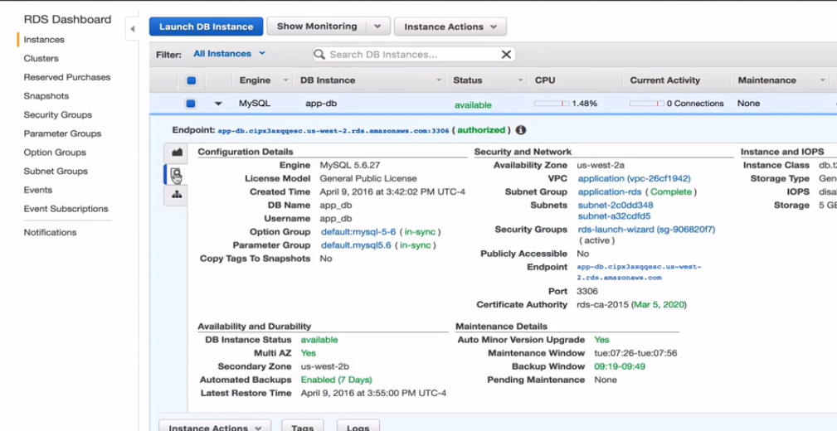

Grab the endpoint

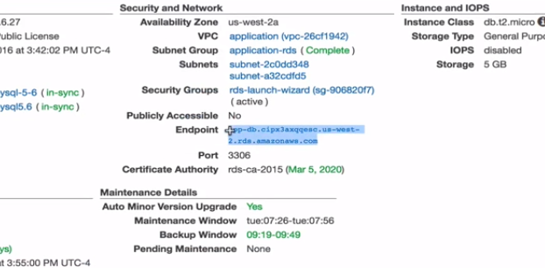



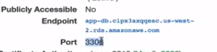

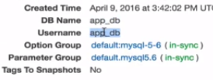

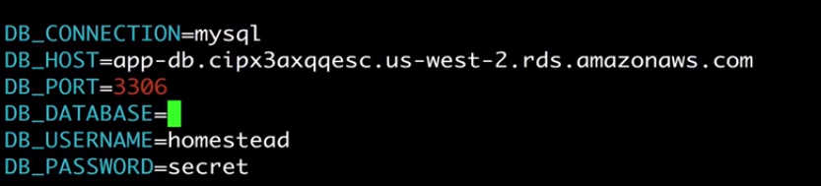

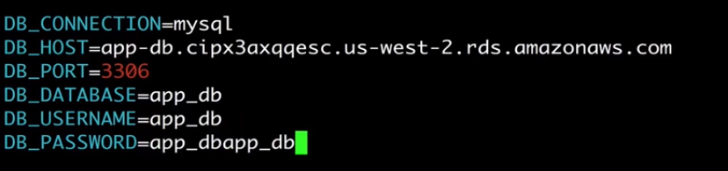

So grab the values of the mysql from the AWS console and change the configuration of the .erb file.

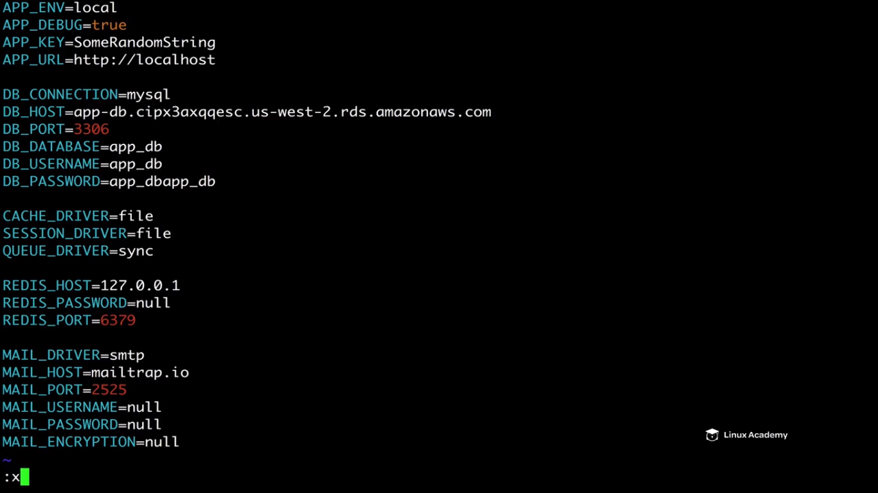

Lets see why it doesn’t work even after configuring it and then we will troubleshoot it.

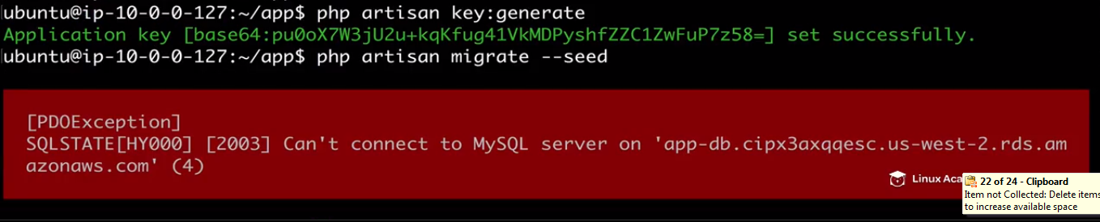

Why did this fail. Why did it say it connect to the mysql database. Its because of the SG’s. If we remember we created the Sg before our RDS instance but bydefault its blocking traffic from coming in which is a security feature what we want however what we want is that our our ec2 instances or our web server instances to be able to communicate with our database. So how can we do that .

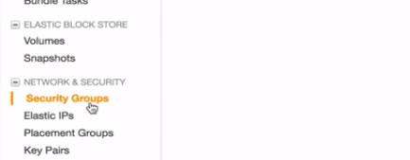

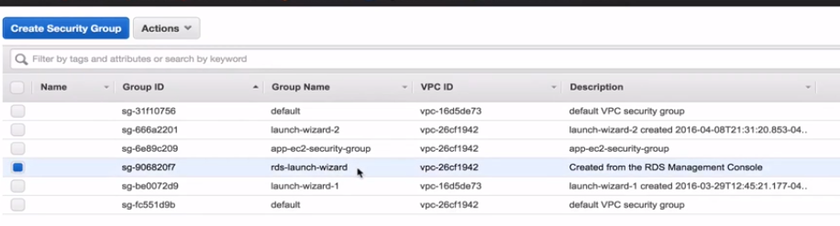

We have our RDS launch wizard SG wich we created .

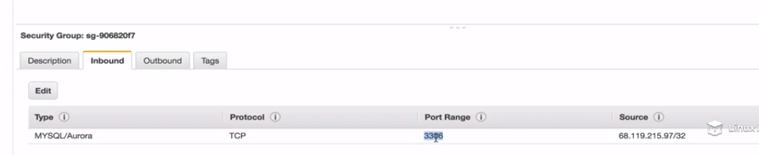

The default rule doesn’t allow our ec2 instance to go through which we need to fix.

Now if we remember when we created this ec2 instance and in the future if I want to create any web server instances I want to use this sg name as below.

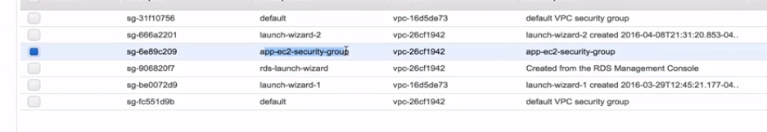

So what should I do, I should grab this sg id as

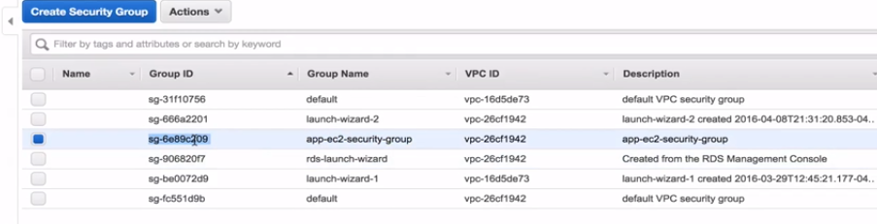

Copy the sg id which we grabed and go back to the RDS SG and edit

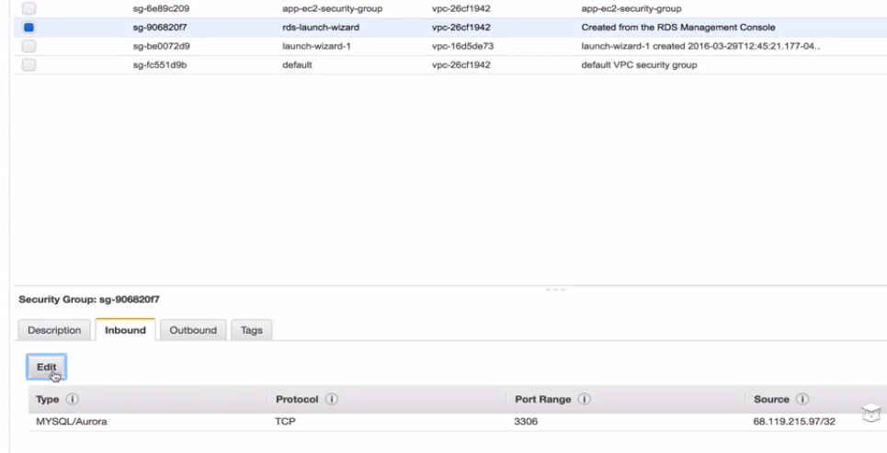

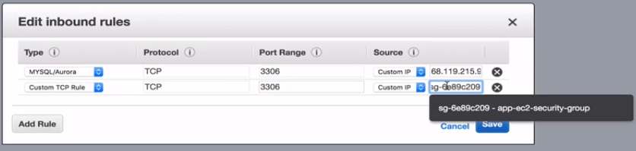

Edit the inbound rule to allow custom TCP from port 3306 and paste the Ec2 SG which we created. That will now allow it to go through

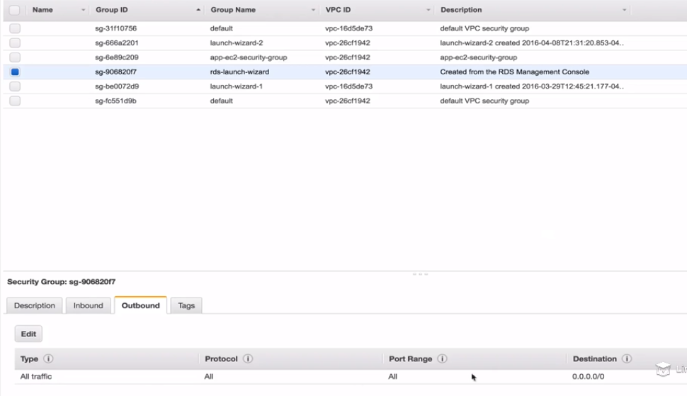

Go to the ec2 instance again and try again.

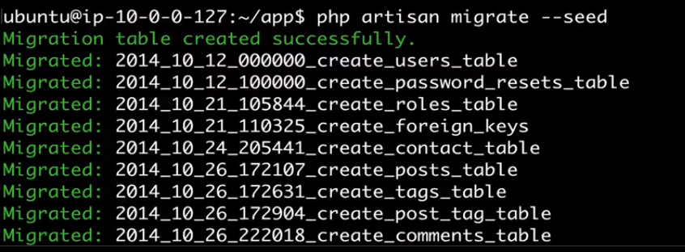

So we are successfully able to connect to our RDS instance. So I have installed ngnx and we have php fpm. Ngnx will send any php request from a user to php fpm which will run the script and send the result back to ngnx which will send the result back to our user. So those 2 need to work together.

Ngnx need to be properly configured to route php request to where it needs to go. How can we do that.So lets first make sure ngnx is working properly.

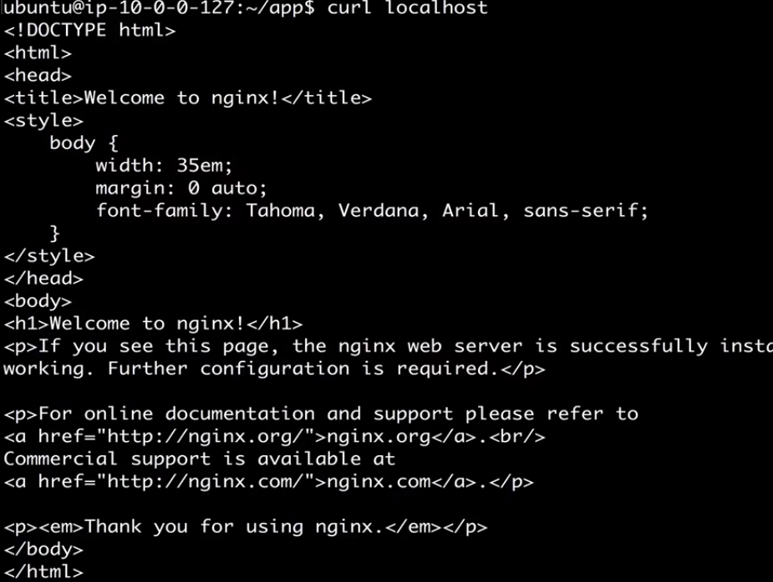

We see the welcome message.So this is working right.

But we want to change this page. We want to server traffic to our leveral application. So where is this page and what is going on here.

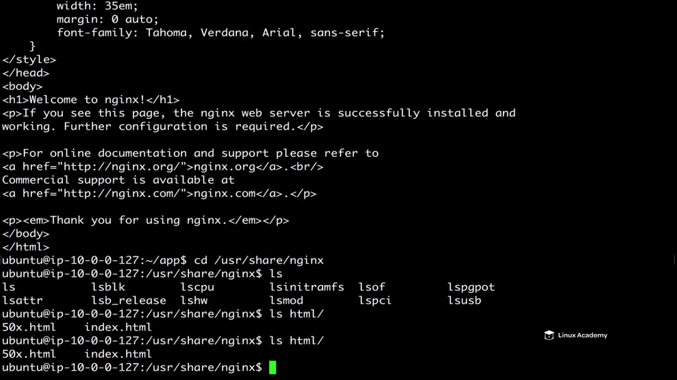

So this is the html file which we were watching, so lets move our application to this directory.

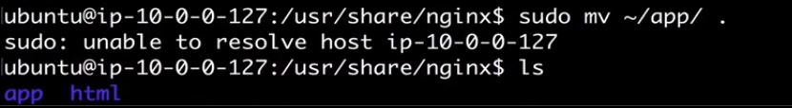

Now we have to point to our application instead of the html directory.

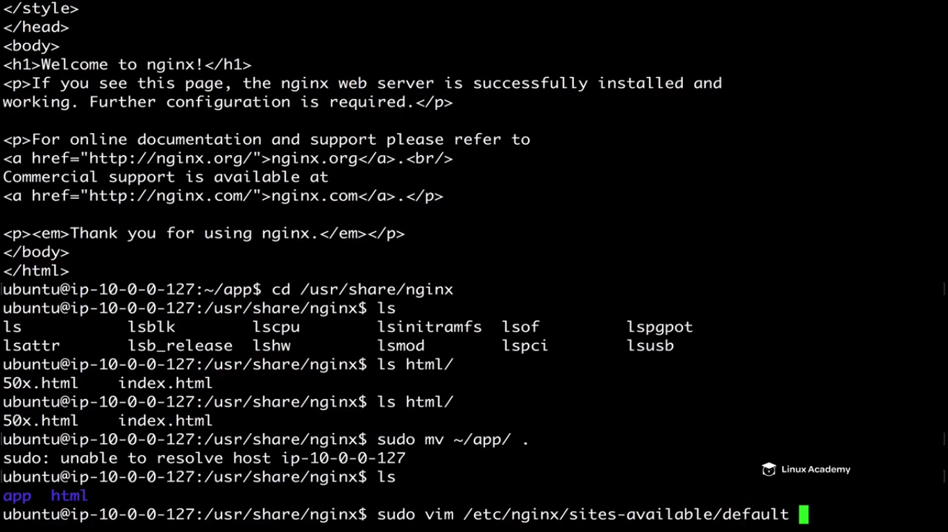

We need to change these two lines

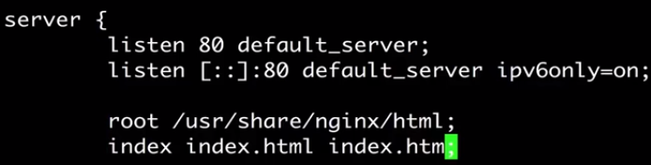

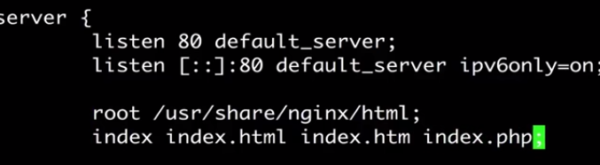

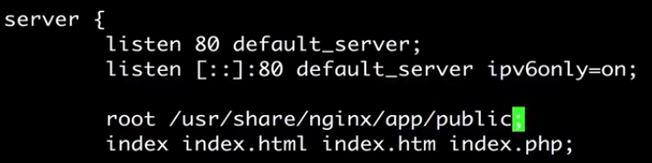

Go down a bit and enable the below lines

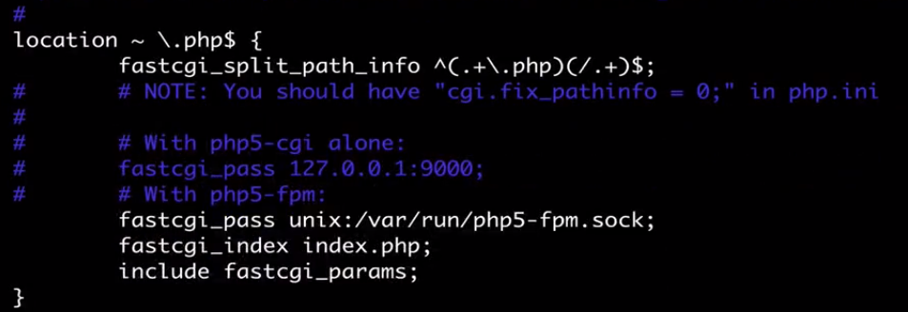

Save this file.

Restart both php and ngnx and then do curl to localhost.

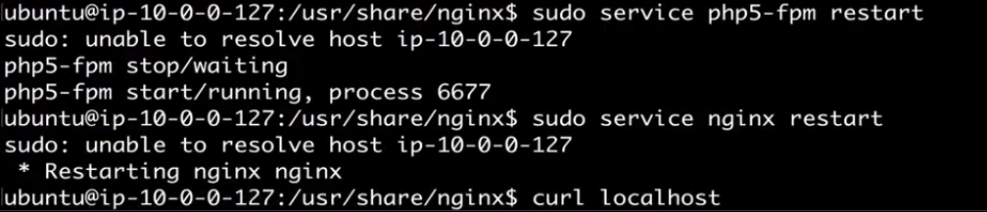

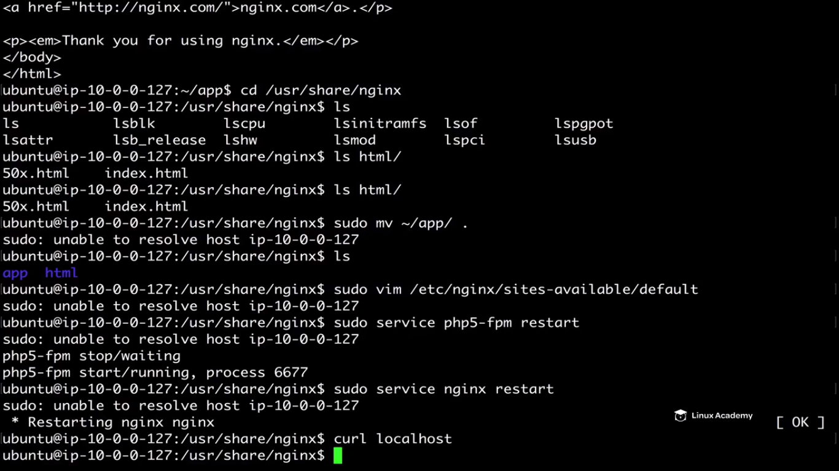

So we didn’t get anything after curl so there must be a problem so the problem is due to a permission in our application directory.

So how I come to know this. So for that go to the log directory as



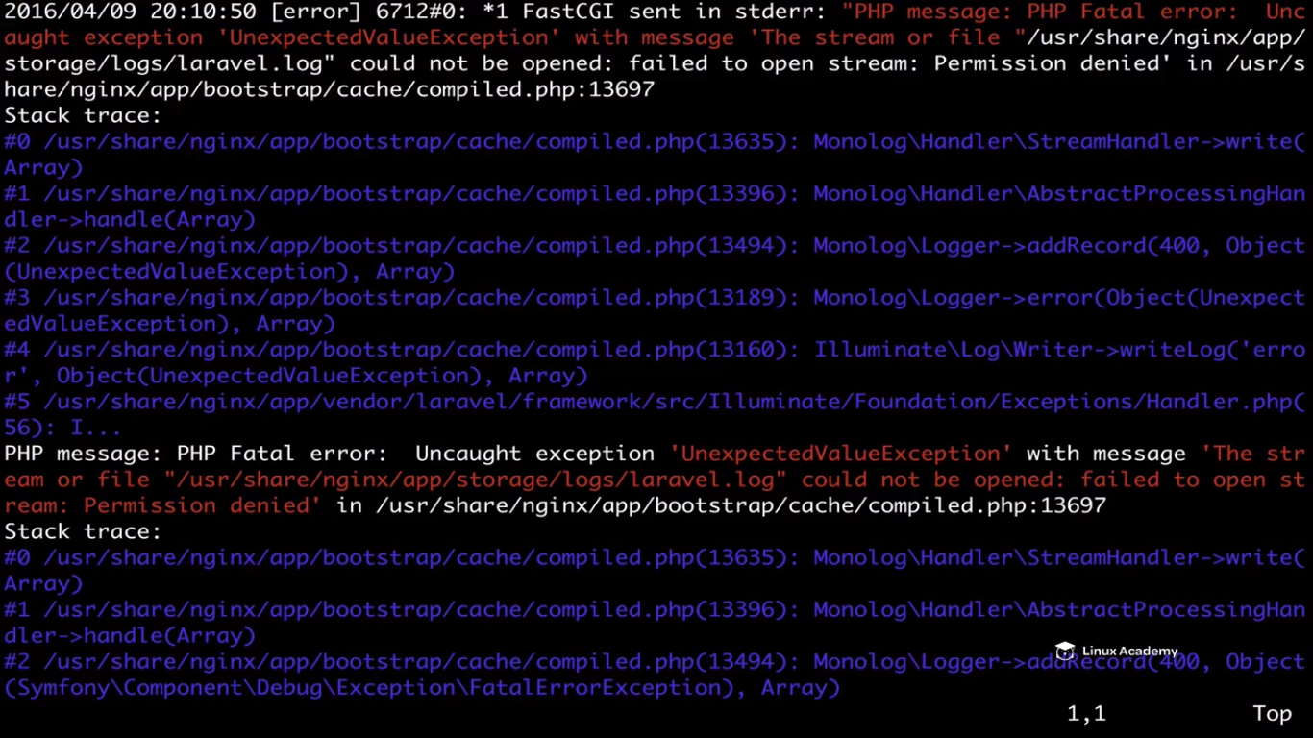

How can we fix that . Lets get out of here.



So lets try to curl and see if we see something now.

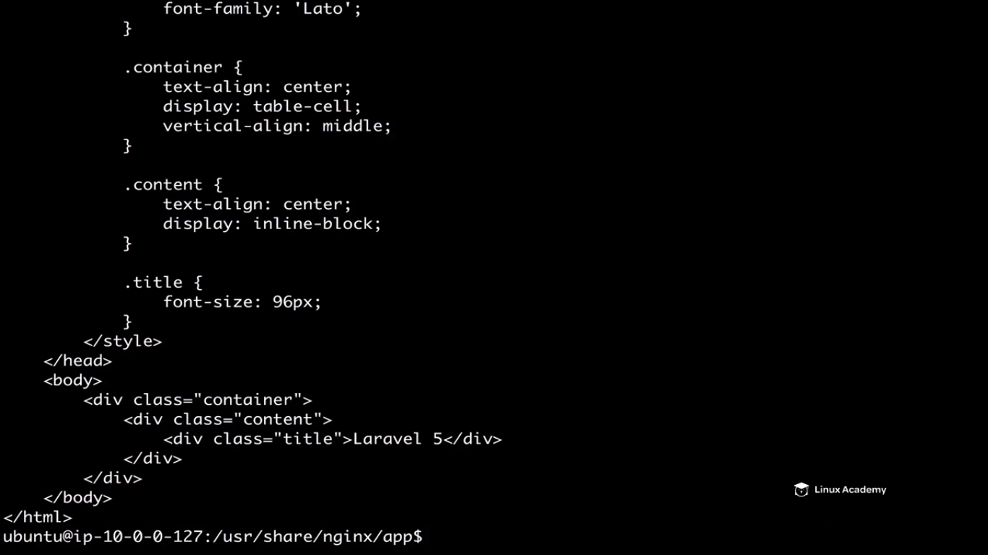

We get response back for our **laravel application.**

We can also verify this by going to the browser and putting the ec2-instance public ip there.

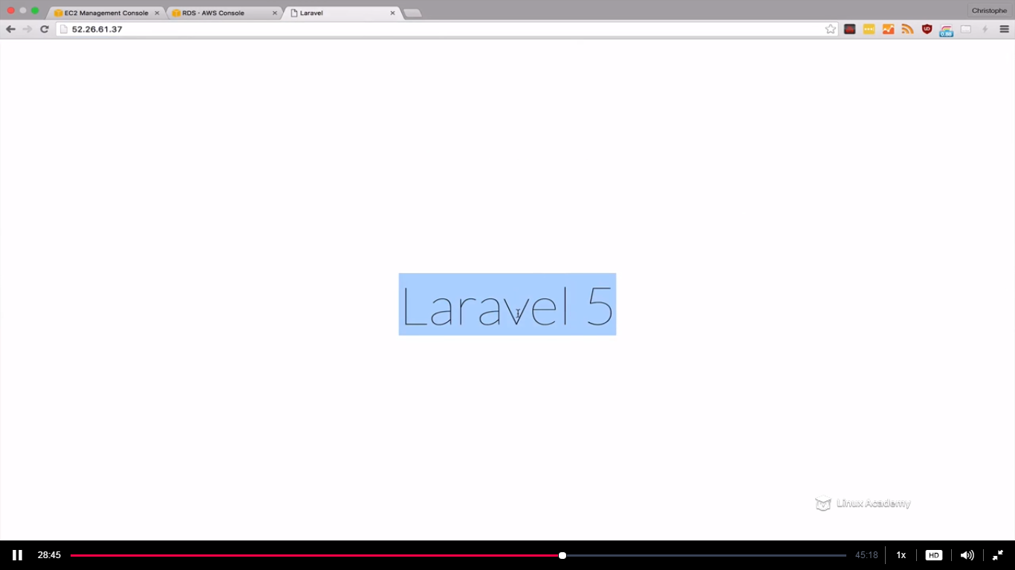

Now create an image of this instance and create new identical instances via autoscaling.

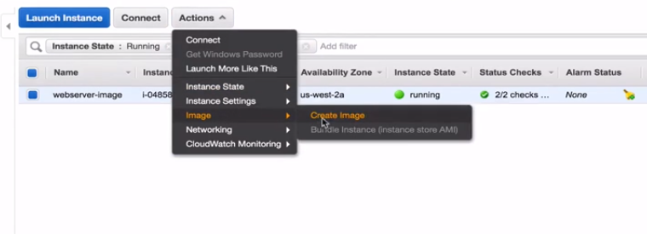

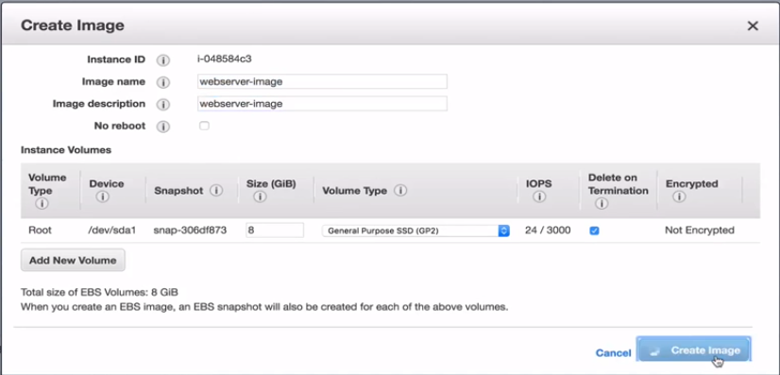

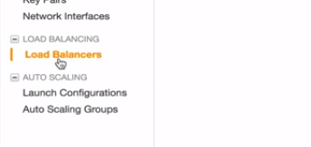

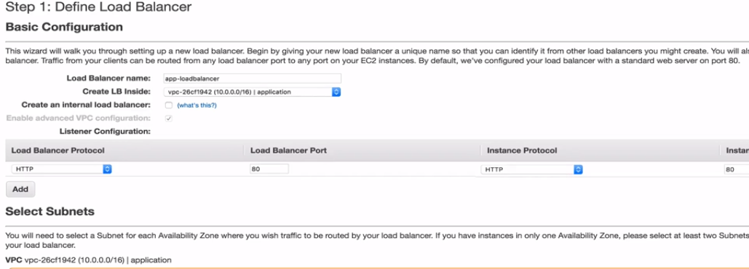

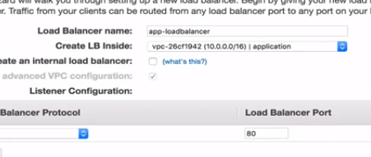

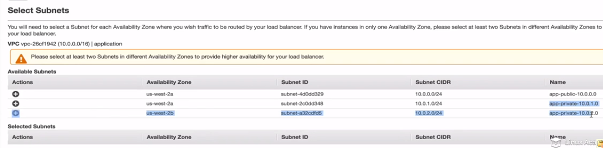

Select both private subnets for the load balancer configuration.

But we are getting the below error down there

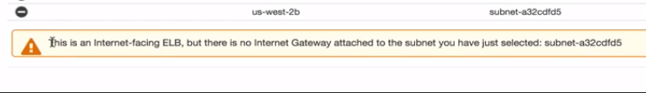

We need to create another public subnet as this is a public facing ELB as we didn’t slected it as an internal ELB. So we need to create another public subnet and need to associate the public subnet to our selected subnets here instead of the private subnets where our actual instances are going to be.

This is an ELB trick so what we are going to do is that

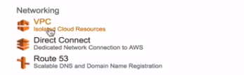

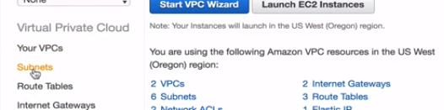

So we have a private and public subnet for availability zone 2a and single private subnet for availability zone 2b so we need to create a public subnet for availability zone 2b

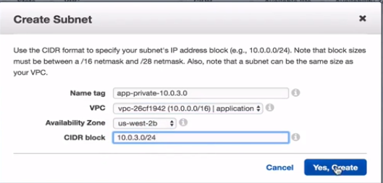

Actually it should be public not private



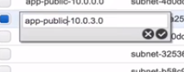

Now we have a public subnet which we have to route to our internet gateway

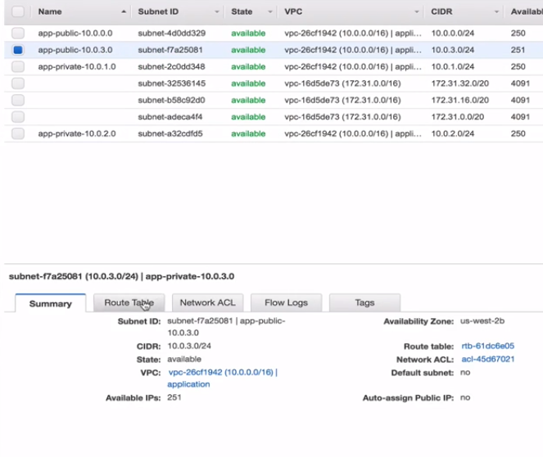

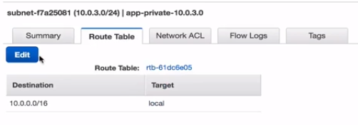

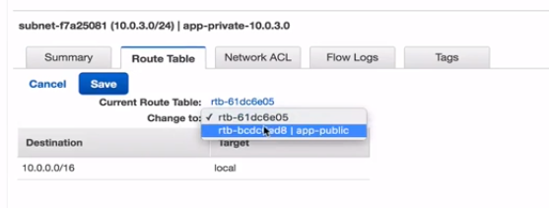

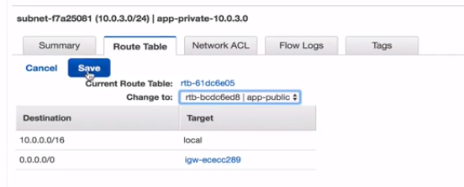

Go to route tables then

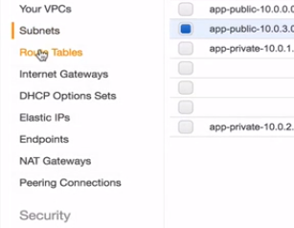

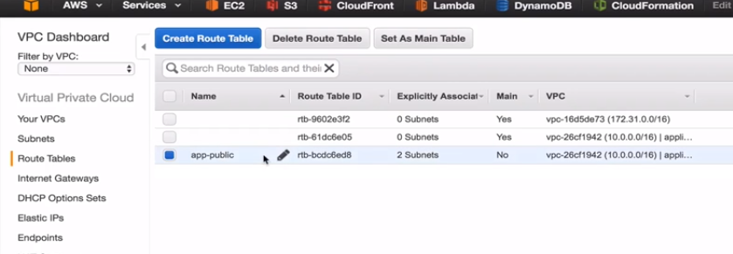

And click on the app-public and make sure that we associate the subnet

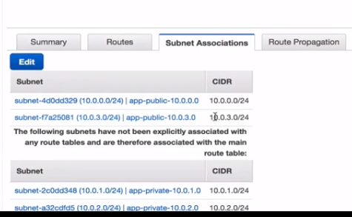

And its already associated

Go to loadbalancer dashboard copy the name as

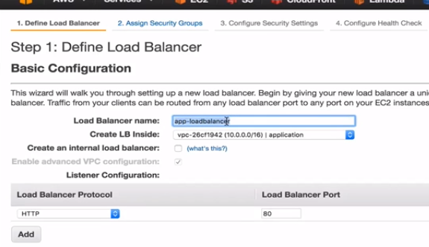

And cancel this load balancer and create a fresh one as

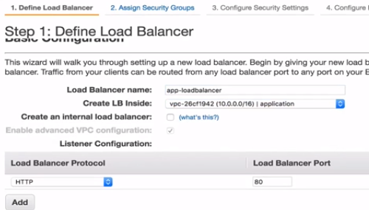

Now we are going to select both of the public subnets as

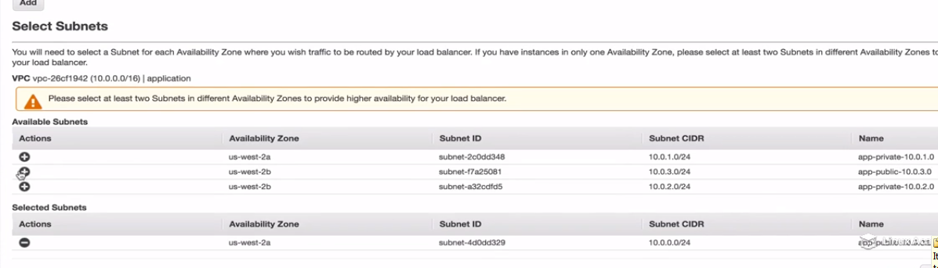

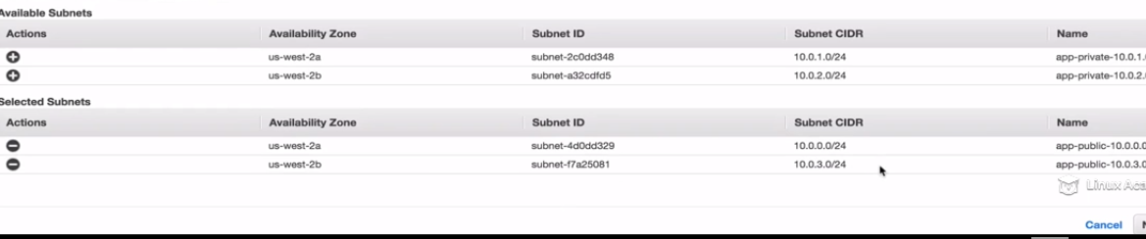

So these subnets match the availability zones of the private subnets.

Create a new SG

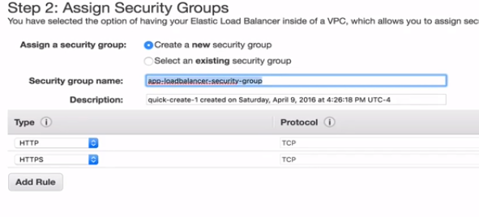

Select http and https from anywhere as the rules

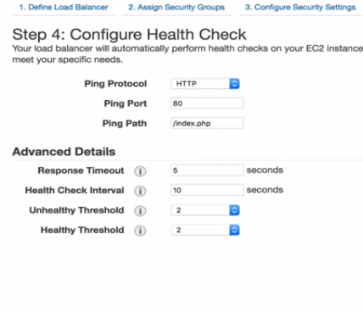

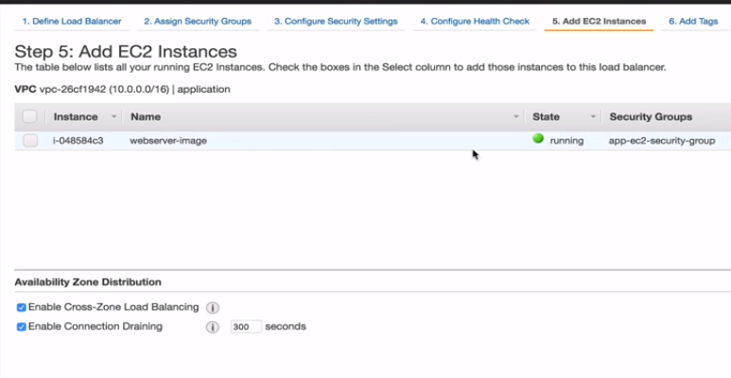

WE are not going to add this instance as this is just an image.

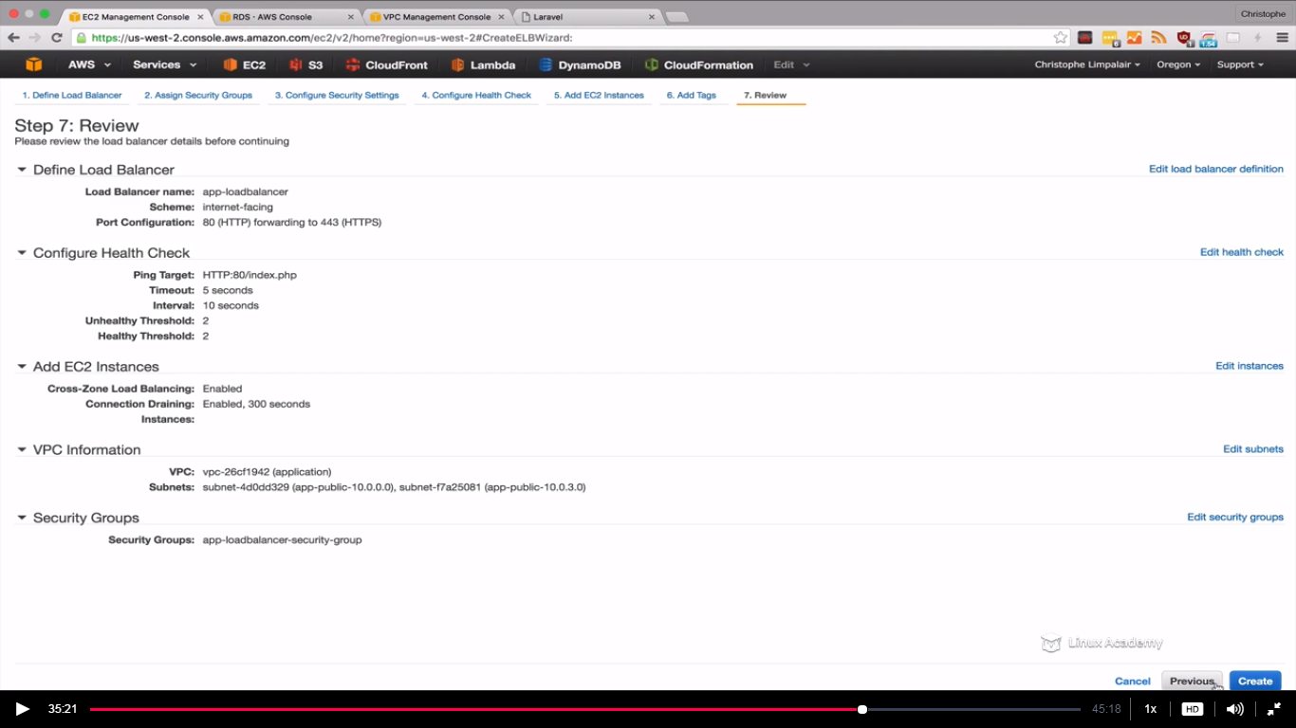

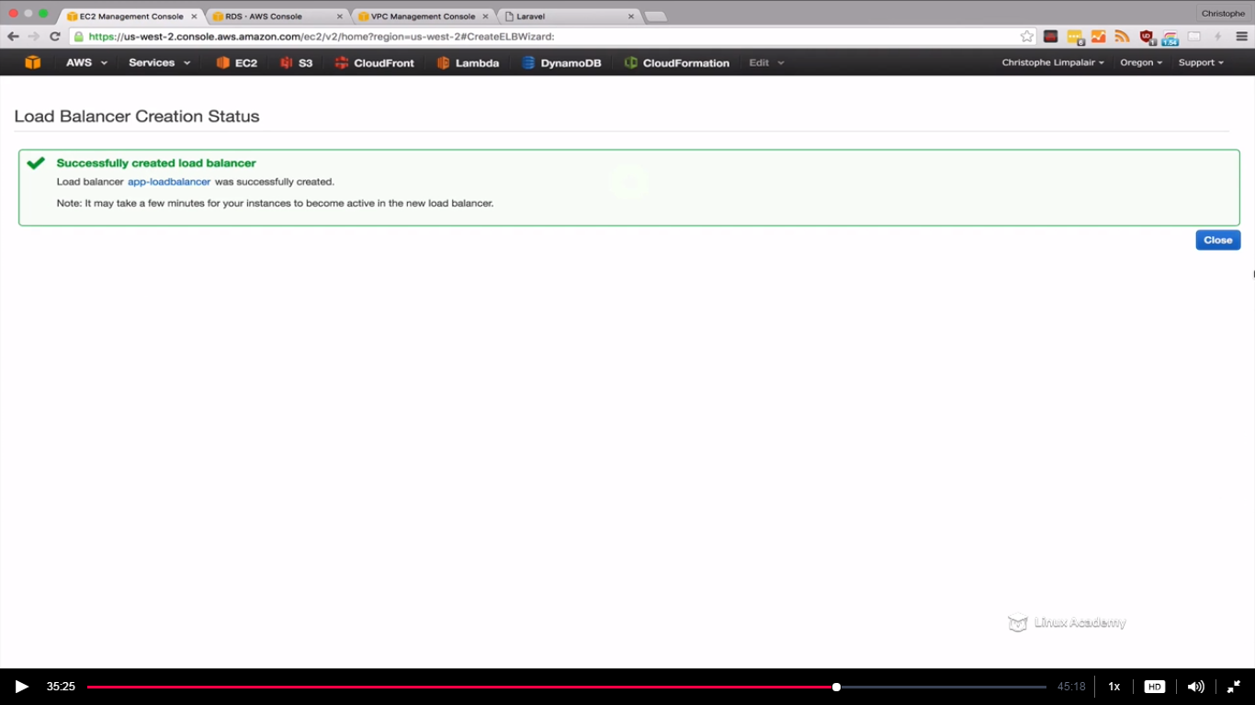

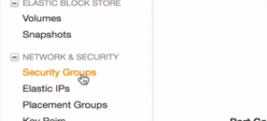

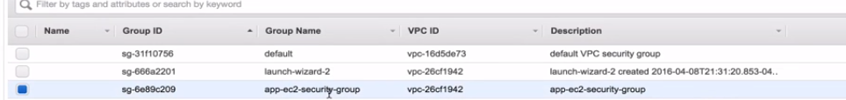

We would allow traffic only for our EC2 instances from the load balancer itself. No one access it unless its coming from the load balancer or the RDS instances.

Go to Ec2 console and stop the instance as we don’t require it more.

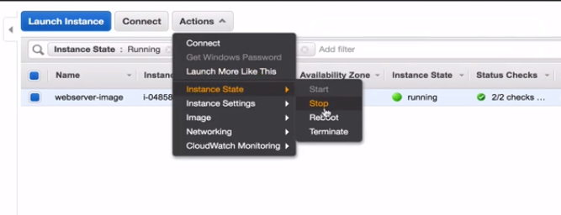

Now everything is configured so lets do the autoscaling.

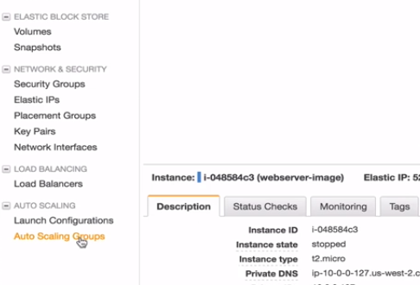

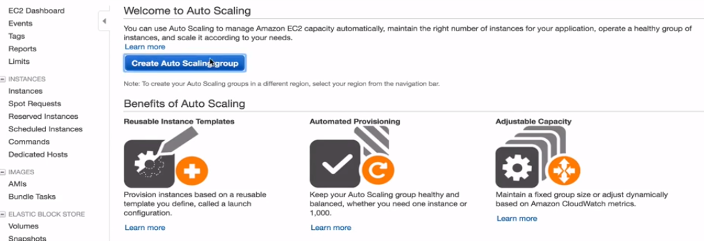

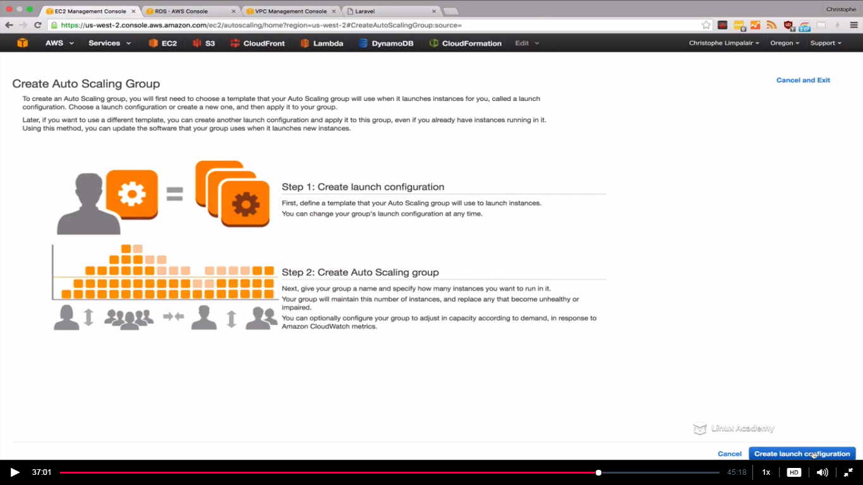

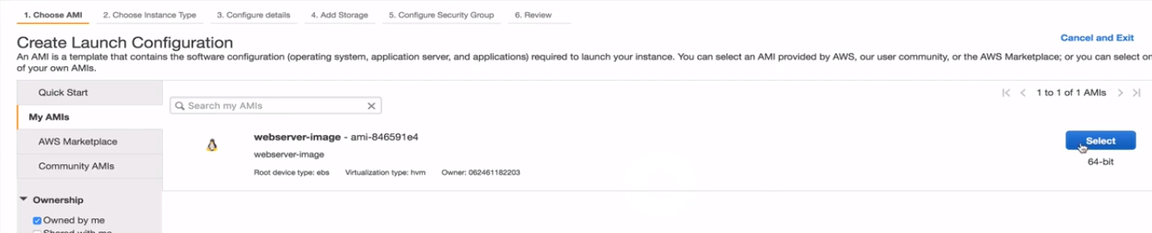

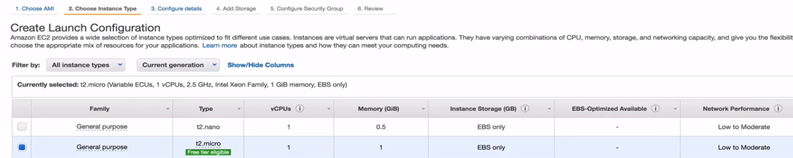

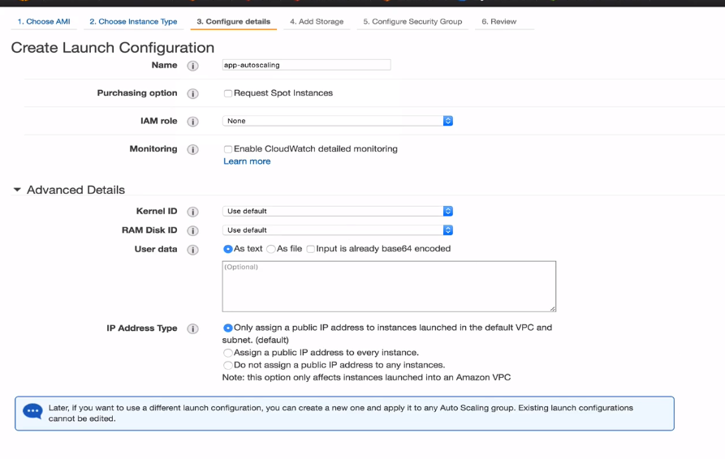

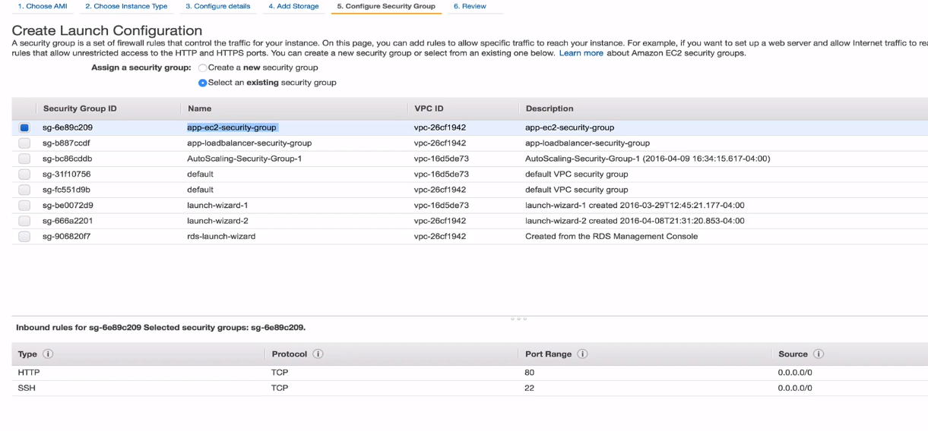

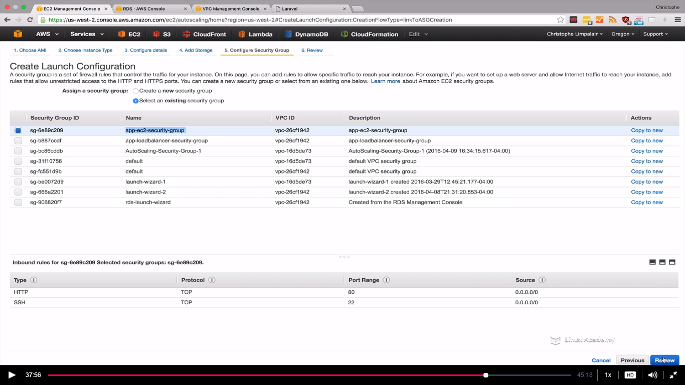

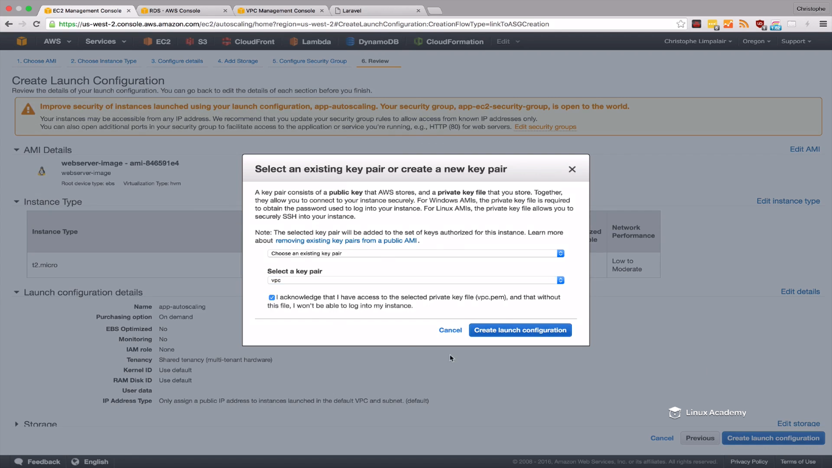

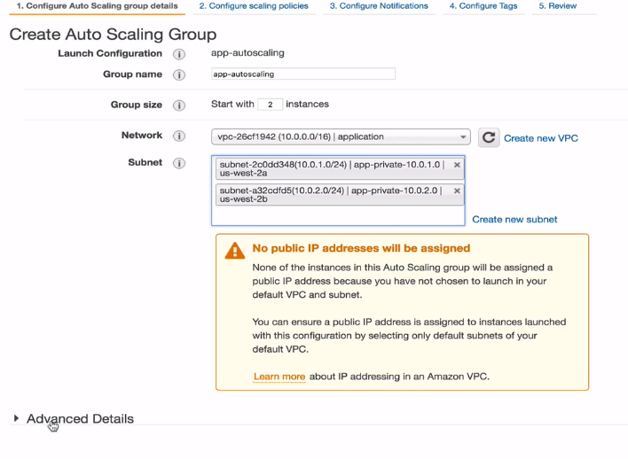

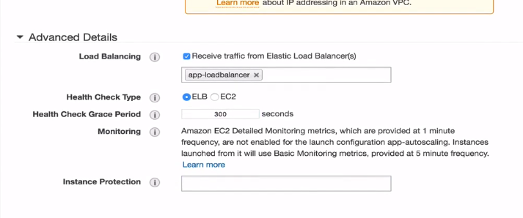

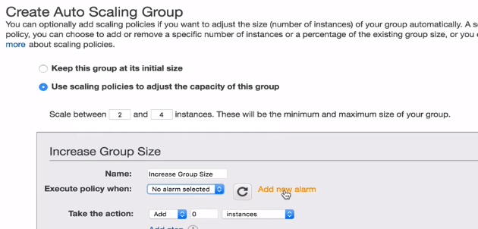

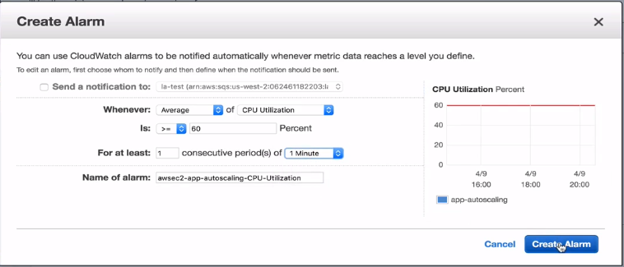

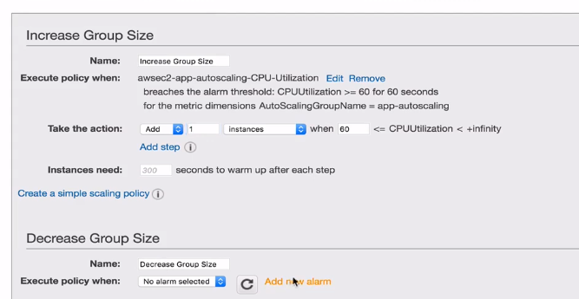

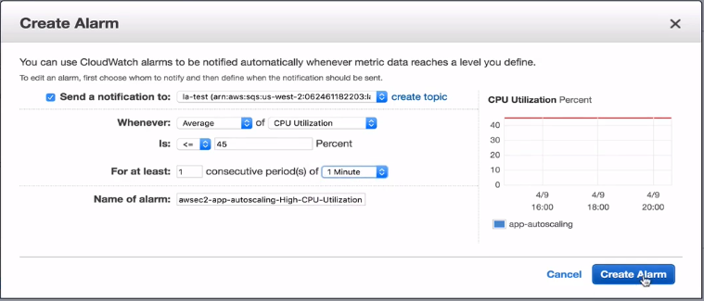

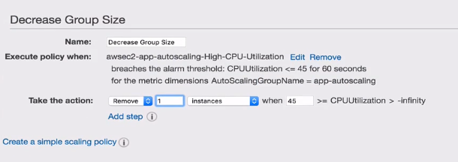

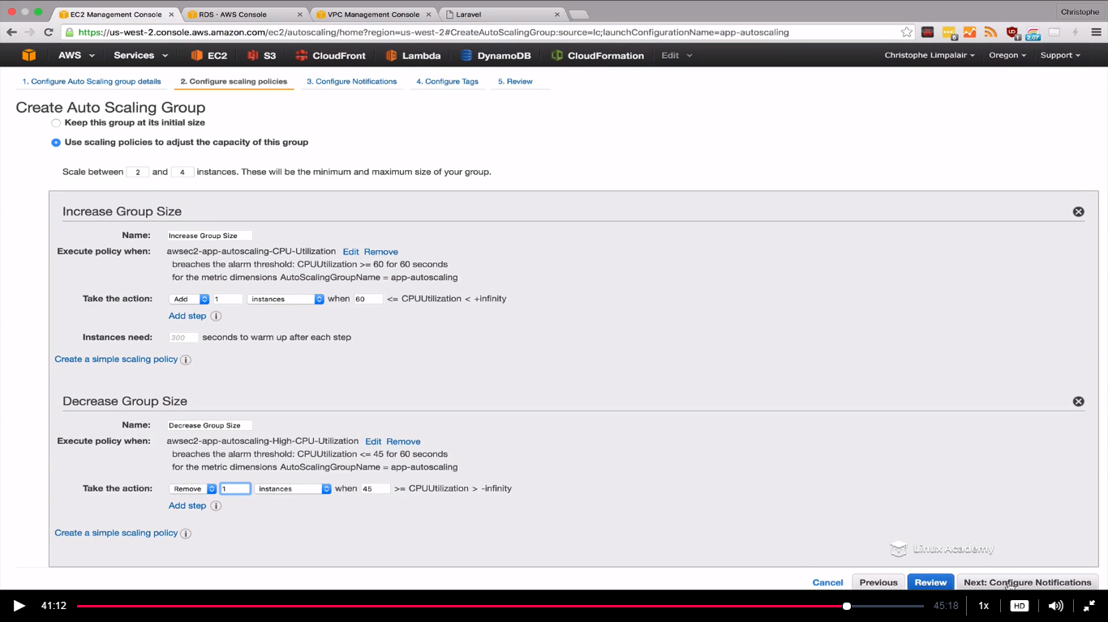

Click configure notification.

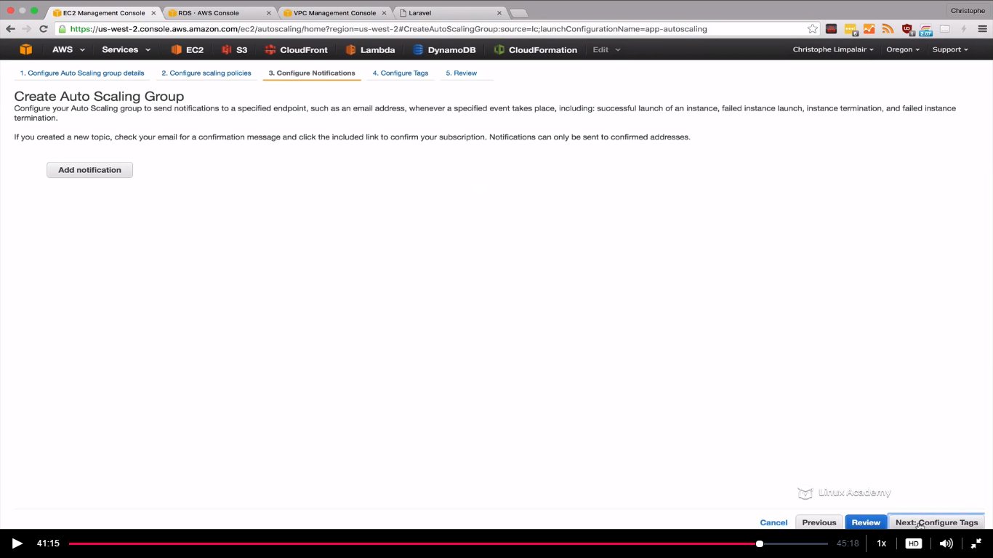

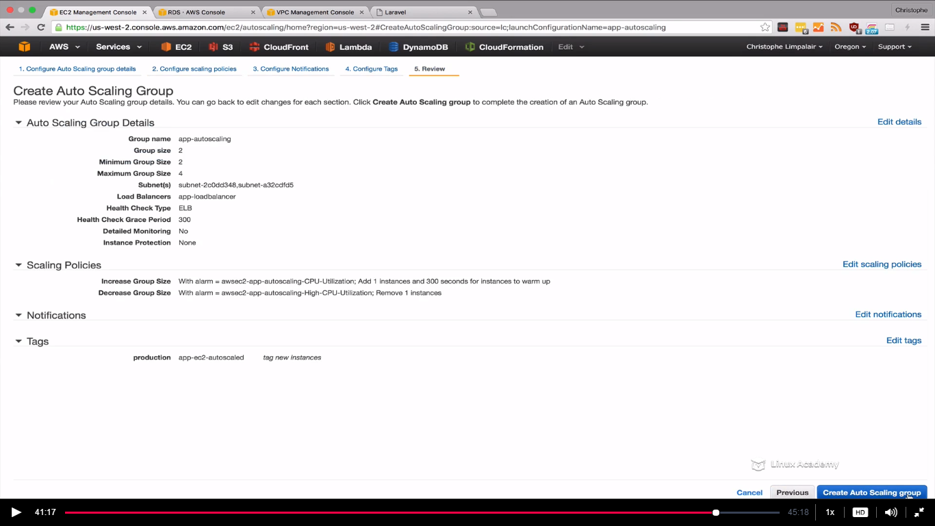

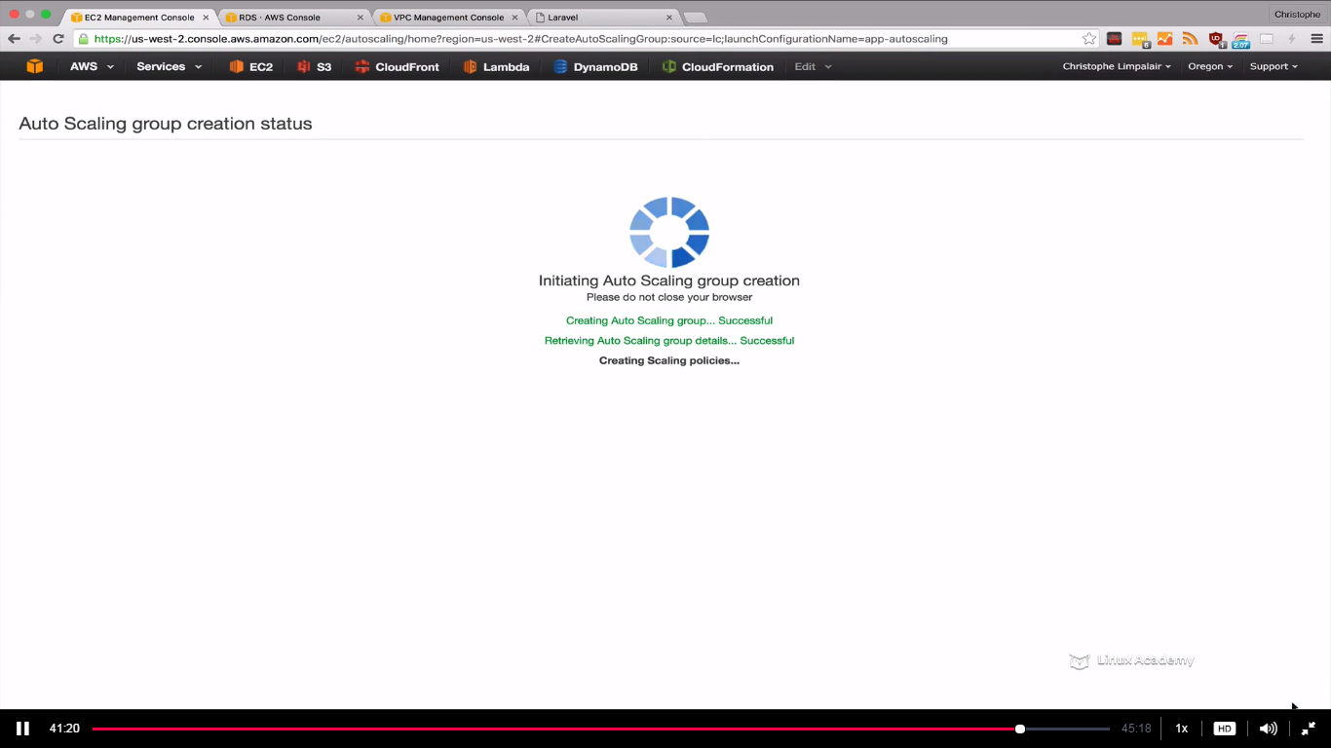

Wait for few minutes so that it can launch two instances.

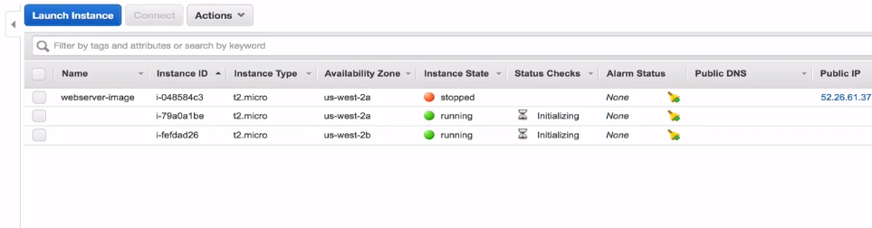

Instances are initializing.

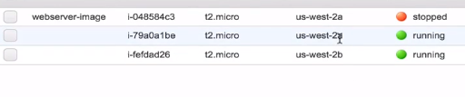

They both are in different AZ’s.

IF we see the instance information we notice that it has a private ip but no public ip

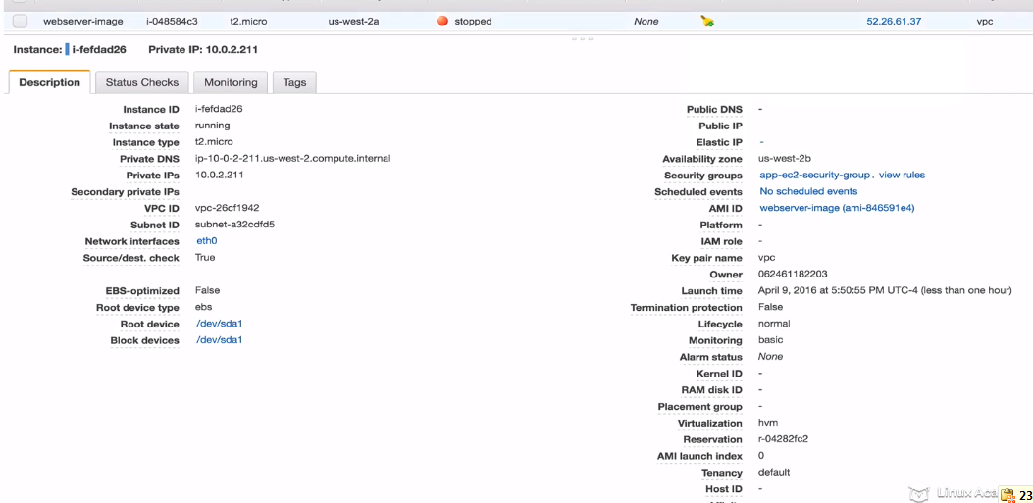

If we go to the other instances we see the same confituration as well.

So we cant access these instances from our local system. I will need something to connect to the public subnet inorder to access them. We need like something called VPN, open swan etc.

If we go to our load balancer

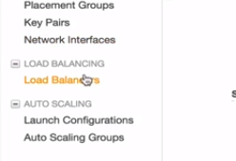

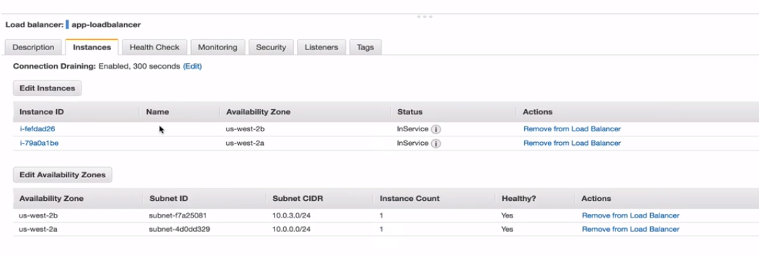

We see two public subnets being attached to the loadbancer and both of them have one instance count as above or lets see below

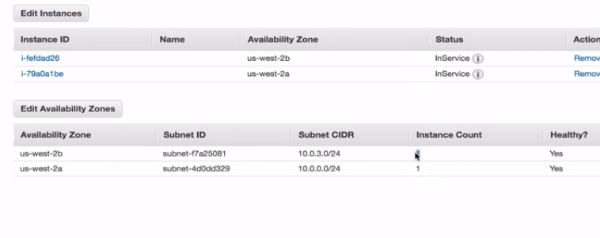

But the instances aren’t in the public subnets. They are inside the private subnets so they are mapping them accordingly. So if I go to the description itself as

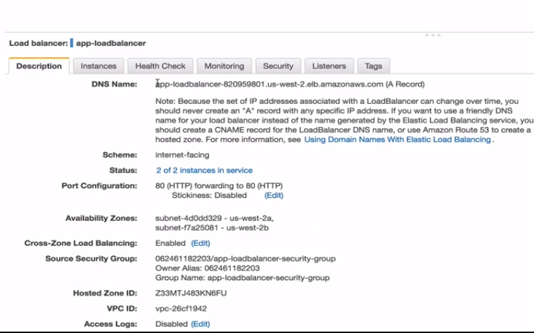

Copy the dns

Paste in the browser and it will load our application as below

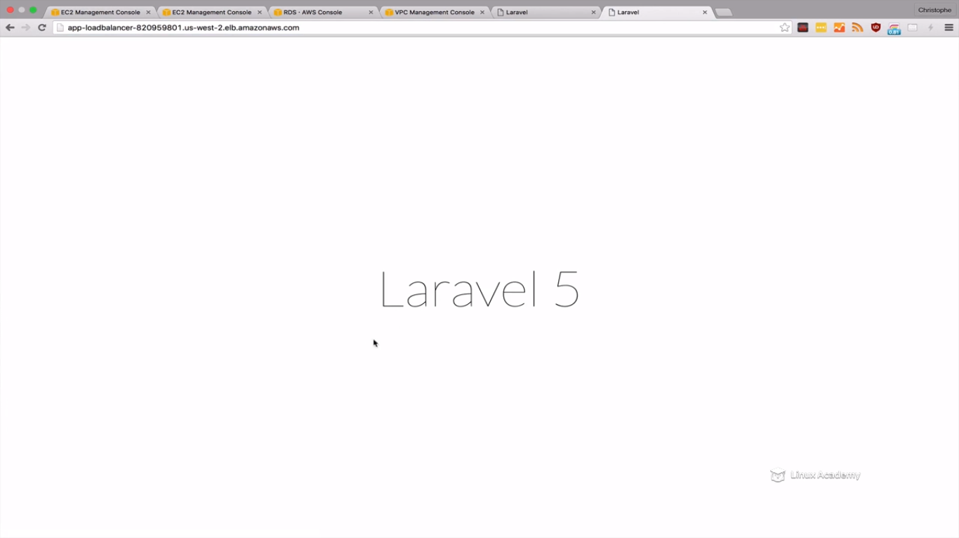

Now refresh the page again and again and it will distribute the request to the instances evenly. Now lets delete one of the instances as

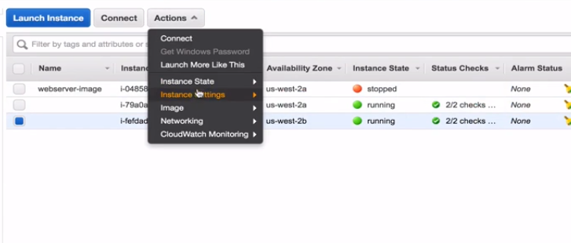

And we would see in a minute of time the autoscaling will spin another instance.

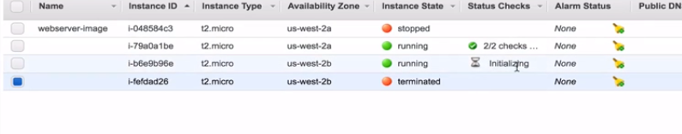

We see one instance initializing as we deleted the one instance.

**Amazon CloudFormation**

**Lecture: CloudFormation Essentials**

In this lesson we will review some essential information and some basics about CloudFormation. This lesson will prepare us for hands-on lessons.

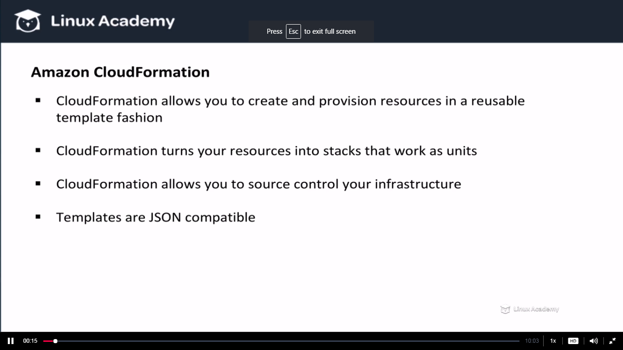

For e.g lets say we want to create an EC2 instance we can declare that in a cloudformation template and then we can save that template. Now everytime we run it it will create our EC2 instance to the exact specific specifications.

A stack is the collection of all the resources in our template. So if you have a list of resources that is going to built up a web application for eg database,webservers and rules all these make a stack.

If for eg any of the resource fails to create the cloudformation template rollsback and deletes the resource that were created up to that point.

**Templates are JSON compatible, what that means is that we can version control it.**

**We can different version for dev with lesser or small infrastructure and prod environment with large infrastructure. We can crated, test templates and then can push them to our repositories.**

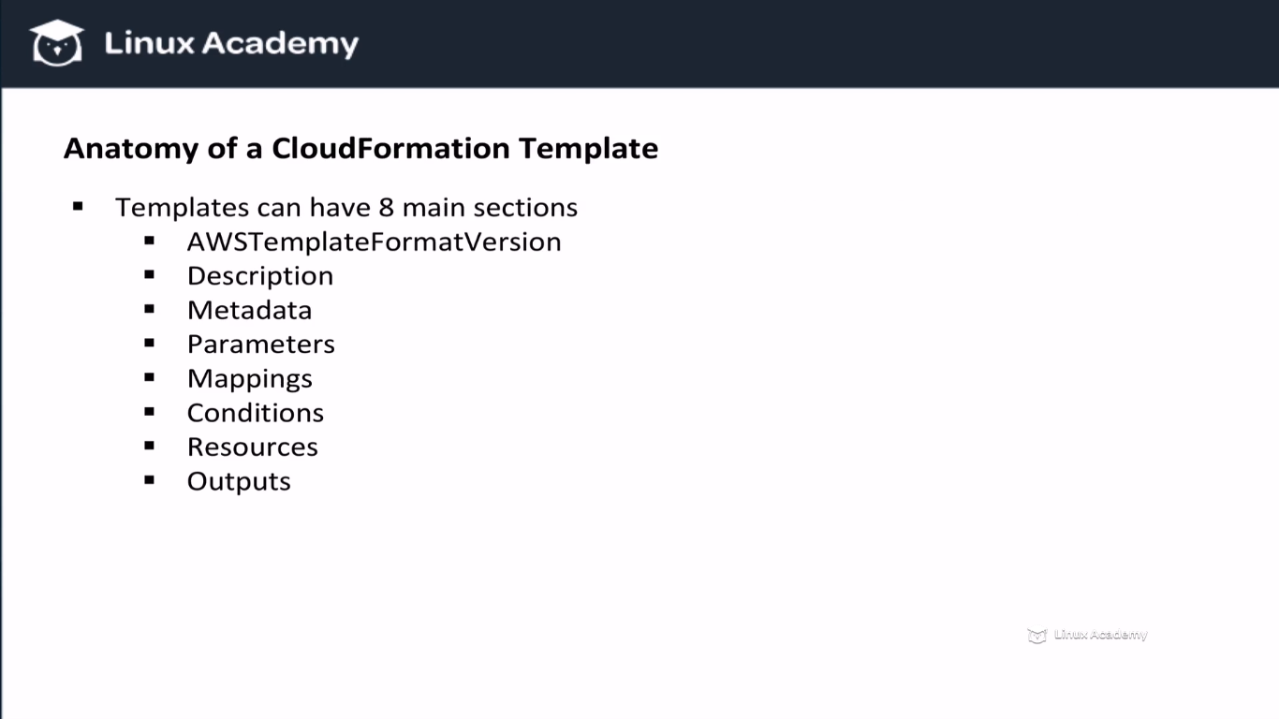

**The required section for the template creation is the resources section. All other sections are optional.**

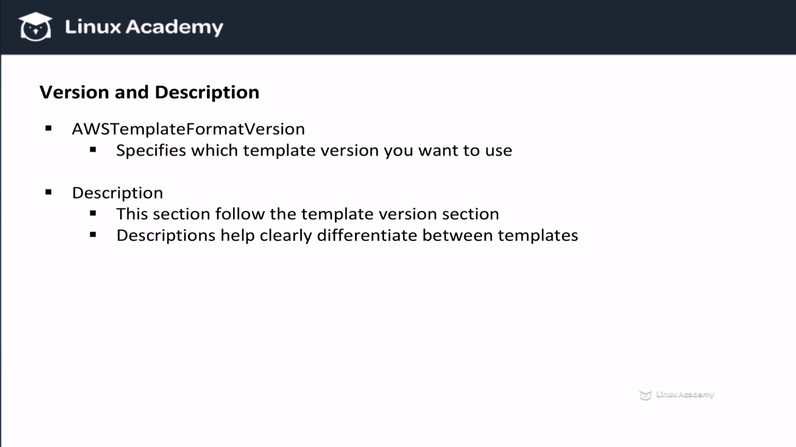

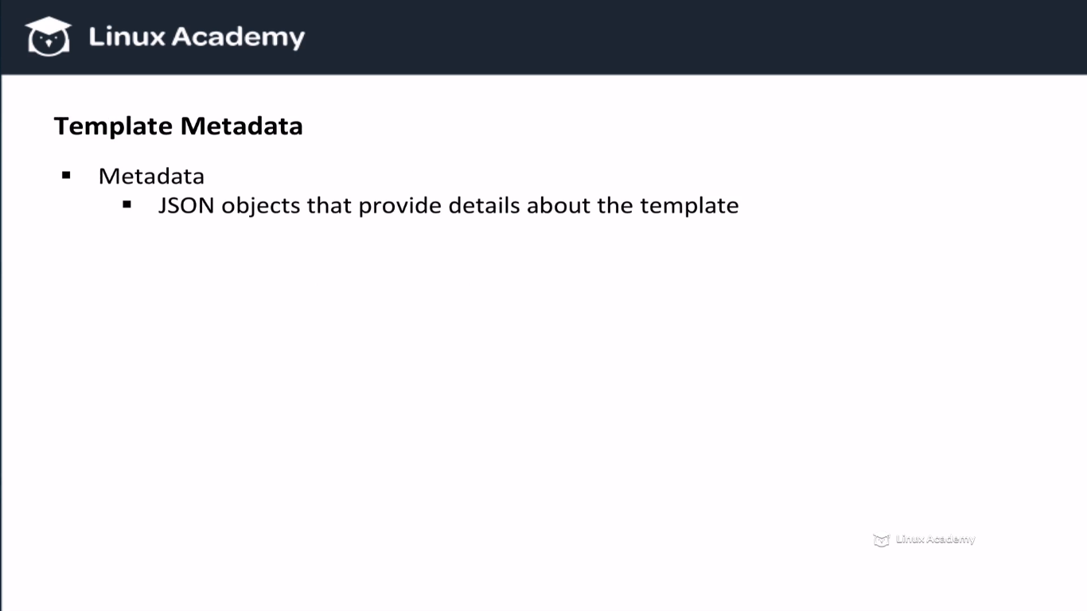

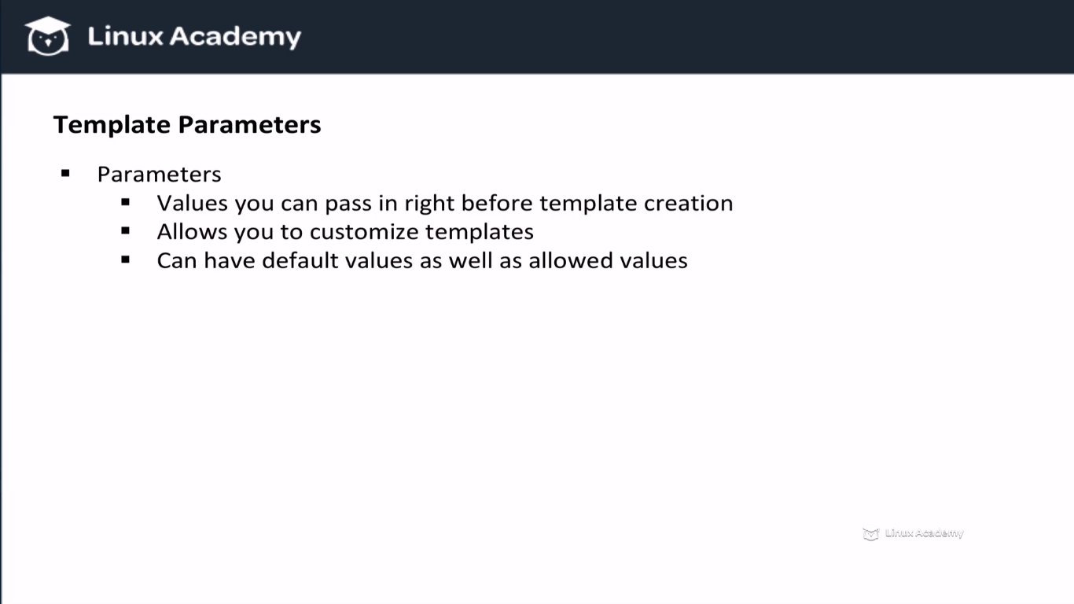

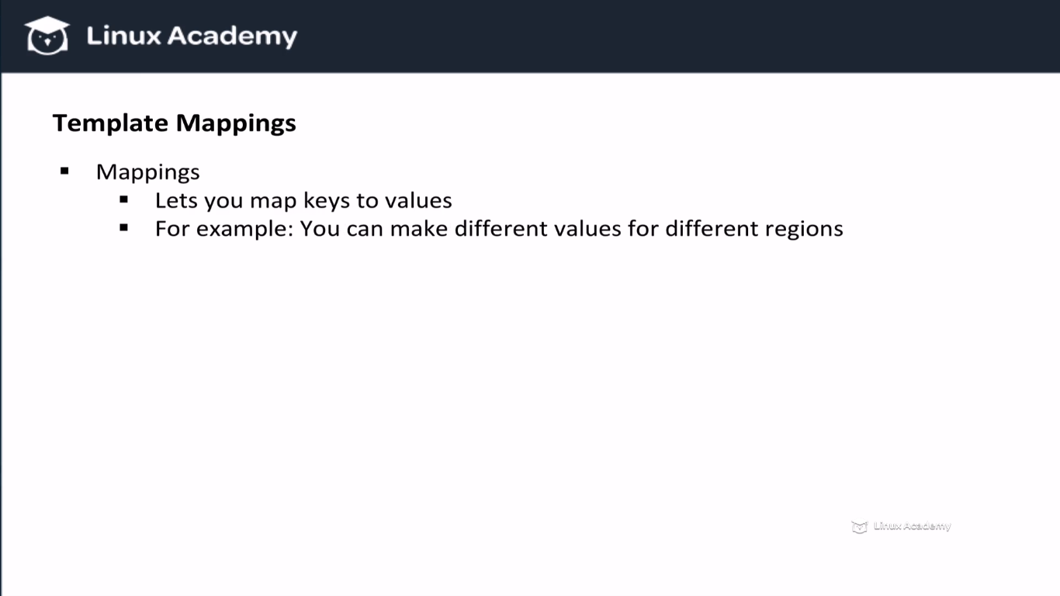

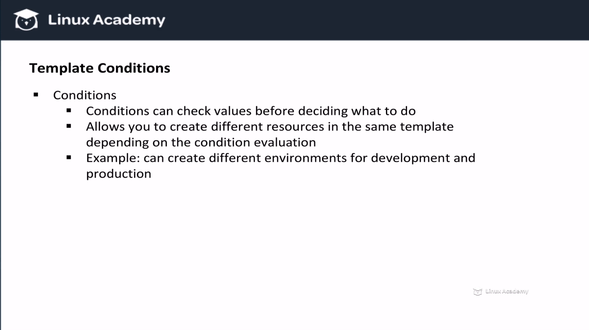

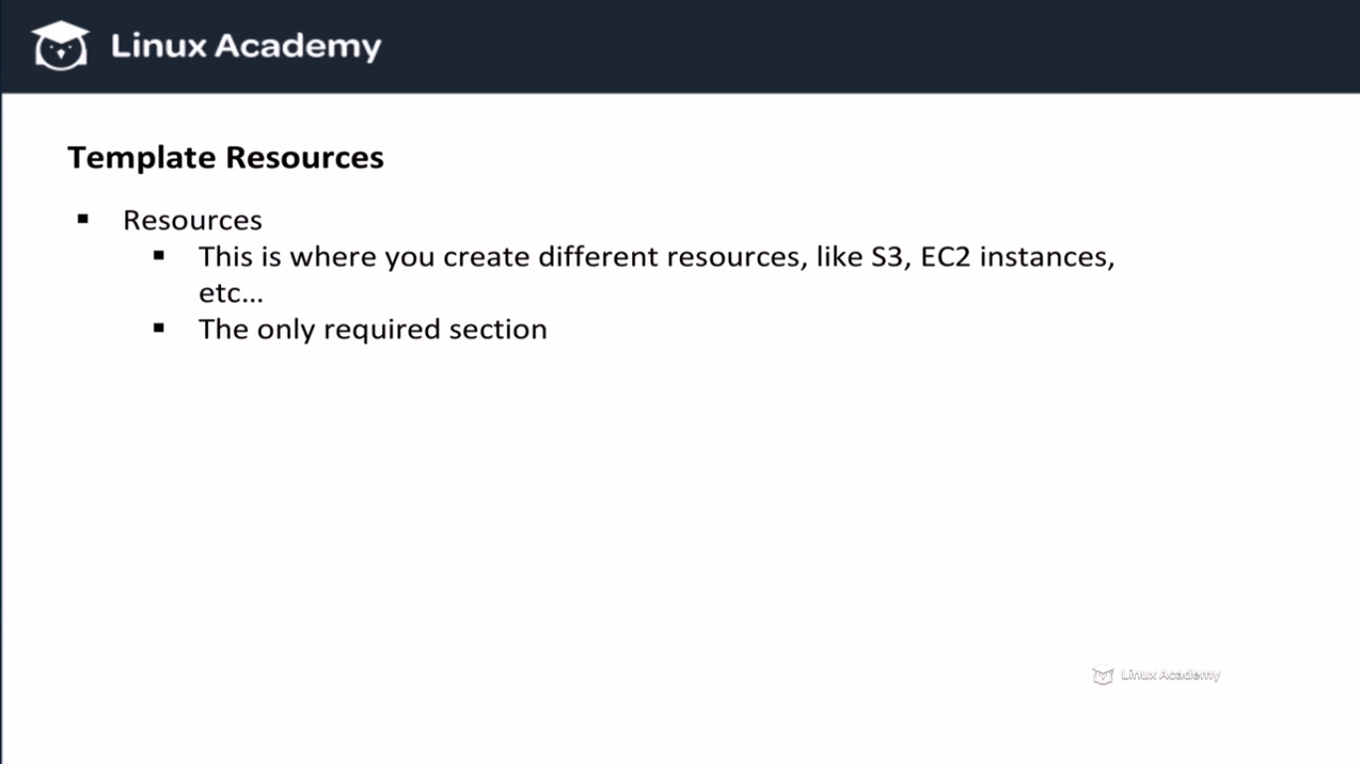

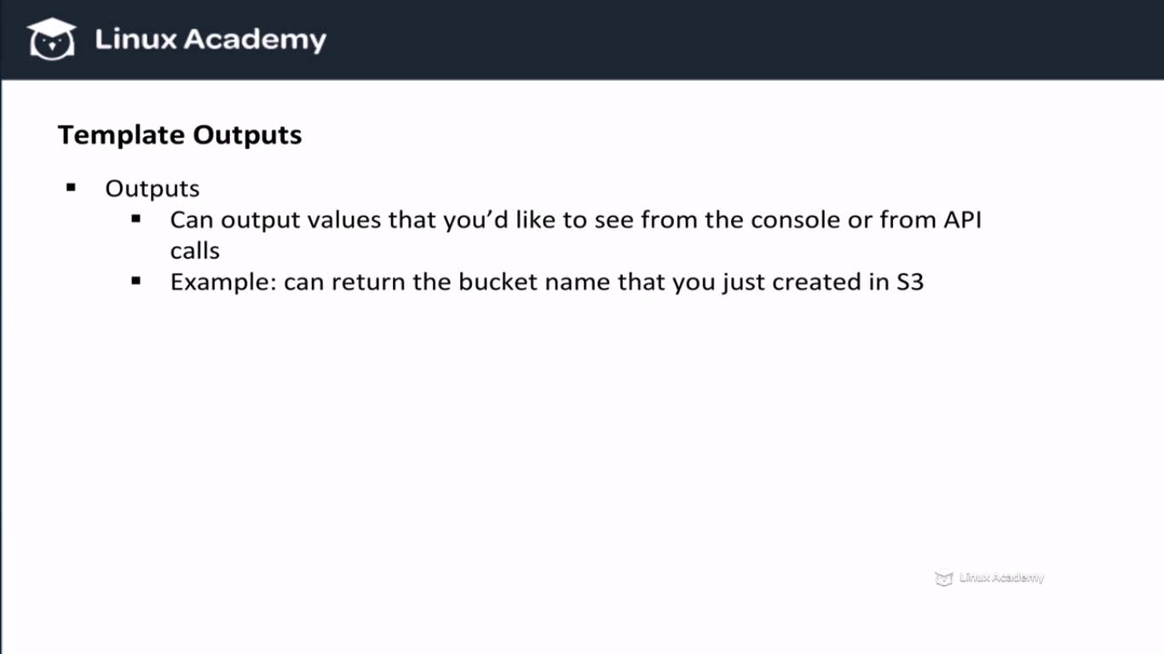

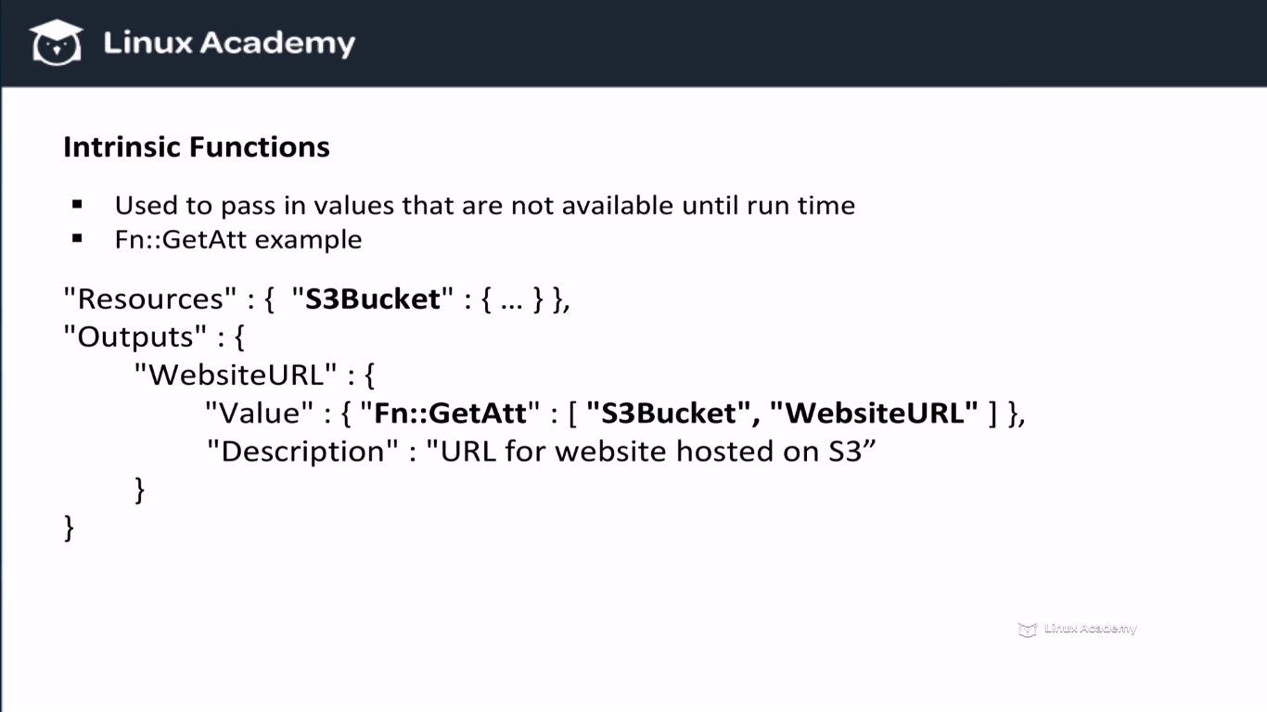

In the above we are left the S3Bucket name blank as this example uses the static website information and as we don’t know them they are left blank in the intrinsic function. We need the bucket arn and hence we left it blanck. Also in the getAtt we specified the WebsiteURL and the cloudformation will get it by its own once we give above in the resource section the name of the bucket on which the static website is hosted.

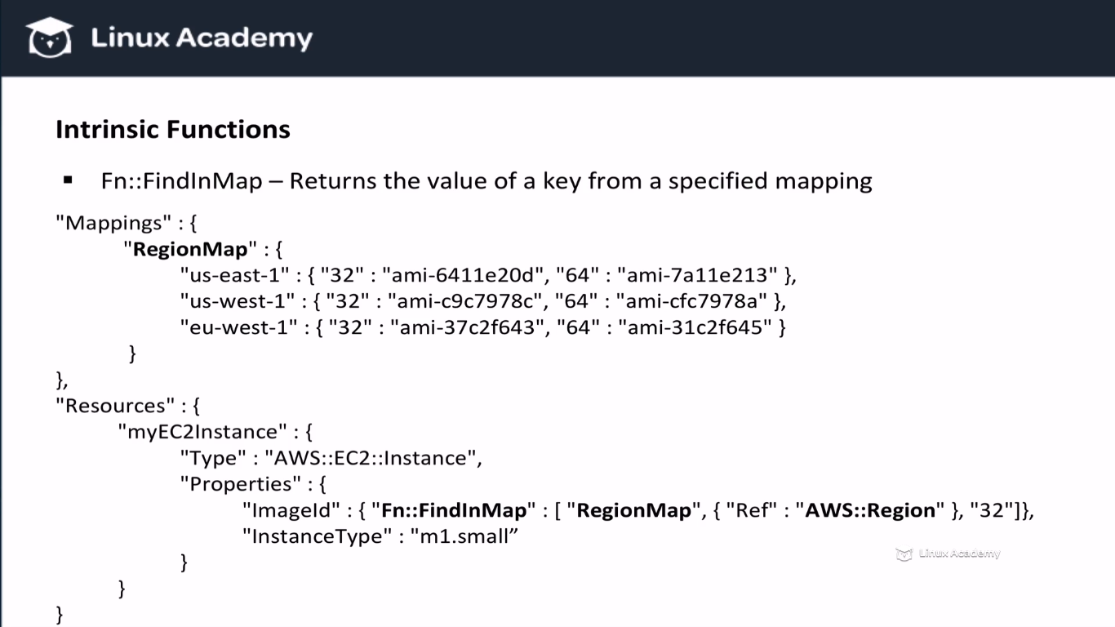

This function the value of a key from a specified mapping. In this example we specify a region map mapping of different region and different AMI’s for different architectures. In the resources section we create an EC2 instances of m1.small. Before the image id we use a function FindInMap to pic the image id based on the current amazon region. So we check the current amazon region and then we look inside of our region map for the right region. Inside of that region we have 2 different architectures one for 32 bit and one for 64 bit. Since we specified 32 bit in our intrinsic function call we get the 32 bit AMI for that region. All of that is done by cloud formation. This is all we have to specify

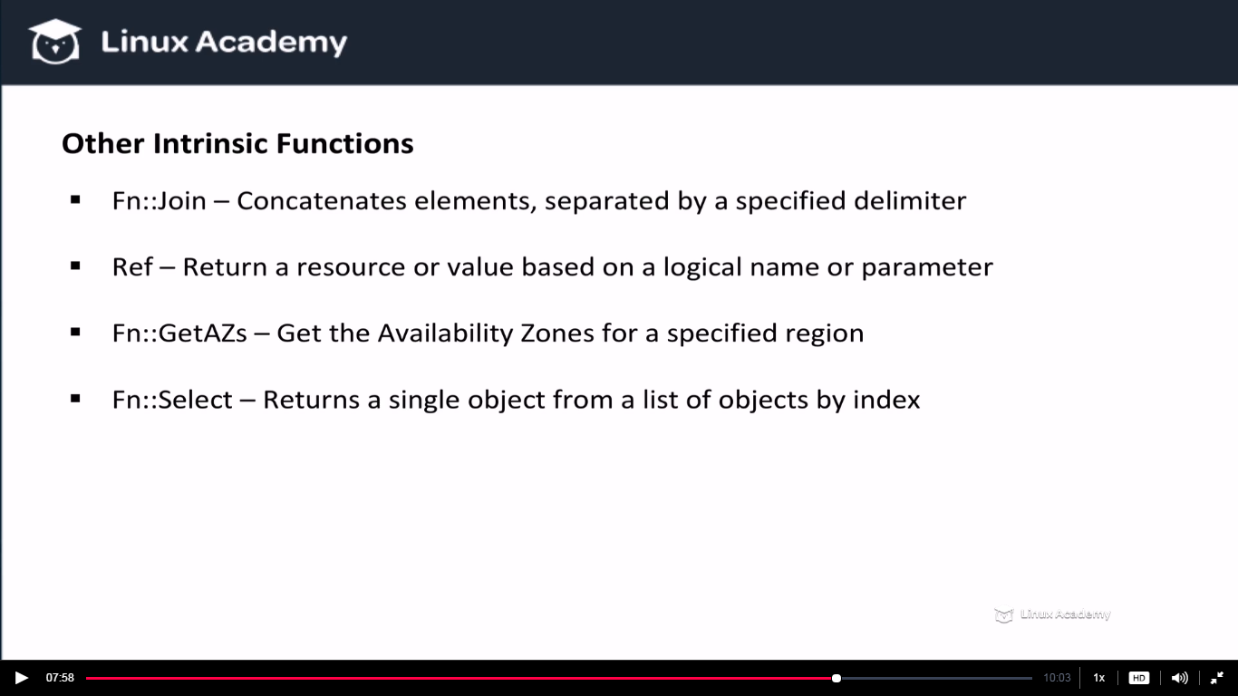

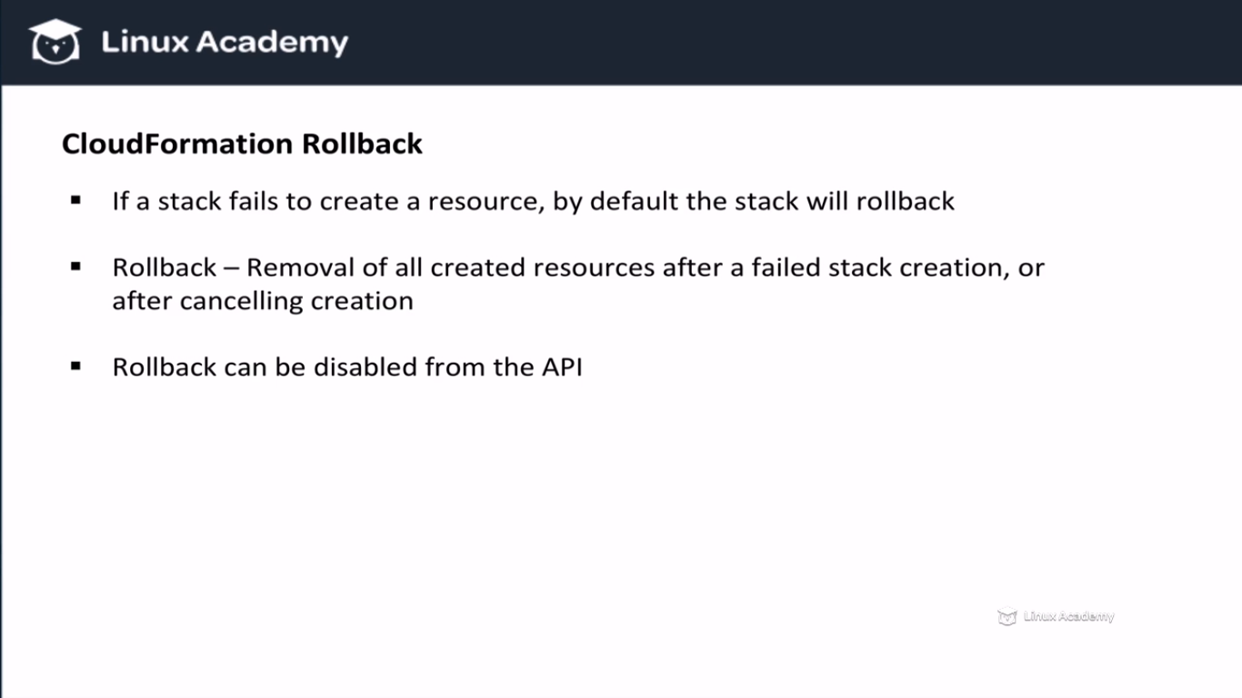

**Rollback can be disabled from the console as well as from the API.**

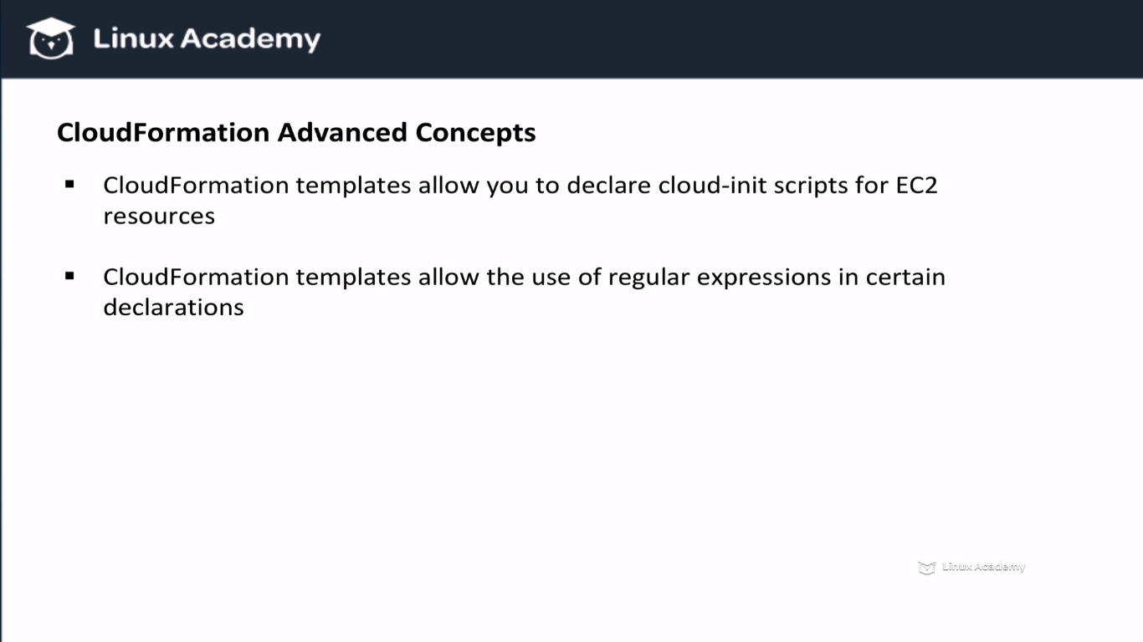

**Lecture: CloudFormation By Example: Deploying EC2 Resources**

In this lesson we are going to look at using CloudFormation to deploy EC2 resources, including an EC2 instance and security group. This lesson covers many of the CloudFormation sections we covered in the essentials lesson.

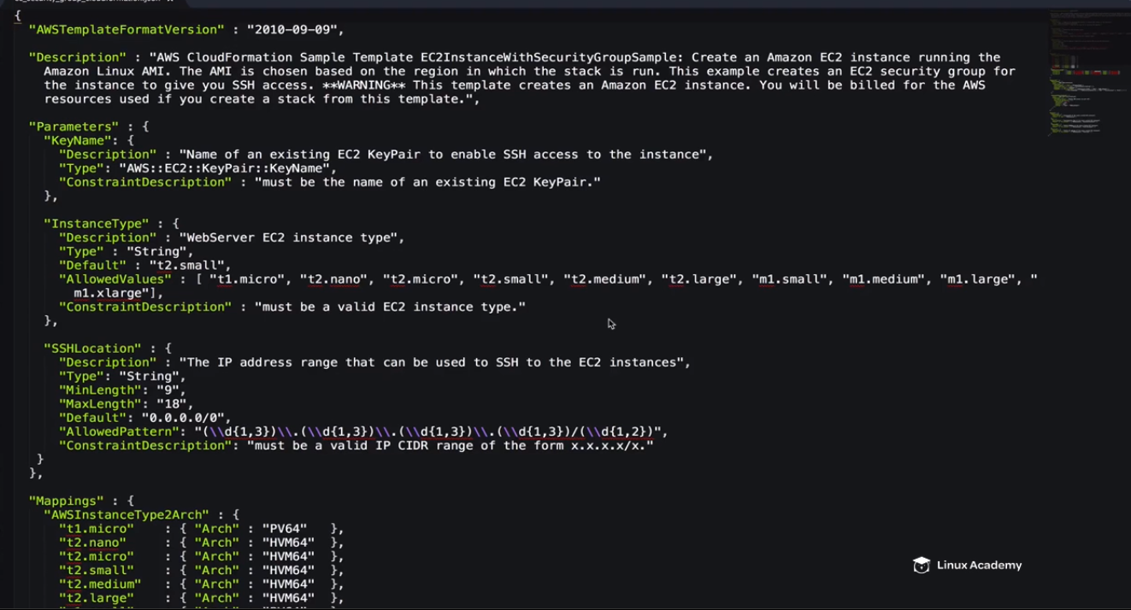

This is amazon’s created template with few changes done by our side.

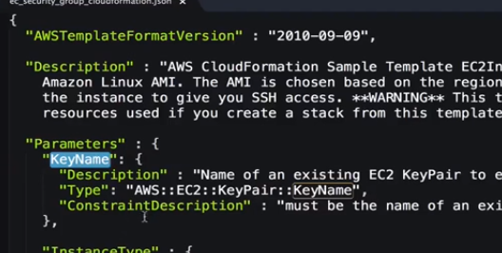

Need to provid this keypair parameter so that later you can ssh into the instance once it get built by this cloudformation template.

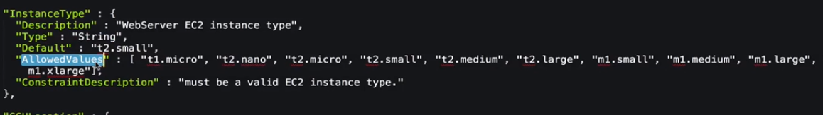

This is the allowed instance type. IF someone types other type then what is specified here then error will be generated as we have defined ConstraintDescription.

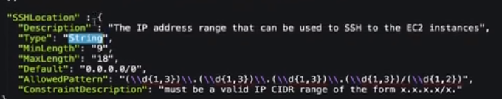

These are the details for the ip, CIDR ranges etc.

So above are the 3 parameter section keyname, instance type and ssh location. Now lets move to the next section which is called mappings.

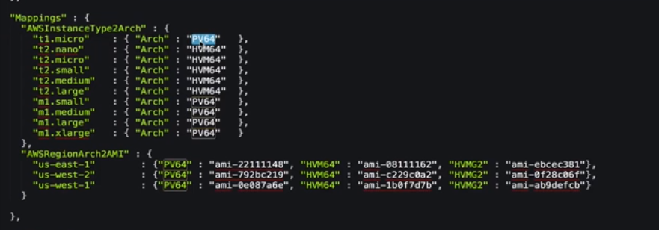

The arch is the architecture types. This here represents the virtualization types. Next is the AWSRegionArchAMI. IT represents the AMI on the region and based opon the instance type and the arch selected in the above mapping section it chooses the ami-id. If a user selected a t1.micro with a PV64 architecture and the region is us-east-1 then the ami-id corresponding to the architecture is ami-221111148. So where we are using all this, this is all being used in the resources section later as below

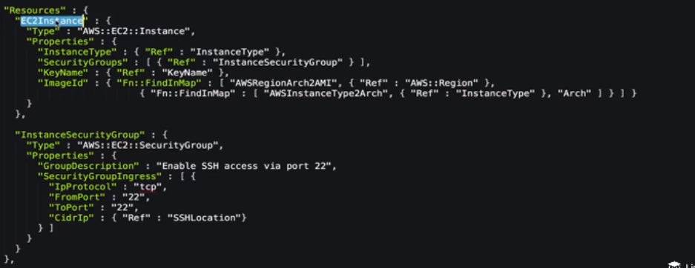

Here we are creating two types of resources ec2 instance and the ec2-security group. We are going to create a SG and will attach it to the instance.

We are not defining the instance here in the resource section statickly, however we are giving dynamic values by using the ref(reference function). We are referencing to the InstanceType section defined previously.

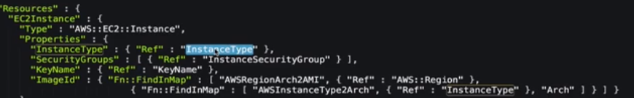

So the name thing we did for the security group, keyname, and for the image-id.

After we need to upload the template in the cloudformation and it will create the instance with the SG.

Now lets do a lab provided here only on linuxacademy.

Download the template. Compete the lab.

**Lecture: CloudFormation By Example: Deploying A WebSite S3 Bucket Configuration**

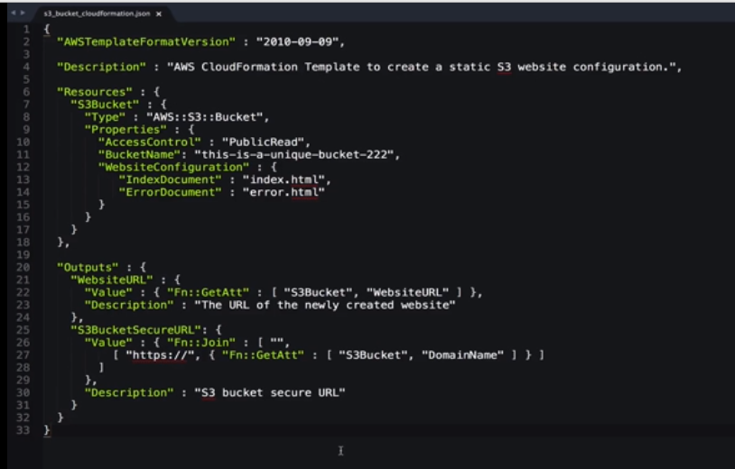

This is going to create a unique bucket and enable website configuration on it.

We can copy the type

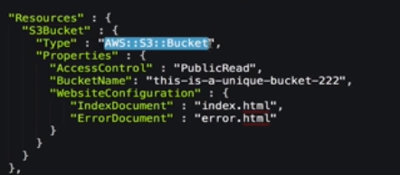

And search for the documentation for this type to understand more as

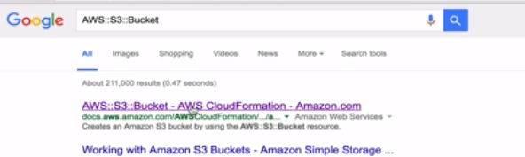

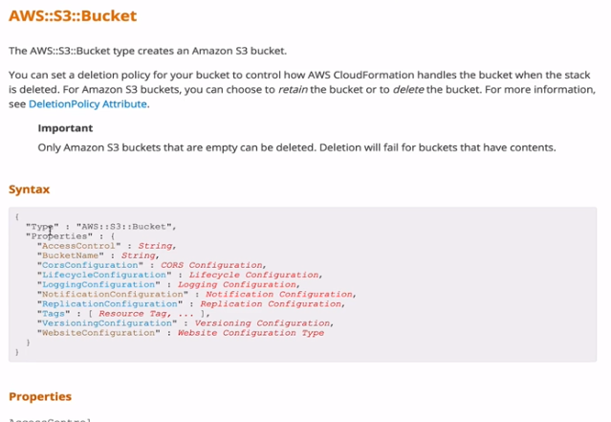

Everything related to the type is here available. We can refer this while creating the template for cloud formation. The same applies for other services as well. Based on the type of resources you can refer to the documentations.

So above in the doc we have website configuration which we are using in our template as well

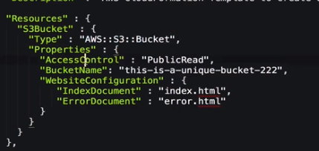

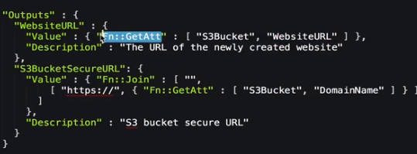

Now we see the Website URL but from where its getting this. So lets look the intrinsic function **GEtATT.**

Go back again to AWS:Bucket:type and search for the getATT function by ctrl+f you would see the function.

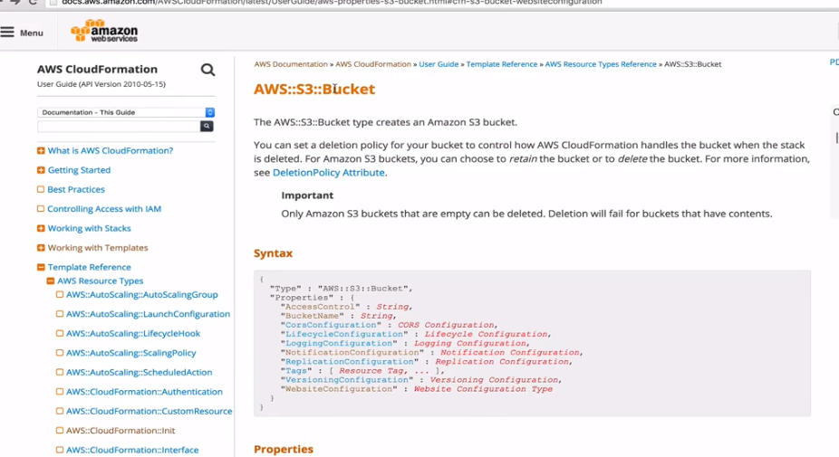

Ctrl+f getAtt

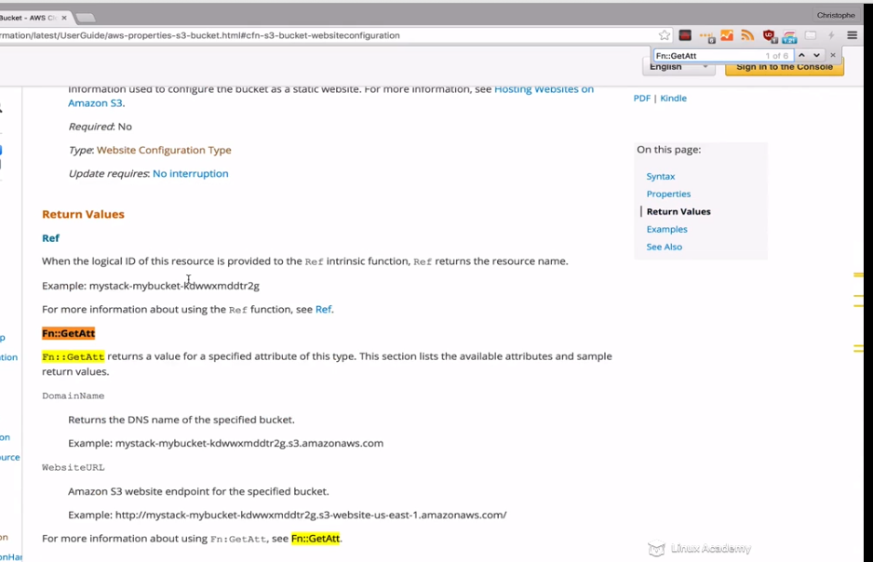

It this function returns two values so url is one of them based on the values which you can find via clicking for more details.

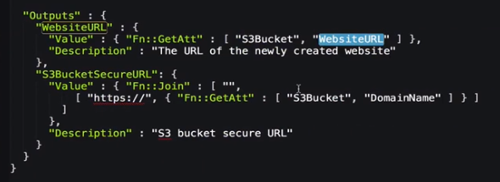

So in our case we are using S3Bucket(resource id) as a reference and Weburl it will get based on this. We already have defined the resource id (S3Bucket) in the resources section. We could have used referrance section as well.

Next we have a function join as

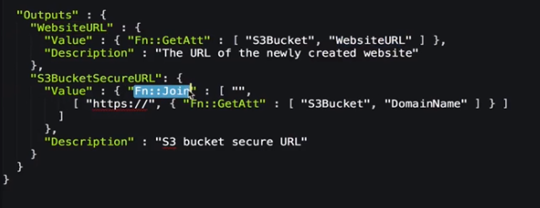

Search this in google

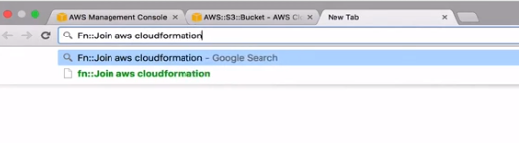

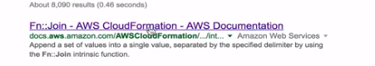

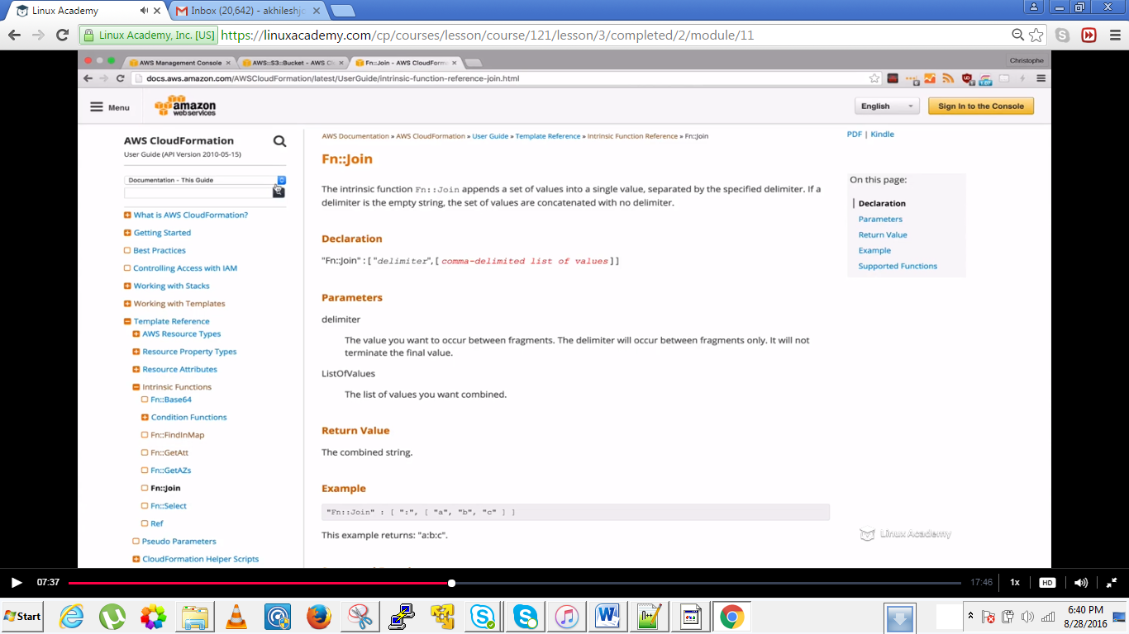

This function takes multiple values and combines them in single value and we can separate them with delimeters.

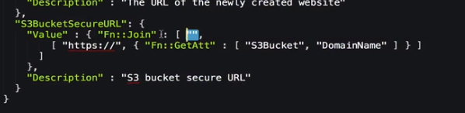

In our case the delimeter is empty but the values we want to append is

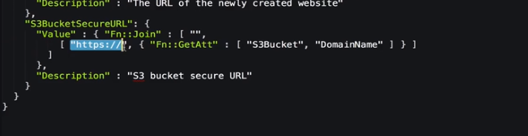

We want the selected to combine with the domainName of the S3bucket returned by the function GetAtt.

IF we put a comma as a delimitter then it would take that comma in the URL as well which we don’t want.

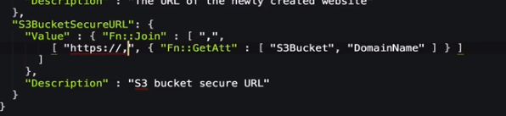

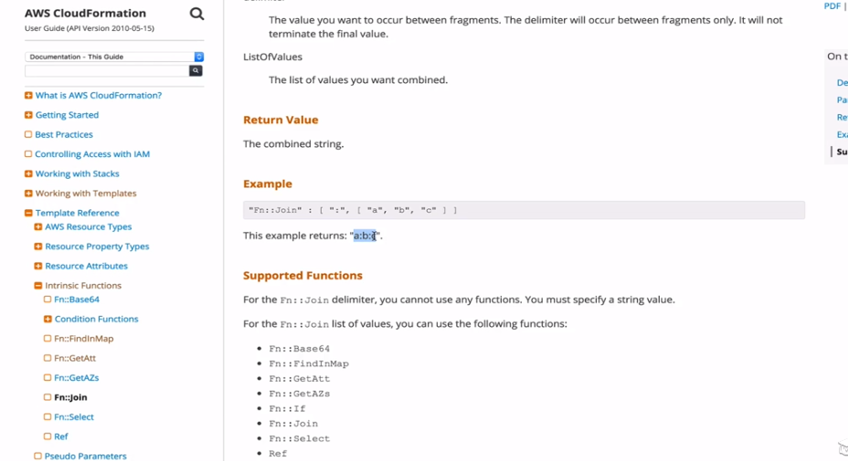

Lets customize this template.

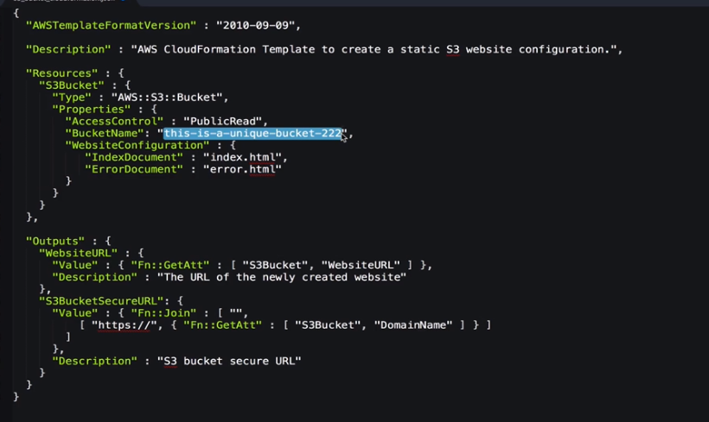

This above is original template where there is a static bucket name but if we want to have a dynamic value. IF we want to use this template later on and we want to have a different name then we need to have parameters which we can set. They will have to input the values whenever they will be prompted for it.

Add this parameters section

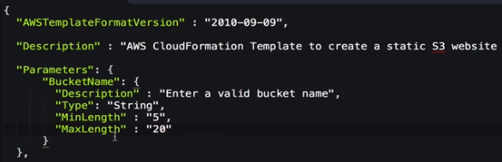

But how do I come to know to put such values. For that

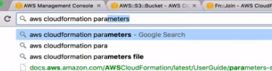

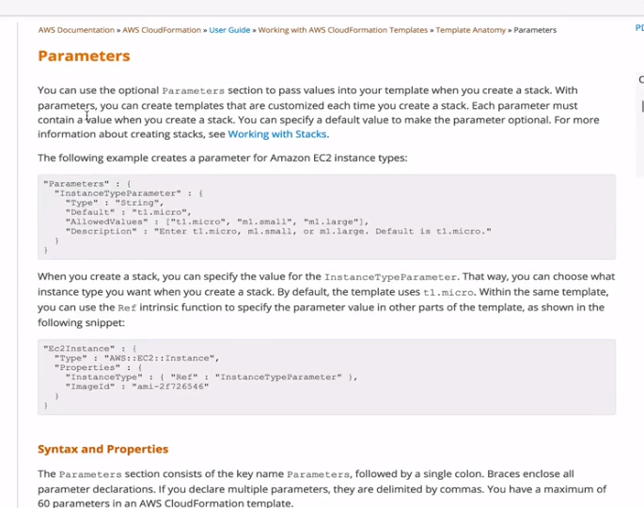

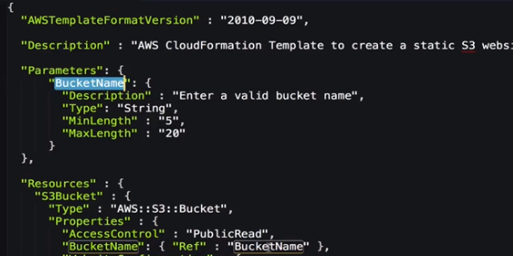

Copy all this template which we created

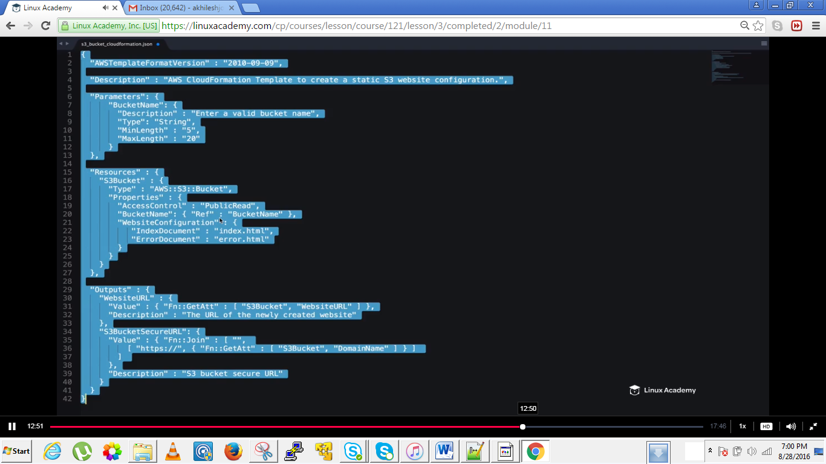

Go to cloudfornation

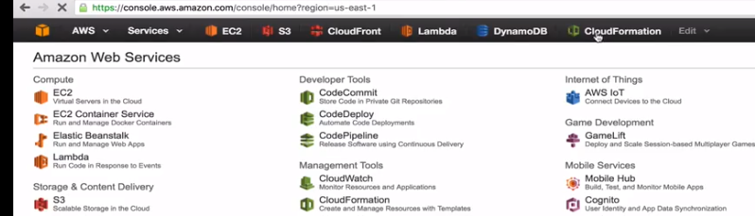

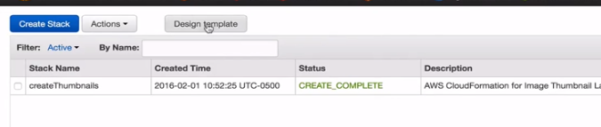

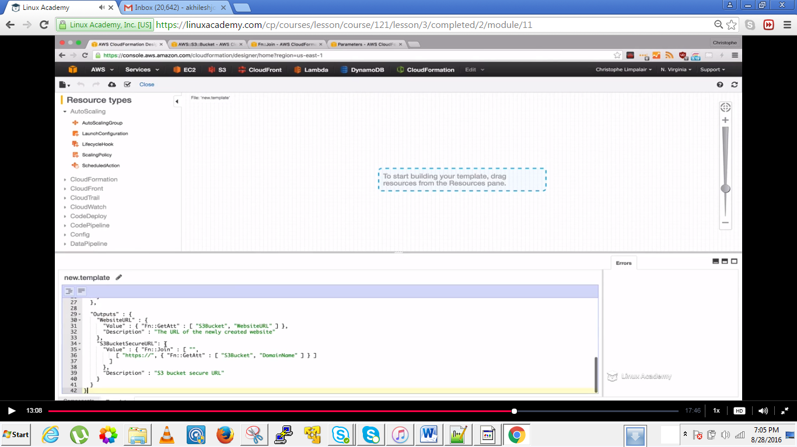

Paste the contents there in the template section.

Validate the template.

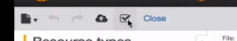

IF no error complete or create it.

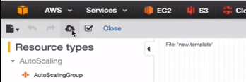

Ok lets go back and see some errors and how to debug it.

Lets copy and paste and deliberately forget a comma and then validate it.

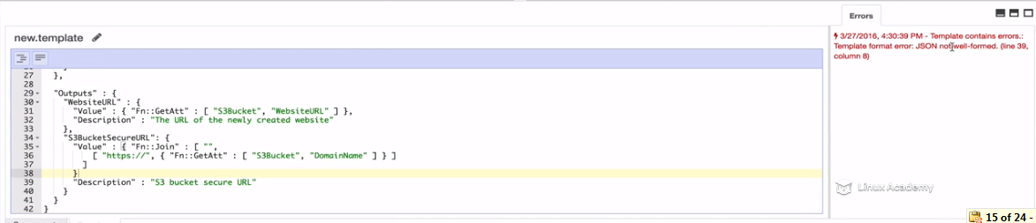

We get error as above.

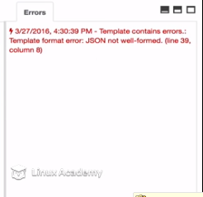

After removing the error create the template again

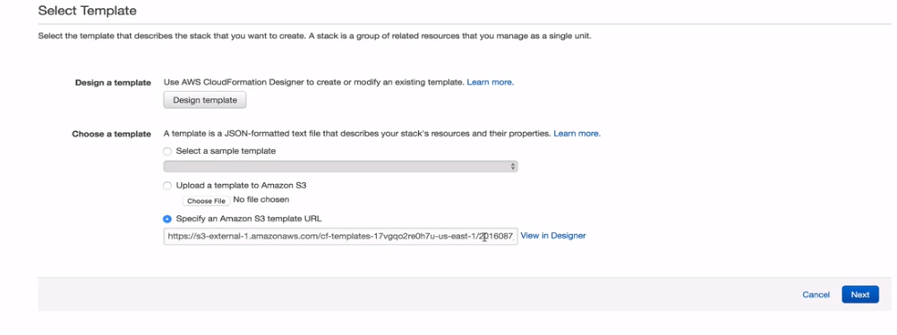

Click next and then

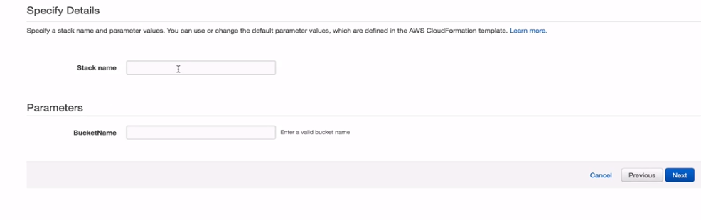

Notice the parameter

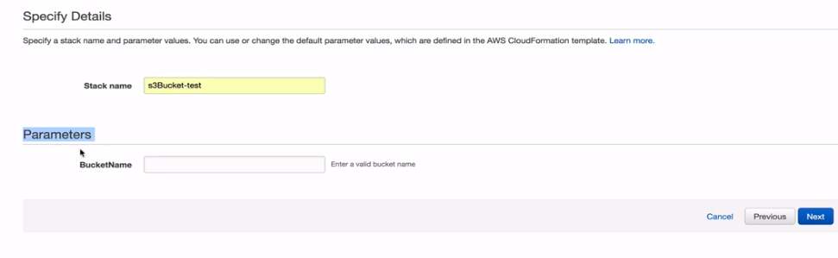

This is just we created in the code

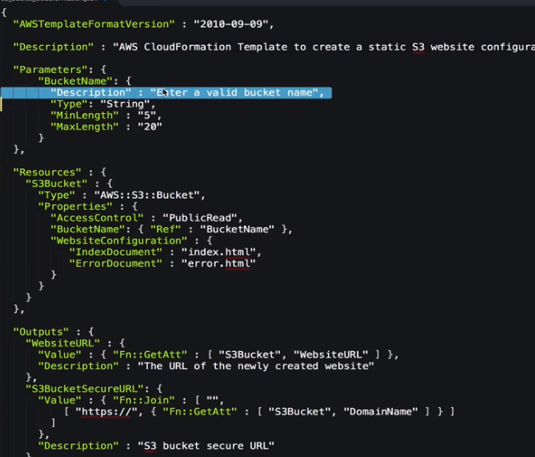

You can do some advanced configuration if you want but here we aren’t changing anything

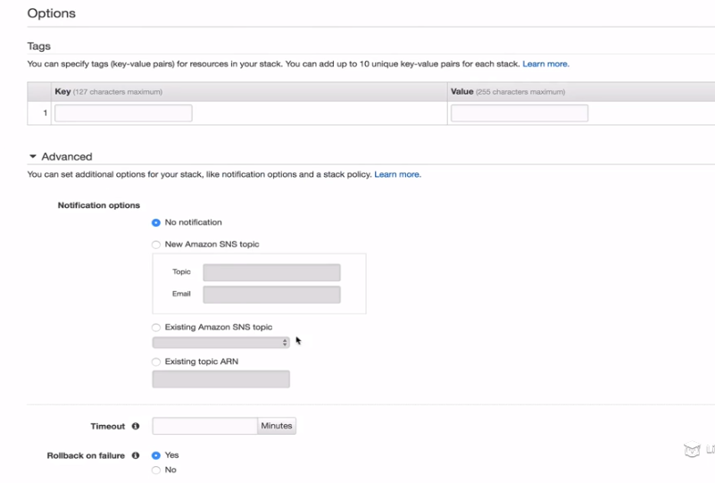

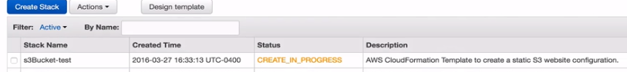

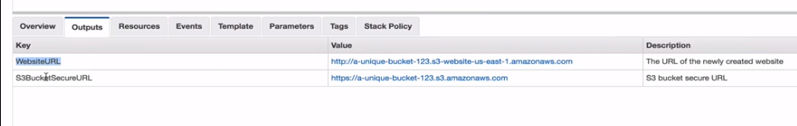

IF we goto s3 we see

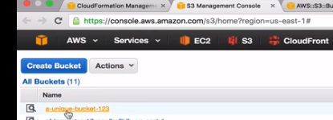

If we go to the properties of the bucket you would see the website enabled as

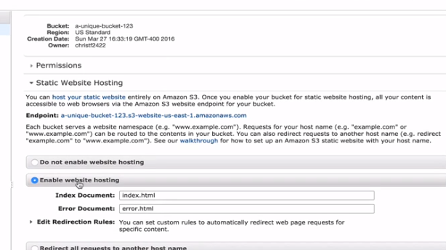

Finally we created a static website so now we can delete the template.

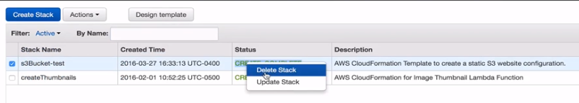

Now what is going to happen is that cloudformation is going to go in the s3 bucket and would delete this bucket.

But we know if there are objects in the bucket this bucket wont delete so what would happen if we try to delete this template, it would through an error and it would have rollbacked and would have cancelled the delete option.

So what could we have done for this situation. We could have written a deletion policy as

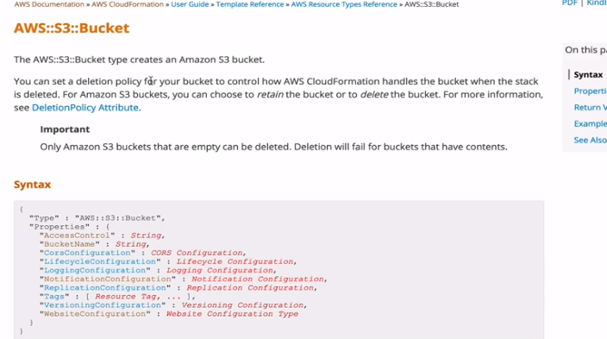

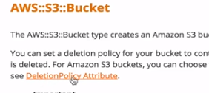

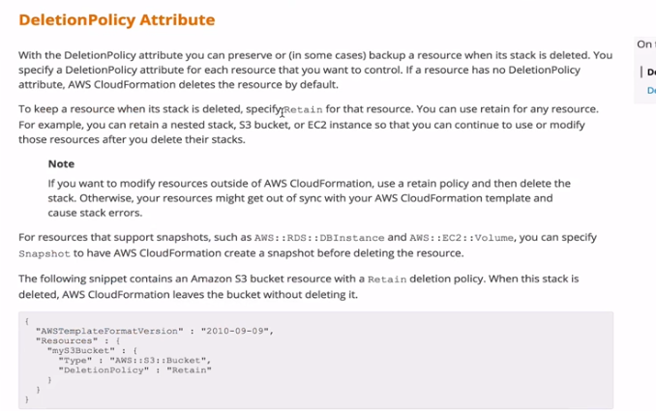

Since we don’t have objects in the bucket so the stack has no resources, everything is deleted.